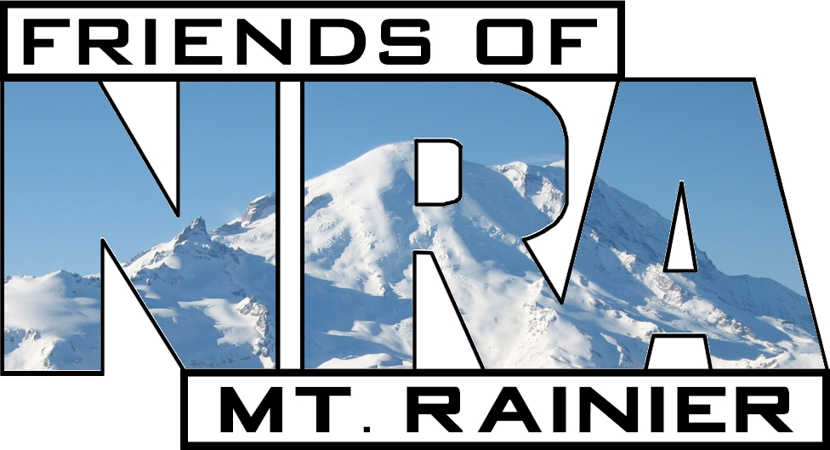
23nd Annual Mount Rainier
Friends of NRA

Saturday, April 9, 2016
Emerald Queen Casino Conference and Ballroom
5580 Pacific Hwy E., Fife, WA 98424
Doors Open at 4:00 p.m. - Dinner at 7:00 p.m. - Auction to Follow

Sponsor Level | _______ @ each = $__________
Ultimate Raffle Package | _______ @ $2080.00 each = $__________
Platinum Raffle Package | _______ @ $1280.00 each = $__________
***NEW***Special Single Raffle Package | _______ @ $1000.00 each = $__________
Gold Raffle Package | _______ @ $800.00 each = $__________
Silver Raffle Package | _______ @ $300.00 each = $__________
Copper Raffle Package | _______ @ $200.00 each = $__________
Pewter Raffle Package | _______ @ $120.00 each = $__________
Dinner Ticket | _______ @ $50.00 each = $__________
Additional Bucket Raffle Tickets | _______ @ $20.00 each = $__________
TOTAL: | $__________

PAYMENT: (Circle One) Cash Check M/O Visa MasterCard Exp. Date
CC Number: Signature:
Name: Phone:
Address:
City: | State: | Zip:
Email Address:

All tickets will be "Will Call" and picked up the night of the fundraiser

Only the Ultimate, Platinum, Special Single, Gold, Silver,
Copper, and Pewter Raffle Packages
Contain Special Raffle Tickets
to Win These Fantastic Prizes:

Big J’s Outdoor Store, Orting, WA | Smith & Wesson SDVE .40 Pistol
Rainier Ballistics | Colt Stainless Commander .45 Pistol
Sportsman's Warehouse  Mount Rainier Friends of NRA | $500.00 Gift Certificate  YETI Tundra 65 Tan Cooler

**FREE DINNERS ARE ONLY AVAILABE WITH THE ADVANCE PURCHASE OF RAFFLE PACKAGES**
Ultimate  Raffle Package $2080.00  ($260.00 Each Dinner Ticket) | - 56 $20.00 Bucket Raffle Ticket Strips (5 Tickets a Strip)  - 48 $20.00 Special Raffle Tickets  - FREE - Eight Dinner Tickets with Reserve Table in Your Name  - FREE - TWO firearms of your choice from the $1280.00 Platinum Raffle Package or ONE from the following Ultimate Raffle Package subject to availability. CIRCLE Choose from:
  *Henry 44 MAG Level Action Octagonal Rifle | * Kimber 84L .30-06 Classic Rifle | * Montana Rifle Co. 22-250 American Standard Rifle
  *Ruger 308 Win GUNSITE Scout Rifle | *Kel-Tec 12 GA KSG Pump Shotgun | *Henry Level .45-70 Lever Action Rifle
  *Kimber Gold Match II 45 ACP Pistol | *Sig Sauer 1911R Scorpion .45 ACP Pistol | *Colt 45 ACP Stainless Commander Pistol
  * DPMS Panther Arms LLC AP4 Carbine 5.56 Rifle | *Daniel Defense Ambush Firearms A11 6.8MM Realtree AP Rifle | *Stag 5.56 NATO AR-15 Model 2 With 2nd Amendment Rifle
  *Ruger 223 REM Mini 14 Ranch Rifle | *Ruger Precision .308 or 6.5 Creedmoor Rifle | *Ruger 308 WIN M77 Stainless Hawkeye
Platinum  Raffle Package $1280.00  ($160.00 Each Dinner Ticket)
  - 32 $20.00 Bucket Ticket Strips (5 Tickets a Strip)
  - 32 $20.00 Special Raffle Tickets
  - FREE - Eight Dinner Tickets with Reserve Table in Your Name
  - FREE - Firearm of your choice subject to availability. CIRCLE Choose from:
  *Benelli Nova Tactical  12 GA Shotgun | *Savage Axis XP.308 Rifle | *Rock Island M1911-A1 CSP .45ACP Pistol
  *Remington Arms Model 783 30-06 Rifle | *Mossberg Turkey Deer Combo 12 GA Shotgun | *Henry Silver Boy .22 LR Rifle NRA Seal on Buttstock
  *Heritage Big Bore Rough Rider .357 MAG Revolver | *Mossberg Patriot 300 Win Mag Rifle | *Weatherby Vanguard .243 Win Rifle
  * Ruger American Rifle Ranch .300 BLK | * Ruger 10/22 Highlander Takedown Kryptek 22 LR Rifle | *Yeti Tundra 65 Tan Cooler
  * Ruger LC9 9MM Pistol | * Ruger SR45 .45 ACP Pistol | * Ruger LCP .380 Pistol
  *Springfield Armory 40 S&W XD Pistol | * Springfield Armory 9MM XD Pistol | *Ruger 7mm-08 Rem American Rifle

*******  *** NEW ***  Special Single Raffle Package  $1000.00 | - 25 $20.00 Bucket Raffle Ticket Strips (5 Tickets a Strip)  - 25 $20.00 Special Raffle Tickets  - FREE - One Dinner Ticket  - FREE - ONE firearm of your choice from the $1280.00 Platinum Raffle Package subject to availability. CIRCLE Choice.

Gold  Raffle Package $800.00 | - 24 $20.00 Bucket Raffle Ticket Strips (5 Tickets a Strip)  - 16 $20.00 Special Raffle Tickets  - FREE - Four Dinner Tickets

Silver  Raffle Package $300.00 | - 9 $20.00 Bucket Raffle Ticket Strips (5 Tickets a Strip)  - 6 $20.00 Special Raffle Tickets  - FREE - Three Dinner Tickets

Copper  Raffle Package  $200.00 | - 6 $20.00 Bucket Raffle Ticket Strips (5 Tickets a Strip)  - 4 $20.00 Special Raffle Tickets  - FREE - Two Dinner Tickets

Pewter  Dinner Package $120.00 | - 5 $20.00 Bucket Raffle Ticket Strips (5 Tickets a Strip)  - 1 $20.00 Special Raffle Tickets  - FREE - One Dinner Ticket

Provide Additional Support
Become a Friends of NRA Sponsor

Liberty  Sponsor  $250.00 | - Framed NRA Seal Display  - Friends of NRA Sponsor Hat  - Subscription to Traditions Magazine (Mailed Quarterly)

Heritage  Sponsor  $600.00 | - Liberty Sponsor Level Benefits  - Choice of:  *Yukon Outfitters Tactical Survival Backpack with Friends of NRA Logo Patch and Survival Kit or  *Silver Stag Frontier Freedom Knife with Leather Sheath and Friends of NRA Logo

Freedom  Sponsor  $1250.00 | - Liberty Sponsor Level Benefits  - Choice of  *Kel-Tec SUB-2000 9MM Rifle with NRA Logo or  *Kel-Tec CMR .22 Mag rifle

Pioneer  Sponsor  $2500.00 | - Liberty Sponsor Level Benefits  Winchester Model 70 .30-06 Rifle with custom “Don’t Tread on Me” text laser-engraved on bolt and the Gadsden rattlesnake and NRA logo on floorplate in selective 24K gold plating – only 50 available

Legacy of Freedom  Sponsor  Limited Editions  $3500.00 | - Liberty Sponsor Level Benefits  - Choice of:  *Limited Edition Ruger No.1 .30-06 Medium Sporter Rifle  *Limited Edition Sig Sauer 1911 Scorpion .45 ACP  *Limited Edition Ruger Vaquero Stainless .45 Colt

Patriot  Sponsor  $5000.00 | - Liberty Sponsor Level Benefits  - Choice of:  *Colt Marine .45 ACP with NRA Logo and “Semper Fi” Text or  *Colt Single Action Army .45 Colt Revolver, NRA Logo in 24k Gold Plating (Only 50 Available) or  *Kimber Custom II Warrior SCO 1911 .45 ACP with NRA Logo (Only 50 Available) or  *Winchester Model 73 Short High Grade .357/.38 with Special Engraving and “National Rifle Association” Text in 24K Gold (Only 75 Available) or  *Daniel Defense DD5 v1 7.62 NATO with NRA Logo(Only 25 Available) or  *Remington UMC Commemorative 1911 with Reproduction Leather Holster, Lanyard, Magazine Pouch, and Two-tone Magazines

Please return this form with payment payable to the “Friends of NRA” to:
Mt. Rainier Friends of NRA c/o
Cary Black 15626 63rd St Ct E, Sumner, WA 98390.
For additional information contact: 253-841-7113 or protect2ndamd@comcast.net
You're Invited
to the 22nd
Mount Rainier
Friends of NRA Fundraiser
March. 15, 2014



