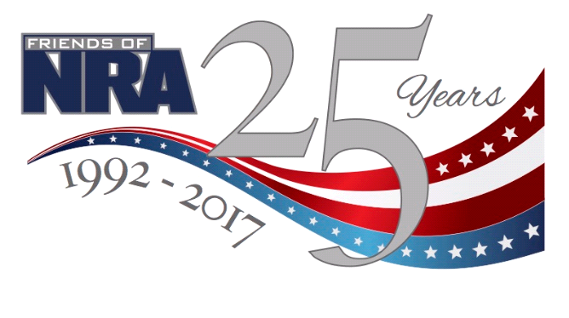
HEARTLAND
FRIENDS OF NRA
Annual Fundraiser
Friday, October 6th, 2017
Abode Venue
1330 E. Douglas Ave, Wichita, Kansas
Doors Open at 5pm
Live Auction, Silent Auction, Games, Drawings!
Individual Ticket $35, Table $400
Sponsor Table $1000 (get one of three firearms!)
Underwriting and Sponsorships Available
***Get Your Tickets Today!***
Contact Douglas Sherwood tel# 316.778.0218 or
Go Online @ www.friendsofnra.org/ks to purchase tickets

