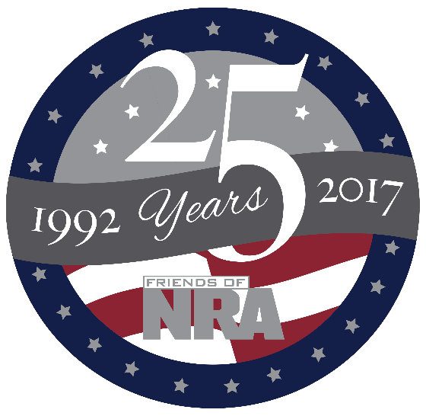

Itasca County FNRA
22th Annual Fundraiser

on behalf of The NRA Foundation
April 21, 2017 ▪ 5:00 pm
TimberLake Lodge 144 SE 17th Street ▪ Grand Rapids, MN 55744

Early Bird Special Drawing
Tickets postmarked or turned in by 3/1/2017 will be eligible for a chance to win two (2) FREE Big Shooter Tickets!

Celebrate a legacy of shooting sports traditions.
Join other champions of the Second Amendment for dinner, raffles, auctions and fun with a chance to win exclusive NRA guns, gear, décor and collectibles!
AUCTION & RAFFLE HIGHLIGHTS

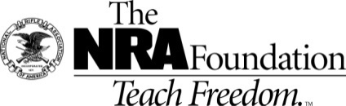
NRA Guns & Prizes |  | Special Raffles/ Table Packages
2017 GUN OF THE YEAR | NRA EXCLUSIVES
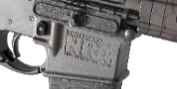  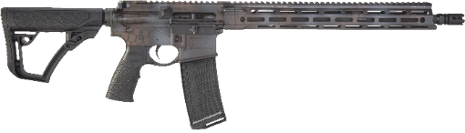  Daniel Defense M4 Carbine V7 5.56mm NATO Rifle  Rattlecan™ Cerakote, Friends of NRA “2017 Gun of the Year” engraving, and custom NRA serialization  Club Level Committee Exclusive  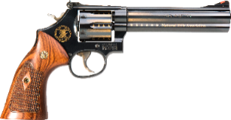  Smith & Wesson Model 586 Revolver  .357 Mag/.38 Spl. with custom 24k gold embellishment | Colt Competition PistolTM  Polished Finish 1911  .45 ACP with NRA Serialization  Kimber K6sTM .357 Mag Revolver  with NRA Serialization  Henry Big Boy Silver Lever Action Rifle  .44 Mag with Anniversary Logo  Sig Sauer P320 Compact  9mm with NRA Logo  Kel-Tec PMR-30 .22 Mag Pistol  with NRA Serialization  Crickett .22LR Rifle  with Silver Anniversary Coin  & MORE!  View all at friendsofnra.org/merchandise | $800 Table  8 Dinner tickets - Special gifts, $320 raffle pkg,  1 -Taurus Millennium G2 9MM  $1600 Table  8 Dinner tickets, Special gifts, 8 $100 raffle pkgs,  1 - DPMS Oracle AR15 Rifle or  Kimber Two Tone Micro .380  $5,000 Table  8 Dinner tickets, Special gifts, 8-$300 raffle pkgs,  8- Stevens M320 Field/Security Combo 12ga  or  1- Savage .338 Lapua with ammo & Case  (other firearm options available)

The NRA Foundation is a 501(c)3 charity of the National Rifle Association. Net proceeds benefit shooting sports programs in our communities. NRA membership is not required to participate. All firearm laws apply. Winners are responsible for any taxes / transfer fees. Firearms transferred through [REEDS OUTDOOR OUTFITTERS].

2017 sponsor program

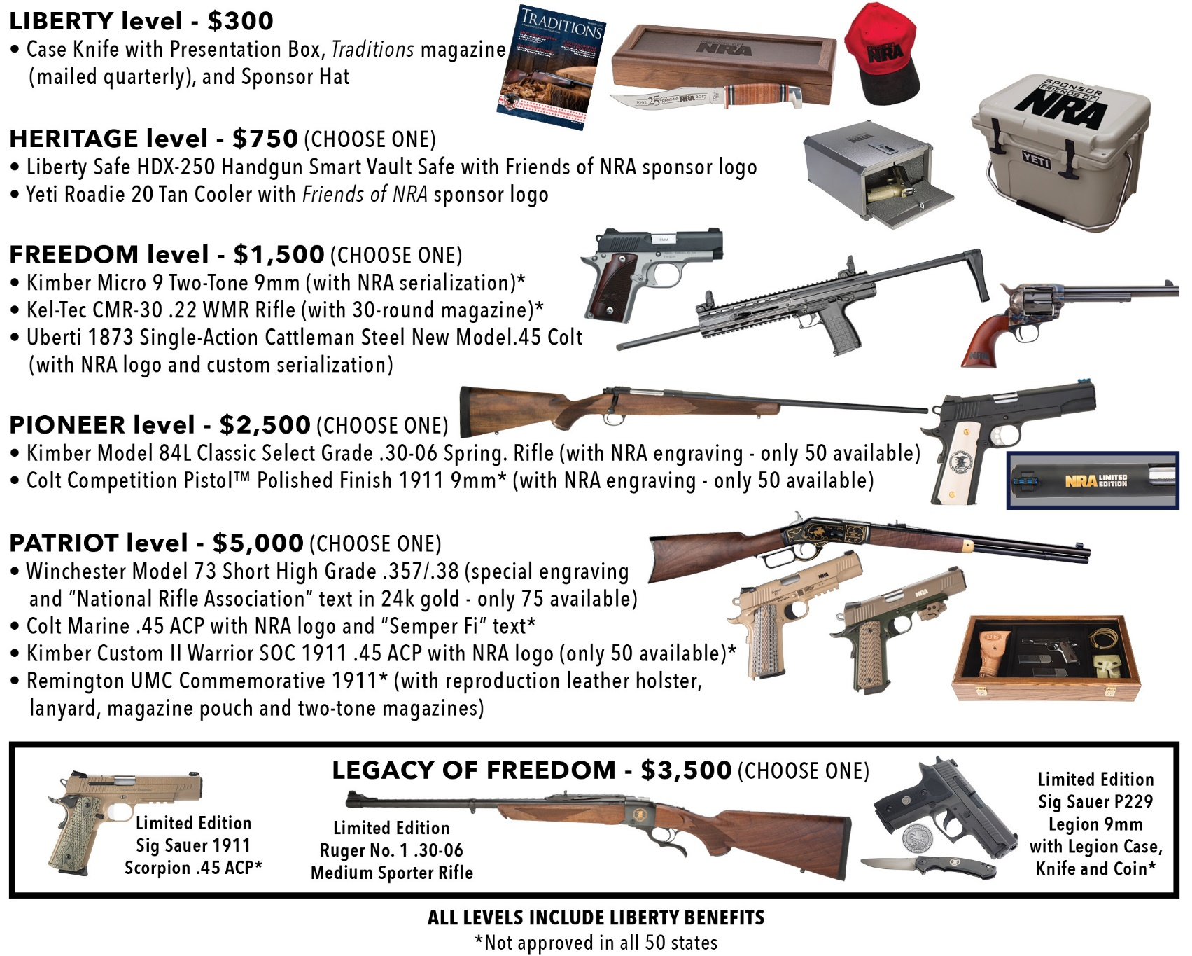
Big Shooter Ticket Chance on the following 15 firearms:

Savage Stevens O/U, 20ga | Rock Island Standard G1, .45
Walther PK380 Black, .380 | Ruger 10/22 Takedown, NRA Logo
Mossberg Night Train w/ Scope, .308 | Savage Axis Wood w/Scope, 6.5 Creedmoor
Kimber Micro Carry Two Tone, .380 | H&K VP9, 9MM
DPMS Oracle, 5.56 | Marlin 336XLR Lever, 30-30
Savage Axis Synthetic Camo w/Scope, .270 | Kimber Hunter, .308
Taurus 85, .38Spl | Big Boy Steel, .44Mag
Remington 870 Express, 12 ga

For additional information or questions contact:
Marge or Jim Kelley -218-327-0317 jkelleygpz@msn.com

