UPPER THUMB FRIENDS OF NRA
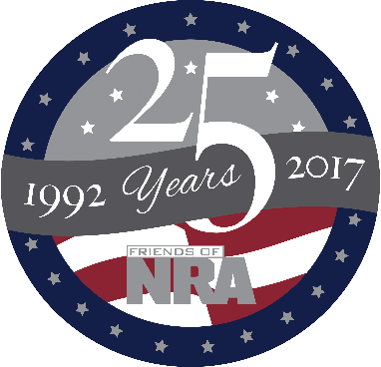
11th Annual Fundraiser

on behalf of The NRA Foundation

Wednesday
September 13th, 2017 ▪ 5:30 pm
FRANKLIN INN
1060 e. huron ave. bad axe, michigan 48413
NRA Guns & Prizes  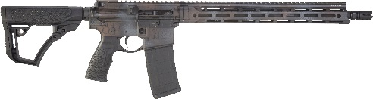  2017 GUN OF THE YEAR  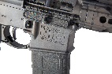  Daniel Defense M4 Carbine V7  5.56mm x 45  Rattlecan Cerakote Pattern, FNRA Logo, engraving Plus Custom NRA Serialization  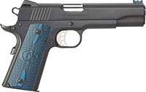  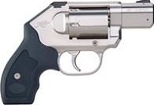  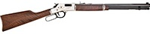 | NRA EXCLUSIVES  Henry Silver Big Boy in .44 Mag with Anniversary logo  Colt Competition Pistol, Polished Finish 1911 .45 ACP  with NRA Serialization  Kimber K6s Revolver  .357 Mag with NRA Serialization  Signed Charlie Daniels Flag Fiddle  Kel-Tec PMR-30 .22 Mag Pistol with NRA Serialization  & MORE!  VIEW ALL AT  friendsofnr.org/merchandise | LOADED GUN SAFE RAFFLE  Win the Sig Sauer P320 Compact 9mm Handgun with NRA Logo and be entered to win a safe with 11 firearms including:  •Remington 870 200th Anniversary 12 ga  •Weatherby Vanguard .30-06 Rifle  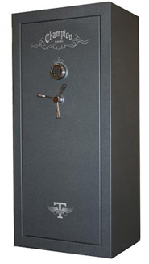  •Henry Golden Boy .22 LR Rifle  •NAA Mini-Revolver .22 Mag  •Taurus Curve .380 ACP Pistol  •Benelli Nova Tactical 12 ga  •Savage B-Mag .17 WSM  •Mossberg 500 Combo 12 ga.  •Colt 1911 .45 ACP Pistol  •Stag Arms AR-15 5.56mm  •S&W 642 Airweight .38 Spl.  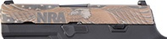  $10 each / 3 for $20 / 10 for $50
TICKET PACKAGES

Dinner Ticket for $35- (1) Event Ticket (includes meal

Big Shooter Package for $100- (1) Event Ticket (includes meal), 40 Patriot Bucket Raffle Tickets ($195 Value)

Super Shooter Package for $300- (2) Event Tickets (includes 2 meals), 100 Patriot Bucket Raffle Tickets ($400 Value) and a guaranteed firearm of your choice!

AUCTION & RAFFLE HIGHLIGHTS

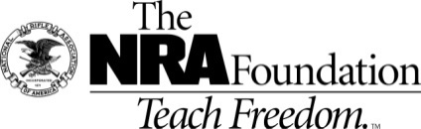

The NRA Foundation is a 501(c)3 charity of the National Rifle Association. 100% of the Net proceeds benefit National level safety programs and local youth shooting sports programs in our communities. 24 FNRA Committees have raised and provided over 1 Million Dollars over the past 48 months to over 300 projects here in Michigan and we THANK YOU for your continued contribution to the cause. NRA membership is not required to participate. All firearm laws and transfers apply.
2017 sponsor program

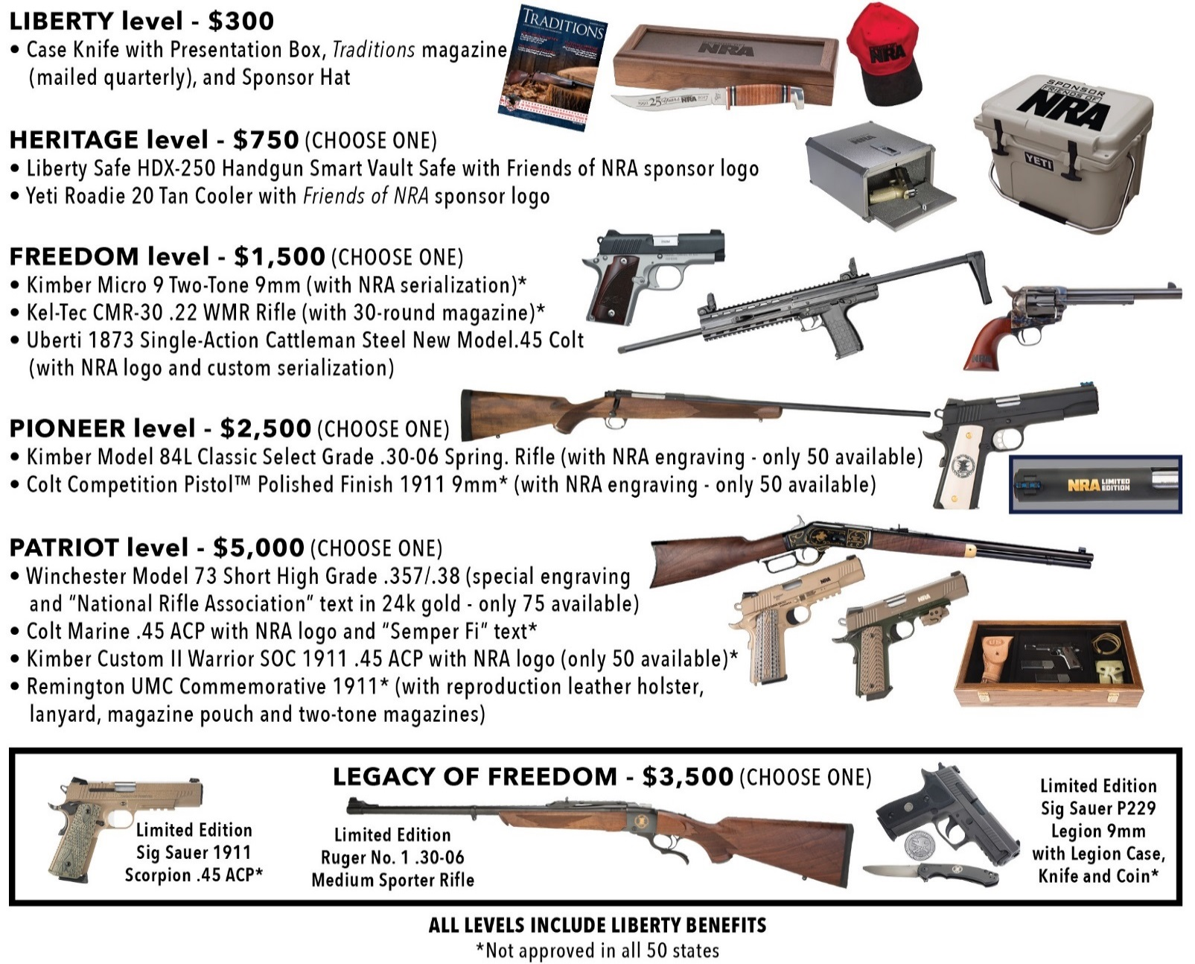

Mail This Portion --- Order and SAVE
Name: __________________________________________ Address: ________________________________________________
City: ______________________ State: _______ Zip: _____________ (Must be same as CC Billing) Phone: (____) _____-_________
Email: ________________________________________________________

Please reserve _____Event Ticket and Meal at $35 each $_________

Please reserve _____$100 Big Shooter Package and 1 Meal- Over $195 Value $_________

Please reserve _____$300 Super Shooter Package and 2 Meals – Over $600 Value- (includes a firearm!) $_________

Please reserve _____ Loaded Gun Safe Raffle Ticket(s) $10 each, 3/ $20 or 10 for $50 $_________

Please List your choice of Sponsor Firearm Here or call the contacts below _______________________________________

Enclosed please find my check/money order, payable to Friends of NRA......................totaling: $__________

Tickets ordered on this form may be picked up at the door the night of the event.
Please charge my Credit Card: (circle) Visa/MC/AMEX/Discover #___________--___________--__________--__________ Expiration Date (Month/Year) ______/________ Security Code: _______
MAIL TO: Randy’s Hunting Center For more information call :
721 East Huron Ave Randy Brown @ 989-269-4867
Bad Axe, MI 48413 Kevin Brown @ 989-550-1508
log onto www.friendsofnra.org THIS FORM MAY BE COPIED

All Levels include Liberty Benefits
Call for tax deduction amounts *Not approved in all 50 states

