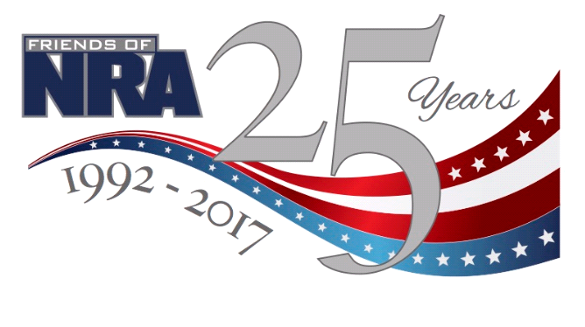
SOUTHWEST KANSAS
FRIENDS OF NRA
2nd Annual Fundraiser
Tuesday, May 16th, 2017
Pratt Community Center
619 N. Main St., Pratt
Doors Open at 5pm-Dinner at 6:30
Live Auction, Silent Auction, Games, Drawings!
Kids 7 and under Free, ages 8-12 $15
Single $25, Couple $40, Reserved Table $225
Sponsor Table $1000 (includes 8 meals & one of three firearms!)
ROCK ISLAND .45—DPMS ORACLE .223—BENELLI NOVA 12 ga
Underwriting and Sponsorships Available
*****EARLY BIRD SPECIALS thru April 30th*****
**BONUS DRAWING FOR EARLY DINNER TICKET PURCHASES**
Contact George Stevens 620.672.8321
Dallas Zielke 620.388.5334
Leah Robinson 620.213.1424 or
Go Online @ www.friendsofnra.org/ks to purchase tickets

