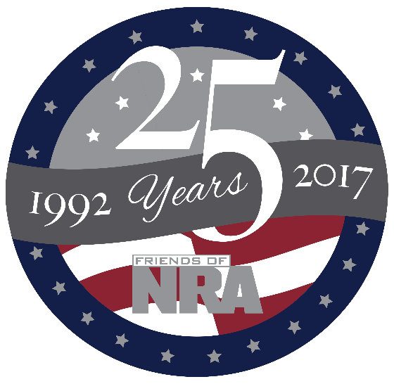

Kandiyohi County
Annual Fundraiser

on behalf of The NRA Foundation
MARCH 25th, 2017 ▪ 5:00 pm
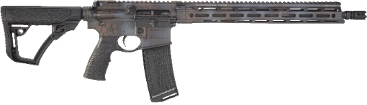
2017 Gun of the Year Daniel Defense M4 Carbine

Willmar Conference Center
240 23rd St SE▪ Willmar, MN

Celebrate a legacy of shooting sports traditions.
Join other champions of the Second Amendment for dinner, raffles, auctions and fun with a chance to win exclusive NRA guns, gear, décor and collectibles!
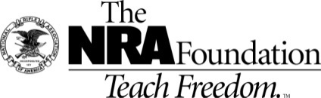
Contact and Ticket info – friendsofnra.org
Kim Eickhoff – 320-491-0237 ike.eickhoff@gmail.com
Mike’s Small Engine – 1101 Hwy 12 E Willmar - 320-979-9173

Ticket and Tables Packages NRA Guns & Prizes |  | Special Raffles
Get Yours Early | NRA EXCLUSIVES
$800 Table Package  8 Dinners - $320 in White Bucket Tickets  And a  9mm OR Rem. 30-06 w/scope  $1911 Table Package  8 Dinner Tickets - 8 Special Gifts  8 $100 Ticket Packages and a  Colt or Kimber 1911 at your table!!!!!  $5,000 Table Package  8 Dinner Tickets – 8 Special Gifts  8 $300 Ticket Packages AND  8 9mm Handguns OR  1 Savage Lapua at your table!!!!! | Colt Competition PistolTM  Polished Finish 1911  .45 ACP with NRA Serialization  Kimber K6sTM .357 Mag Revolver  with NRA Serialization  Henry Big Boy Silver Lever Action Rifle  .44 Mag with Anniversary Logo  Sig Sauer P320 Compact  9mm with NRA Logo  Kel-Tec PMR-30 .22 Mag Pistol  with NRA Serialization  Crickett .22LR Rifle  with Silver Anniversary Coin  & MORE!  View all at friendsofnra.org/merchandise | 5 Gun Raffle  Savage 220 20ga. Deer Gun  Hitzer .243 Single Shot Pistol  DPMS Oracle AR-15  Kimber Micro Carry 380  Rem 783 30-06 w/scope  Tickets $5.00 Each  $1,000 Bucket Package = $3,600 worth of Bucket tickets AND  A gun!!!!!!

The NRA Foundation is a 501(c)3 charity of the National Rifle Association. Net proceeds benefit shooting sports programs in our communities. NRA membership is not required to participate. All firearm laws apply. Winners are responsible for any taxes / transfer
fees.

