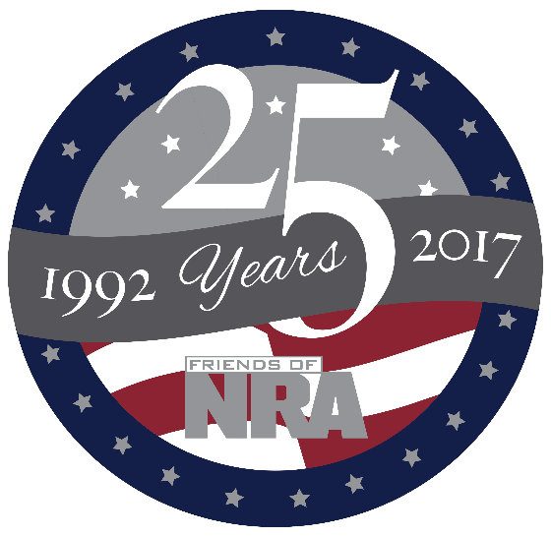
2017 Kandiyohi County
Friends of NRA Order Form
March 25th, 2017 – Willmar Conference Center
Order tickets online:
www.friendsofnra.org
All tickets held at door
Cancelled check or CC charge is your receipt/confirmation

Questions?
Kim Eickoff
Ike.eickhoff@gmail.com
320-491-0237
Or mail order by
Clip address below & tape to envelope for easy addressing!

Kim Eikhoff
901 Olena Ave SE
Willmar, MN 56201

QTY |  |  | $40 Individual Dinner |  |  |  |  | $
 |  |  | $800 Table: 8 Dinners, $320 Tickets, 30-06 w/scope or 9mm |  |  |  |  | $
 |  |  | $1,911 TABLE: 8 Dinners, 8 Gifts, 8-$100 Tickets pkgs, Choice of 1911 |  |  |  |  | $
 |  |  | $5,000 TABLE:8 Dinners, 8 Gifts, 8 $300 Ticket Pkgs , AND  8 -9mm Handguns OR 1 Savage .338 Lapua!!!!!! Ask for other choices as well!!!! |  |  |  |  | $
 |  |  | $5 - 5 Gun Pre-event Raffle-Tickets will be held at the door! |  |  |  |  | $
 |  |  | $1,000 Bucket Raffle Package |  |  |  |  | $
 |  |  | Any one of our other popular sponsors ($300, $750, etc..) |  |  |  |  | $
Please enclose check to NRA FOUNDATION or complete credit card info below |  |  |  |  |  |  |  | $
AmEx/Disc/MC/Visa charged upon receipt. All sales are final.
Card # |  |  |  |  | Expiration
Signature |  |  |  |  | Sec Code
Name |  |  |  |  | Company
Address |  |  |  |  | Phone
City/St/Zip |  |  |  |  | Email
,

Veteran Name_______________________________________
Service __________________________________________
Years of Service____________________________________________________
In Honor____ _______ In Remembrance_______________________________
Donation $_________________________________________________________

2016
The Friends of NRA always honor the men and women who have served this great country!! This year with a donation we will honor your personal veteran at our event.
Forever Freedom!!

