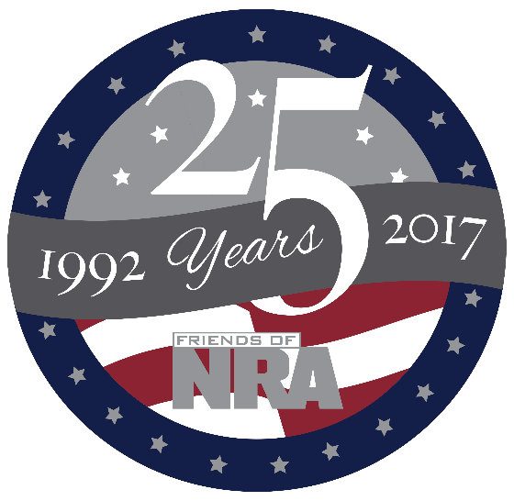

NORTH WEST JERSEY FRIENDS OF NRA
Annual Fundraiser

on behalf of The NRA Foundation

October 26, 2017 ▪ 5:00 pm
CASH ONLY BAR

CASH ONLY BAR

BEAR BROOK VALLEY
23 PLAYERS BLVD., FREDON, NJ 07860

Hot & Cold Hors d’oeuvres- 5pm
Shooters Games – Starting at 5pm
Dinner- 7pm
Celebrate a legacy of shooting sports traditions.
Join other champions of the Second Amendment for dinner, raffles, auctions and fun
with a chance to win exclusive NRA guns, gear, décor and collectibles!
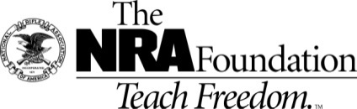
AUCTION & RAFFLE HIGHLIGHTS

NRA Guns & Prizes |  | Special RafflesTable Packages
2017 GUN OF THE YEAR | NRA EXCLUSIVES | HIGH Caliber Club Table-$2500
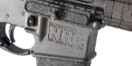  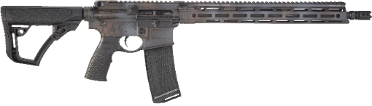  Daniel Defense M4 Carbine V7 5.56mm NATO Rifle  Rattlecan™ Cerakote, Friends of NRA  “2017 Gun of the Year” engraving,  and custom NRA serialization  Club Level Committee Exclusive  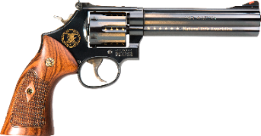  Smith & Wesson Model 586 Revolver  .357 Mag/.38 Special. with custom 24k gold embellishment | Colt Competition PistolTM  Polished Finish 1911  .45 ACP with NRA Serialization  Kimber K6sTM .357 Mag Revolver  with NRA Serialization  Henry Big Boy Silver Lever Action Rifle  .44 Mag with Anniversary Logo  Sig Sauer P320 Compact  9mm with NRA Logo  Kel-Tec PMR-30 .22 Mag Pistol  with NRA Serialization  Crickett .22LR Rifle  with Silver Anniversary Coin  & MORE!  View all at friendsofnra.org/merchandise | 1-Benelli Nova Tactical -12Ga  10 Dinner Tickets  $300 Bucket Raffle tickets  10-25th Anniversary NRA Hats  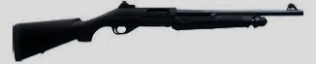  John Wayne Table-$2000  1-Rock Island 1911- A1 .45cal  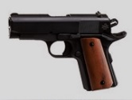  8 Dinner Tickets  $200 Bucket Raffle tickets  8-NRA Hats  Early Bird Package  $165 per TICKET  1 Dinner Ticket  $200 in Bucket Raffle tickets  (Not Available Banquet Night)
The NRA Foundation is a 501(c)3 charity of the National Rifle Association. Net proceeds benefit shooting sports programs in our communities. NRA membership is not required to participate. All firearm laws apply. Winners are responsible for any taxes / transfer fees. Firearms transferred through Simon Peter Sport Shop Route 206, Andover, NJ
2017 sponsor program

ORDER FORM ●NORTH WEST JERSEY FRIENDS OF NRA 10/26/2017
Order tickets online:
www.friendsofnra

Cancelled check or CC charge is your receipt/confirmation

Questions?
Maria Alampi
stirandshoot@yahoo.com
973-948-5069

Or mail order by 10/20/17
Clip address below &
tape to envelope
for easy addressing!

North West Jersey FNRA
c/o Maria Alampi
5 BUTTERNUT LANE
SANDYSTON, NJ 07826
QTY |  | $65 INDIVIDUAL 1 Dinner Ticket |  |  |  |  |  | $
 |  | $165 EARLY BIRD : 1 Dinner + $200 Bucket Raffle Tickets |  |  |  |  |  | $
 |  | $2500 HIGH CALIBER CLUB TABLE: 10 Dinners +$300 Bucket Raffle + 1 Gun |  |  |  |  |  | $
 |  | $2000 JOHN WAYNE TABLE: 8 Dinners + 200 Bucket Raffle + 1 Gun |  |  |  |  |  | $
 |  | TAX-DEDUCTIBLE SPONSORSHIP (Dinner tickets are not included) |  |  |  |  |  | $
 |  | [ ] $300 Liberty Case Knife & Presentation Box
 |  | [ ] $750 Heritage Liberty Safe or Yeti Cooler
 |  | [ ] $1,500 Freedom Kimber Micro 9, Kel-Tec CMR-30, or Uberti 1873 Cattleman
 |  | [ ] $2,500 Pioneer Colt Competition Pistol or Kimber Model 84L Rifle
[ ] $5,000 Patriot Winchester Model 73, Colt Marine, Kimber Custom II Warrior,
or Remington UMC Commemorative 1911
Please enclose check to NRA FOUNDATION or complete credit card info below |  |  |  |  |  |  |  | $
Name
Address |  |  |  |  | Phone
City/ST/Zip |  |  |  |  | Email
Meals |  |  | ________ Filet Mignon | _______ Chicken |  |  | ______ Vegetarian
CIRCLE: AmEx/Disc/MC/Visa charged upon receipt. All sales are final
Card # |  |  |  |  | Expiration Date
Signature |  |  |  |  | Sec Code
