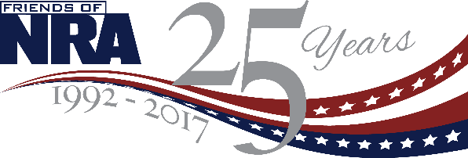
2017 BUCKET TICKET PACKAGES
Purchase your bucket ticket packages by
The Early Bird Date and Get Additional Chances to Win Firearms!
$100 Bucket Package
5 Bonus Bucket Tickets
20 White Bucket Tickets
1 Red Bucket Ticket
Early Bird- Add 1 more Red and 1 Blue Bucket Ticket

$250 Bucket Package
10 Bonus Bucket Tickets
40 White Bucket Tickets
2 Red Bucket Tickets
1 Blue Bucket Ticket
Early Bird- Add 2 more Red and 1 more Blue Bucket Ticket

$600 Bucket Package
30 Bonus Bucket Tickets
120 White Bucket Tickets
4 Red Bucket Tickets
2 Blue Bucket Tickets
Early Bird- Add 4 more Red and 2 more Blue Bucket Tickets

$1000 Bucket Package
30 Bonus Bucket Tickets
120 White Bucket Tickets
8 Red Bucket Tickets
4 Blue Bucket Tickets
ALSO! Your choice of one of three firearms!
Early Bird- Add 4 more Red and 2 more Blue Bucket Tickets

Early Bird Bucket Ticket Packages are sold through the committee and can be picked up at the event during check-in. Visit www.friendsofnra.org for more information and to purchase event tickets.

