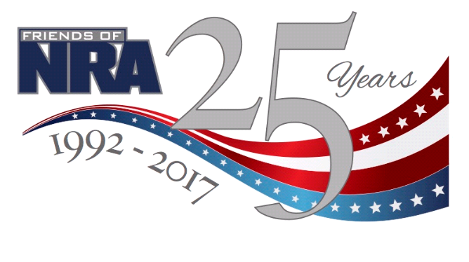
FLINT HILLS FRIENDS OF NRA
1ST Annual Fundraiser
THURSDAY, MAY 25th, 2017
BLUE HILLS ROOM
2315 Tuttle Creek Rd, Manhattan
Doors Open at 5pm
Live Auction, Silent Auction, Games, Drawings!
Single $35, Couple $50, Table $300
Kids 5-16 $20, under 5 eat free
Sponsor Table $1000 (get one of three firearms!)
Underwriting and Sponsorships Available
*EARLY BIRD SPECIALS FOR RAFFLE TICKETS!*
Contact Alison @ 785.770.2340 or Thom @ 316.761.2969
Go Online @ www.friendsofnra.org/ks to purchase tickets
and to get more info

