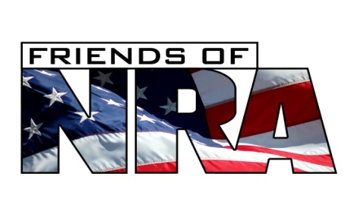

Buy Event tickets

**Prior to** **7/24/17**

& be entered to win a

**Taurus 605 .357 Mag**

**WINNER CHOICE**

**Pick The one Handgun You Have Always Wanted! (1) Winner only giving (1) Gun away!**

**1. Kimber Custom II 45 ACP 5”**

**2. Kimber Ultra Carry 45 ACP 3”**

**Both Guns have custom FNRA Grips**

**$20 EACH**

*\* Only 200 tickets being sold \**

Drawing will be 8/18/17. Need not be present to win.

**\*BEST VALUE!* All Sponsor Packages include:**

**Sponsor Only Raffle Ticket(s) for a**

**Henry 2nd Amendment Tribute Edition .22 LR**

**Double Plus**: @ $ 375 = $

**1/2 Table Plus**: @ $ 900 = $

**Table Plus**: @ $ 1,400 = $

**Bronze Table**: @ $ 1,700 = $

**Silver Table**: @ $ 2,800 = $

**2017 Table of the Year**: @ $ 3,550 = $

**Gold Table**: @ $ 5,750 = $

**Platinum Table**: @ $ 7,750 = $

**Diamond Table**: @$10,750 = $

**TOTAL ORDER $**

Gun choice (Package Buyer):

Gift choice (All Package Buyers)  NRA Knife —or—  $80 in raffle tickets

Name:

Address:

City/State/Zip:

Phone:

Email:

**# Of Event Ticket(s)**: @ $60/ea = $

**Winner Choice:**

1/$20: @ = $

: @ = $

❑ Check Enclosed  M/C  VISA  AMEX  DISCOVER

Card Number Exp Date

Authorized Signature

Live Auction  Silent Auction Special Drawings

Limited Edition Firearms  Custom Knives  NRA Commissioned Art  Special Ladies Merchandise

Plus Many Items Created Especially for this NRA Event and Much More!

**Friday, August 18, 2017 – 5:00 PM**

**Delano Elks Lodge- 708 Cecil Ave, Delano CA**

Complete and return this form to:

**Delano Friends of NRA**

**PO Box 157 Delano, CA 93216**

For information on event sponsorships, donations, or to assist the committee, call:

**Michelle Withrow (661) 586-8448**  **Chris Norman (661) 805-0164**  **Paul Rodarmel 559-410-8412**

**To purchase tickets, mail in the order form at the right or go to www.*FriendsofNRA.org***

Annual Friends of NRA Fundraising Banquet & Auction

*The* ***Delano Friends of NRA***

*Committee cordially invites you to attend the:*

**Diamond Table PLUS PACKAGE - $10,750**

* Eight (8) NRA Event tickets
* NRA Knife (or $80 in raffle) and hat
* $3,000 in Raffle tickets (including progressive drawings)
* Twenty (20) *Package only* gun drawing tickets
* **Plus: A custom package that will include a gun or guns**

**Platinum Table PLUS PACKAGE - $7,750**

* Eight (8) NRA Event tickets
* NRA Knife (or $80 in raffle) and hat
* $2,000 in Raffle tickets (including progressive drawings)
* Fifteen (15) *Package only* gun drawing tickets
* **Plus: A custom package that will include a gun or guns**

**Gold Table PLUS PACKAGE - $5,750**

* Eight (8) NRA Event tickets
* NRA Knife (or $80 in raffle) and hat
* $1,500 in Raffle tickets (including progressive drawings)
* Ten (10) *Package only* gun drawing tickets
* **Plus: A custom package that will include a gun**

**2017 Table of the Year**

**PACKAGE - $3,550**

* **Eight (8) NRA Event tickets**
* **NRA Knife (or $80 in raffle) and hat**
* **$1,000 in Raffle tickets (including progressive drawings)**
* **Seven (7) *Package only* gun drawing tickets**
* **Plus: Your choice of a Ruger Precision Rifle in .308 or in 6.5 Creedmoor, or A Set of Yeti Coolers(1) of each Roadie 20, Tundra 35. 45, 50, & 65, in White, Blue, or Tan, or $1500 in Raffle tickets**

**Silver Table PLUS PACKAGE - $2,800**

* Eight (8) NRA Event tickets
* NRA Knife (or $80 in raffle) and hat
* $1,000 in Raffle tickets (including progressive drawings)
* Five (5) *Package only* gun drawing tickets
* **Plus: Your Choice of a Sig P220 45 ACP 4.4”, or a Kimber 84m Hunter 6.5 Creedmoor, or a CZ Redhead Premier O/U 12ga 28”, or $1000 in Raffle tickets**

**Bronze Table PLUS PACKAGE - $1,700**

* Eight (8) NRA Event tickets
* NRA Knife (or $80 in raffle) and hat
* $500 in Raffle tickets (including progressive drawings)
* Four (4) *Package only* gun drawing tickets
* **Plus: Your choice of a Glock 23 in 40 S&W, or Glock 19 in 9mm, a Thompson Center Venture .308, 7MM, .300WM, or a Stevens 555 O/U 20ga, or a Yeti Cooler Tundra 65 Tan, White, Blue, or $600 in Raffle tickets**

**Table PLUS PACKAGE - $1,400**

* Eight (8) NRA Event tickets
* NRA Knife (or $80 in raffle) and hat
* $500 in Raffle tickets (including progressive drawings)
* Three (3) *Package only* gun drawing tickets
* **Plus: Your choice of a S&W M&P Shield 9mm, or 40cal, or a Rock Island 5” 1911 45acp, or a Remington 783 w/scope Camo. 30-06, .308, .270, or a Weatherby PA-08 12ga 28” or a Yeti Cooler Tundra 50 Tan, White, Blue , or $500 in Raffle tickets**

**Half Table PLUS PACKAGE - $900**

* Four (4) NRA Event tickets
* NRA Knife (or $80 in raffle) and hat
* $300 in Raffle tickets (including progressive drawings)
* Two (2) *Package only* gun drawing ticket
* **Plus: Your choice of a Savage 93R17GV 17HMR, or a North American Arms Mini Revolver 22mag, or In 22LR or a Yeti Cooler Tundra 35 in Tan, White, Blue, or $200 in Raffle tickets**

**Double PLUS PACKAGE - $375**

* Two (2) NRA Event tickets
* NRA Knife (or $80 in raffle) and hat
* $200 worth Raffle tickets (including progressive drawings)
* One (1) *Package only* gun drawing ticket

***The NRA Foundation granted over 1 Million Dollars to Central California Hunting & Shooting Programs in 2016 – Please help us keep this proud tradition going!***

**2017 Delano 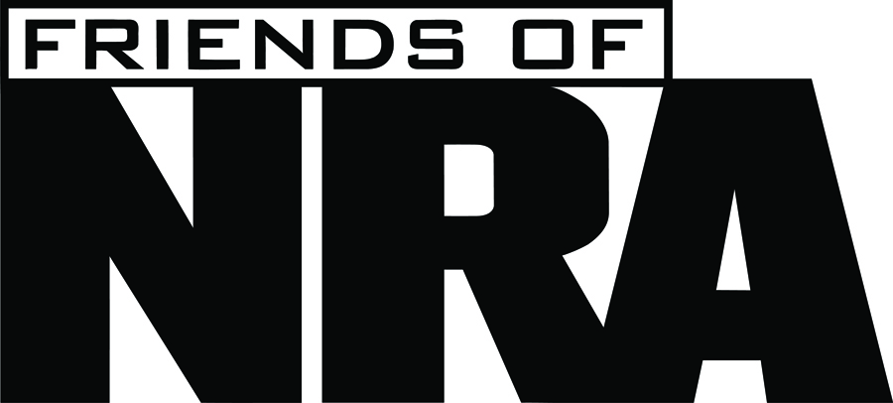 Table Packages**

***Merchandise and Firearms are subject to availability. Substitutions may be made. Please contact your local Committee Chair or NRA Field Rep.***

***Contributions to Friends of NRA support The NRA Foundation, Inc., a 501(c)(3) public charity, and are tax-deductible to the extent allowed by law.***

**National Liberty Sponsorship - $300** ($180 Income Tax Deduction)

2017 Sponsor Case Knife with Presentation Box, Cap, Special Recognition in the Event Program, complimentary *Traditions* magazine subscription, and discounts on NRA Foundation Online Store merchandise and Sponsors only apparel!