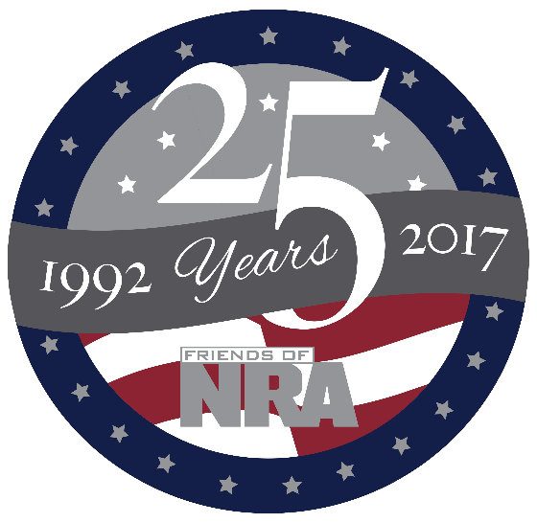

**BEMIDJI AREA**

**Annual Fundraiser**

**on behalf of The NRA Foundation**

**Thursday October 19th, 2017** ▪ **5:00 pm**

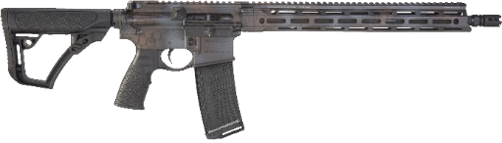

**2017 Gun of the Year Daniel Defense M4 Carbine**

Bemidji Eagles Club

1270 Neilson Ave▪ Bemidji, MN

***Prime Rib Dinner!!!!***

*Celebrate a legacy of shooting sports traditions.*

Join other champions of the Second Amendment for dinner, raffles, auctions and fun with a chance to win exclusive NRA guns, gear, décor and collectibles!

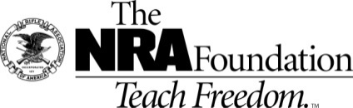

**Contact and Ticket info – friendsofnra.org**

**Mark Farabee - 218-760-5757 or bjishooters@gmail.com**

**Kurt Cease- 218-766-7592 or kecease@paulbunyan.net**

|  |  |  |
| --- | --- | --- |
| **Ticket and Tables Packages NRA Guns & Prizes** | | **$800 Table Gun Options** |
| **Individual Tickets $35** | **NRA EXCLUSIVES** |  |
| ***$800 Table Package***  ***8 Dinners - $320 in White Bucket Tickets***  ***And 1 of the guns on the right side of this page!!!!***  ***$1911 Table Package***  ***8 Dinner Tickets - 8 Special Gifts***  ***8 $100 Ticket Packages and a***  ***Colt Commander or Kimber Custom II 1911***  ***at your table!!!!!***  ***$5,000 Table Package***  ***8 Dinner Tickets – 8 Special Gifts***  ***8 $300 Ticket Packages AND***  ***8 9mm Century Arms Handguns OR***  ***1 Savage 10 BA Stealth at your table!!!!!*** | **Colt Competition PistolTM**  **Polished Finish 1911**  .45 ACP with NRA Serialization  **Kimber K6sTM .357 Mag Revolver**  with NRA Serialization  **Henry Big Boy Silver Lever Action Rifle**  .44 Mag with Anniversary Logo  **Sig Sauer P320 Compact**  9mm with NRA Logo  **Kel-Tec PMR-30 .22 Mag Pistol**  with NRA Serialization  **Crickett .22LR Rifle**  with Silver Anniversary Coin  **& MORE!**  View all at friendsofnra.org/merchandise | **C:\Users\Frep\2017 Committees\East Central\Honor Gaurd.jpg**  **Honor Guard Sub-compact 9MM**  **C:\Users\Frep\Pictures\2952.jpg**  **Weatherby 12 Ga.**  **Pump Synthetic**  **C:\Users\Frep\Pictures\mosspic27902.jpg**  **Mossberg Patriot**  **300 Win Mag.** |

****The NRA Foundation is a 501(c)3 charity of the National Rifle Association. Net proceeds benefit shooting sports programs in our communities. NRA membership is not required to participate. All firearm laws apply. Winners are responsible for any taxes / transfer

fees. 