NORTH METRO
8th Annual Fundraiser on behalf of The NRA Foundation

MARCH 9, 2018 ▪ 5:00 pm
BANQUETS OF MINNESOTA
6310 Highway 65 NE, Minneapolis, MN 55432
Celebrate a legacy of shooting sports traditions.
Join other champions of the Second Amendment for dinner, raffles, auctions and fun with a chance to win exclusive NRA guns, gear, décor and collectibles!
Come join us in helping raise grant money for shooting sports here in Minnesota!

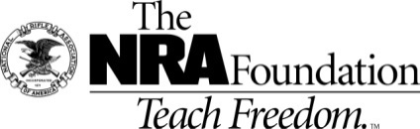
AUCTION & RAFFLE HIGHLIGHTS Order your tickets today at www.friendsofnra.org/events or call Colleen 612.201.8999

NRA Guns & Prizes
2017 GUN OF THE YEAR | NRA EXCLUSIVES
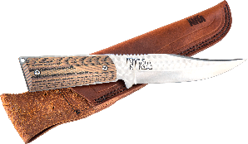  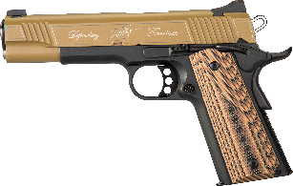  Kimber Custom II .45 ACP and Silver Stag Knife  Display case, matching grips, Friends of NRA logo and “Defending Freedom engraving, and NRA serialization  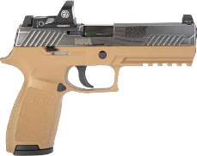  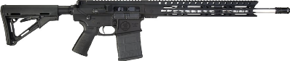  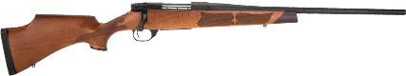 | Sig Sauer P320 RX  9mm with NRA Logo and American Flag Design  Diamondback DB10 Rifle  .308 Win with NRA Seal and NRA Serialization  Henry Lever Action Shotgun  .410 Gauge with Second Amendment engraving,  NRA Seal and NRA Serialization  Colt Cobra® Double Action Revolver  .38 Spl with Custom NRA Grips  Crickett™ Precision Rifle  .22LR with Second Amendment Dipped Stock  Weatherby Vanguard® Camilla™ Women’s Rifle  7mm-08 Rem with NRA Seal  AND MORE!  View all items at www.friendsofnra.org/merchandise

The NRA Foundation is a 501(c)3 charity of the National Rifle Association. Net proceeds benefit shooting sports programs in our communities. NRA membership is not required to participate. All firearm laws apply. Winners are responsible for any taxes / transfer fees. Firearms transferred through [FFL DEALER].
2018 sponsor program

ORDER FORM ● NORTH METRO FRIENDS OF NRA MARCH 9TH, 2018
Order tickets online:
www.friendsofnra.org

All tickets held at door
Cancelled check or CC charge is your receipt/confirmation
Questions? Colleen Olsen
Nra.nwmfriends@gmail.com
612.201.8999

Or mail order by February 15th
Clip address below & tape to envelope for easy addressing!

COLLEEN OLSEN
2244 THORNDALE AVE.
NEW BRIGHTON MN 55112
QTY |  |  | $100 LOCK & LOAD RAFFLE CARD ($140 VALUE) |  |  |  |  | $
 |  |  | $40 INDIVIDUAL: 1 Dinner |  |  |  |  | $
 |  |  | $100 COUPLES: 2 Dinners + $100 Raffle Pack |  |  |  |  | $
 |  |  | $800 TABLE: 8 Dinners + 8 SPECIAL GIFTS + 1 Gun Kel-Tec .22 mag |  |  |  |  | $
 |  |  | TAX-DEDUCTIBLE SPONSORSHIP (Dinner tickets are not included) |  |  |  |  | $
 |  |  | [ ] $300 Liberty Buck Knife with Presentation Box
 |  |  | [ ] $750 Heritage Heritage Rough Rider or Yeti Cooler
 |  |  | [ ] $1,500 Freedom Kimber Micro 9 or Uberti 1873 Cattleman
 |  |  | [ ] $2,500 Pioneer Kimber Ultra CDP II or Weatherby Vanguard
[ ] $5,000 Patriot Winchester Model 73, Kimber Custom II Warrior,
or Remington UMC Commemorative 1911
Please enclose check to NRA FOUNDATION or complete credit card info below |  |  |  |  |  |  |  | $
AmEx/Disc/MC/Visa charged upon receipt. All sales are final.
Card # |  |  |  |  | Expiration
Signature |  |  |  |  | Sec Code
Name |  |  |  |  | Company
Address |  |  |  |  | Phone
City/St/Zip |  |  |  |  | Email
