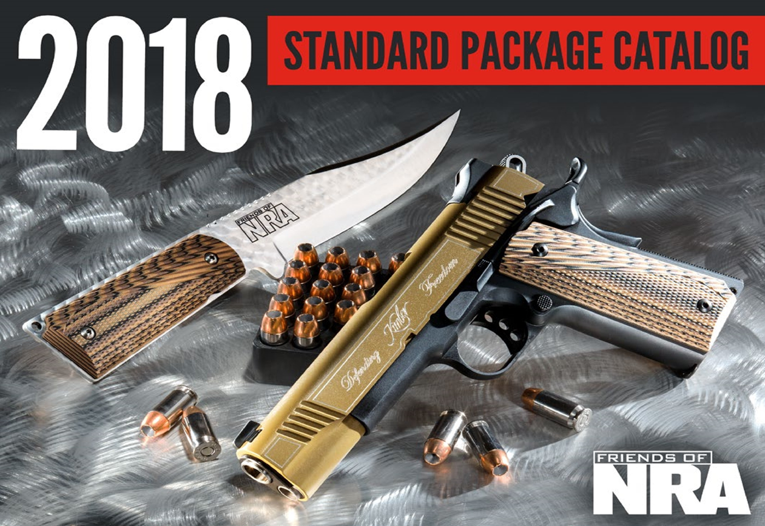
PURCHASE YOUR TICKETS TODAY
NORTH METRO 9TH ANNUAL FRIENDS OF NRA BANQUET
INDIVIDUAL TICKET $40
COUPLES TICKETS $100 INCLUDES 2 DINNER TICKETS AND 1 $100 TICKET RAFFLE PACKAGE (TICKET PACKAGE HELD AT CHECK IN)
TABLE SALES
$800 INCLUDES 8 DINNER TICKETS + CHOICE OF EITHER ONE KEL-TEC PMR .22 MAG OR ONE TRI-STAR .12 GA O/U
$1911 INCLUDES 8 DINNER TICKETS + 8 SPECIAL GIFTS + 1 KIMBER CUSTOM II 1911
$5000 INCLUDES 8 DINNER TICKETS + 8 SPECIAL GIFTS+ $300 TICKET PACKAGE YOUR CHOICE OF ONE
LEG Howa HCRA 6.5 Creedmoor or 308, 24 Inch Heavy Barrel ,Threaded American Flag Finish, LUTH MBA-4 Adjustable Stock, 10 Round, Nikko-Stirling Diamond 30mm 4-16x50 Long Range Riflescope or 8 of your choice of one of the following * Stevens. Mode 320 tactical. Shotgun in 12 or 20 ga. * Savage Axis XP available. In 300 WM, 30-06, 270, 308, or 223 * Kel-Tec PMR30 22 MAG * Ruger LCP (2) in 380 depending on availability
FOR MORE INFORMATION OR ORDERING PLEASE CONTACT COLLEEN @
NRA.NWMFRIENDS@GMAIL.COM OR 612.201.8999

