ARMSTRONG COUNTY
Annual Fundraiser on behalf of The NRA Foundation

MAY 10TH, 2018 ▪ 5:30 pm
WEST KITTANNING FIRE HALL
401 ARTHUR ST. ▪ KITTANNING, PA 16201

Celebrate a legacy of shooting sports traditions.
Join other champions of the Second Amendment for dinner, raffles, auctions and fun with a chance to win exclusive NRA guns, gear, décor and collectibles!

AUCTION & RAFFLE HIGHLIGHTS

NRA Guns & Prizes |  | Special Raffles/  Table Packages
2018 GUN OF THE YEAR | NRA EXCLUSIVES
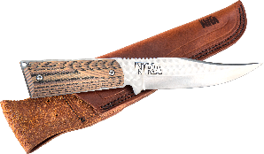  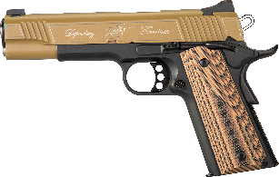  Kimber Custom II .45 ACP and Silver Stag Knife  Display case, matching grips, Friends of NRA logo and “Defending Freedom engraving, and NRA serialization  Club Level Committee Exclusive  Ruger® M77 Hawkeye® Rifle  6.5 Creedmoor with custom 24k gold embellishment | Sig Sauer P320 RX  9mm with NRA Logo and American Flag Design  Diamondback DB10 Rifle  .308 Win with NRA Seal and NRA Serialization  Henry Lever Action Shotgun  .410 Gauge with Second Amendment engraving,  NRA Seal and NRA Serialization  Colt Cobra® Double Action Revolver  .38 Spl with Custom NRA Grips  Crickett™ Precision Rifle  .22LR with Second Amendment Dipped Stock  Weatherby Vanguard® Camilla™ Women’s Rifle  7mm-08 Rem with NRA Seal  AND MORE!  View all items at www.friendsofnra.org/merchandise | RED, WHITE, BLUE AND GOLD RAFFLE  THE RAFFLE IS ALL GUNS AND HIGH-END SPORTING EQUIPMENT!  ORDER PACKAGES EARLY BEFORE MAY 3rd AND THERE WILL BE MORE GUNS!  OUR BUDGET ON GUNS CLOSES ON MAY 3rd!

The NRA Foundation is a 501(c)3 charity of the National Rifle Association. Net proceeds benefit shooting sports programs in our communities. NRA membership is not required to participate. All firearm laws apply. Winners are responsible for any taxes / transfer fees. Firearms transferred through MAHONING VALLEY MILLING CO INC.
2018 sponsor program

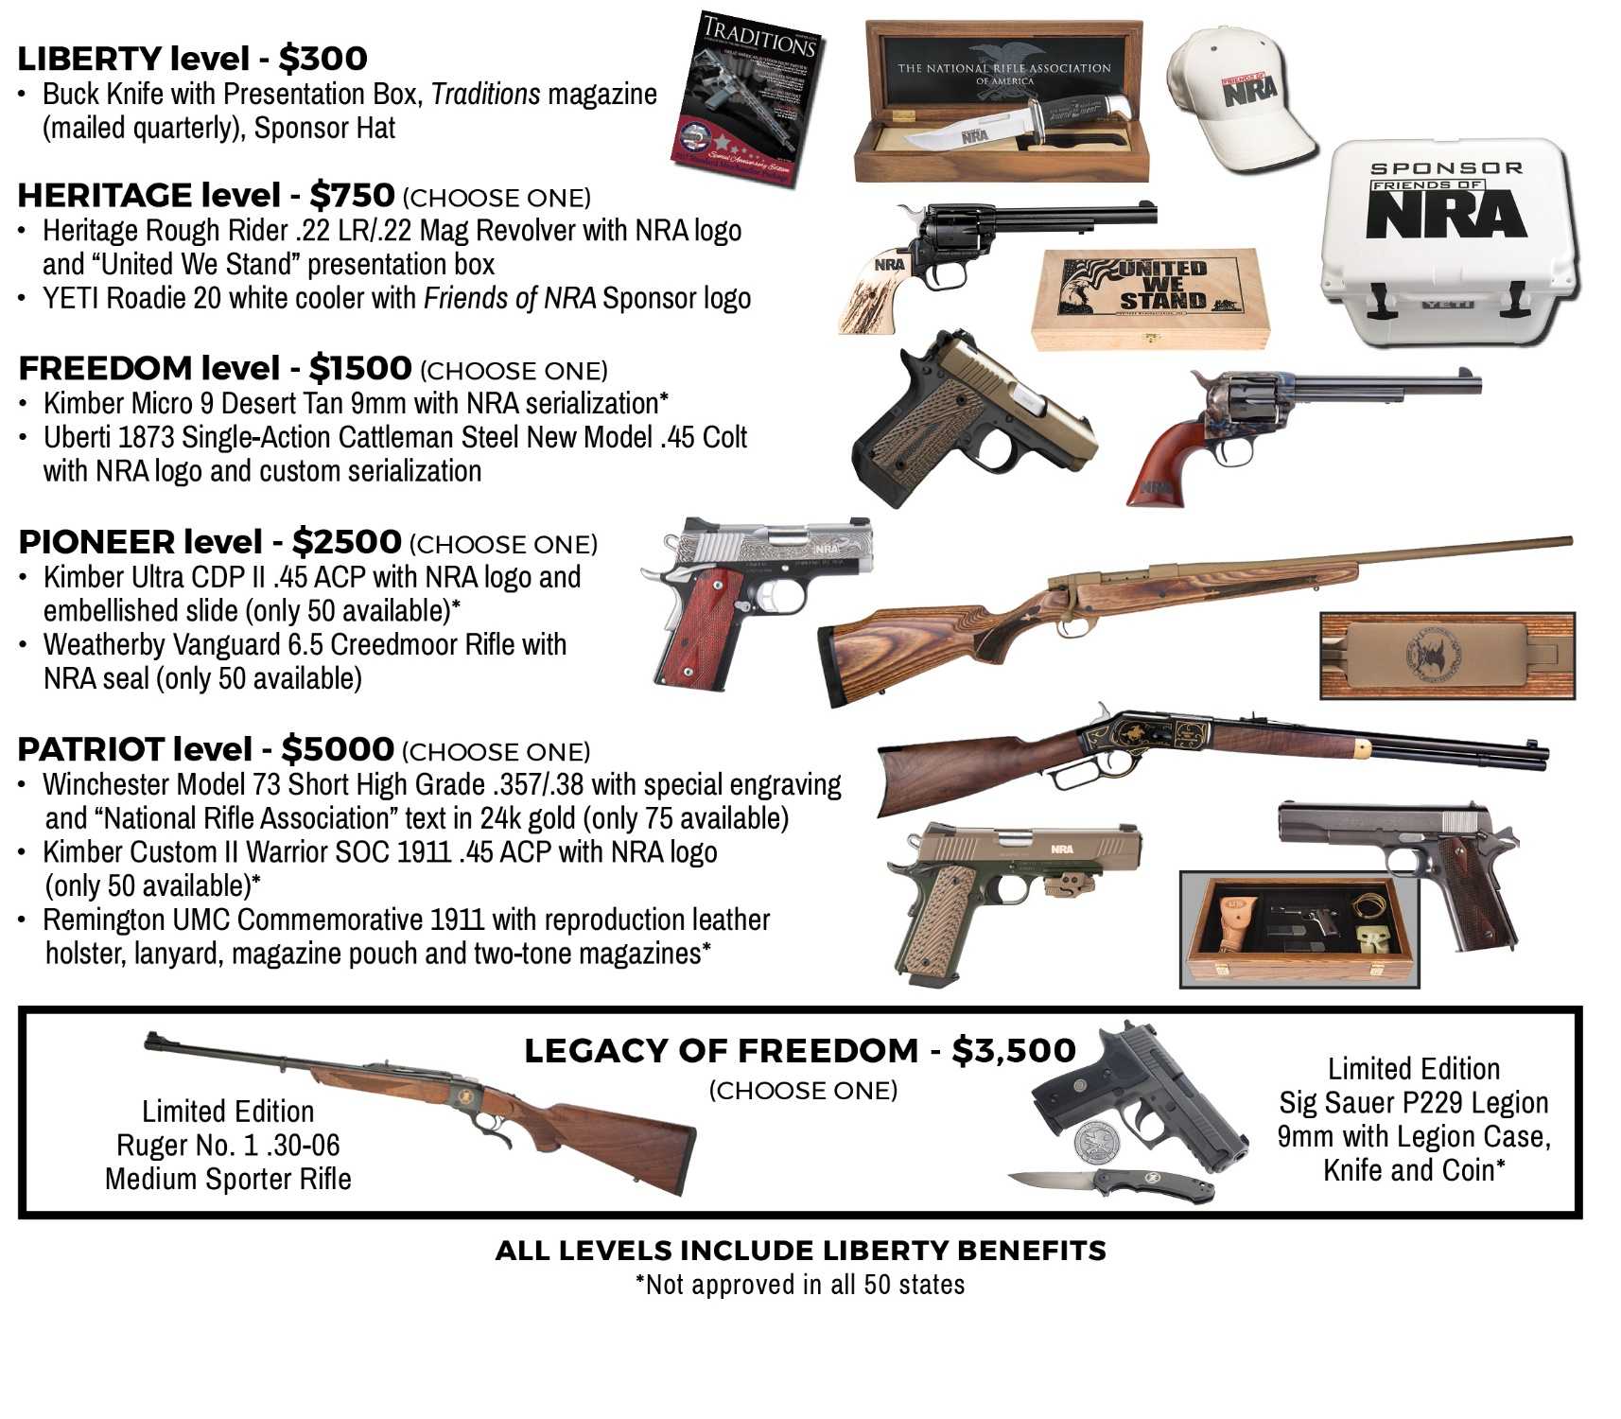

The Red, White, Blue and Gold Raffle is almost all guns. We thought guns were more interesting to win than sporting items. The more pre-event ticket packages and Raffle Packs you buy, the more guns there will be to win! No limit!

The buckets are color coded and each color represents a different value gun. The white buckets (and white tickets) are the least expensive guns. The red bucket guns cost more than the white, blue bucket guns more than the red and the gold guns are the most expensive.
Raffle tickets come with the packages. They can also be bought straight out. The best deal is when you buy the packages that come with guns and tickets!

● ARMSTRONG COUNTY FRIENDS OF NRA 5/10/18 ●
All orders received by May 3rd adds to the gun budget for the Red, White, Blue, and Gold Raffle.
Packages and Raffle Packs bought before that date, get the number of tickets on the top part of the raffle pack chart on back!

All tickets held at door
Cancelled check or CC charge is your receipt/confirmation

Questions?

Randy Atkinson

(724) 525-0614

Or mail order by 5-3-18
Clip address below & tape to envelope for easy addressing!

Randy Atkinson
P O Box 421
Worthington, PA 16262

 | QTY | Table Name ____________________________
 | ____ | $45 Dinner Ticket: 1 Dinner Ticket |  |  |  |  |  | $
 | ____ | $325 PA Knife Package: 1 dinner ticket + 1LT Wright Knife + $300 Raffle Pack + 1 chance on the Dinner Package /Sponsor Gun |  |  |  |  |  | $
 | ____ | $325 2 Person Package: 2 Dinners + $300 Raffle Pack + 1 Chance on the Dinner Package /Sponsor Gun |  |  |  |  |  | $
 | ____ | $800 1/2 TABLE: 4 Dinners + $400 Raffle Pack + 1 Chance on the Dinner Package /Sponsor Gun + 1 Gun (Please check your choice)  ___ Heritage Arms NRA embellished .22/.22mag  ___ Henry AR-7 Survival rifle.22  ___ North America Arms .22  ___ $300 Raffle Pack in place of the gun |  |  |  |  |  | $
 | ____ | $450 Table:: 8 Dinner tickets + 1 chance on the Dinner Package/Sponsor Gun |  |  |  |  |  | $
 | ____ | $1500 Table: 8 Dinner tickets + $500 Raffle Pack + 4 chance on the Dinner Package /Sponsor Raffle Gun + 1 Gun: (Please check your choice)  ___ Kel-Tec 9MM pistol  ___ Walther PPK .22  ___ Mossberg Patriot Rifle in 300win-mag  ___ Rem 783 30:06 w/ Scope  ___ $500 Raffle Pack in place of the gun |  |  |  |  |  | $
 | ____ | $3000 Table: 8 Dinner tickets + $1000 raffle pack + 8 chances on the Dinner Package/Sponsor Gun + 1 Gun (Please check your choice)  ___ Kimber Custom II .45 two tone  ___ Stag Arms .223/556 AR w/ Second Amendment on the Lower  ___ $1000 Raffle Pack in place of the gun |  |  |  |  |  | $
 | ____ | $100 Red, White, Blue & Gold Raffle Packs - in quantities of $100….(see chart on back) |  |  |  |  |  | $
 | ____ | Key Gun Raffle- 4 tickets for $50 (3 for $50 the night of)
 | ____ | $45 Dinner Ticket and the purchase of a NRA Tax-Deductible Sponsorship (listed below): 1 Dinner ticket and 1 chance on the Dinner Package/Sponsor Gun |  |  |  |  |  | $
 | ____ | $300 Liberty Case Knife & Presentation Box |  |  |  |  |  | $
 | ____ | $750 Heritage: [ ]Heritage Rough Rider .22LR/.22 Mag or [ ]Yeti Cooler |  |  |  |  |  | $
 | ____ | $1,500 Freedom: [ ]Kimber Micro 9 or [ ]Uberti 1873 Cattleman |  |  |  |  |  | $
 | ____ | $2,500 Pioneer: [ ]Kimber Ultra .45ACP or [ ]Weatherby Vanguard 6.5 Creedmoor |  |  |  |  |  | $
 | ____ | $3500 Legacy of Freedom: [ ]Ruger 30-06 or [ ]Sig Sauer 9mm |  |  |  |  |  | $
 | ____ | $5,000 Patriot: [ ]Winchester Model 73, [ ]Kimber Custom II Warrior,  or [ ]Remington UMC Commemorative 1911 |  |  |  |  |  | $
Please enclose check to NRA FOUNDATION or complete credit card info below |  |  |  |  |  |  |  | $
(Circle one): AmEx/Disc/MC/Visa charged upon receipt. All sales are final.
Card # |  |  |  |  | Expiration
Signature |  |  |  |  | Sec Code
Name |  |  |  |  | Company
Address |  |  |  |  | Phone
City/St/Zip |  |  |  |  | Email

Red, White, Blue & Gold Raffle
Purchase by 5/3 and receive: (early order incentive, Great Deal!)
Purchase | $100 | $200 | $300 | $400 | $500 | $600 | $700 | $800 | $900 | $1000 | $1100 | $1200 | $1300 | $1400 | $1500
Receive:
$20 White Tickets | 5 | 10 | 15 | 20 | 25 | 30 | 35 | 40 | 45 | 50 | 55 | 60 | 65 | 70 | 75
$30 Red Tickets | 4 | 8 | 12 | 16 | 20 | 24 | 28 | 32 | 36 | 40 | 44 | 48 | 52 | 56 | 60
$50 Blue Tickets | 2 | 4 | 6 | 8 | 10 | 12 | 14 | 16 | 18 | 20 | 22 | 24 | 26 | 28 | 30
$100 Gold Tickets | 1 | 2 | 3 | 4 | 5 | 6 | 7 | 8 | 9 | 10 | 11 | 12 | 13 | 14 | 15

After 5/3 and at the banquet:
Purchase | $100 | $200 | $300 | $400 | $500 | $600 | $700 | $800 | $900 | $1000 | $1100 | $1200 | $1300 | $1400 | $1500
Receive:
$20 White Tickets | 5 | 10 | 15 | 20 | 25 | 30 | 35 | 40 | 45 | 50 | 55 | 60 | 65 | 70 | 75
$30 Red Tickets | 2 | 4 | 6 | 8 | 10 | 12 | 14 | 16 | 18 | 20 | 22 | 24 | 26 | 28 | 30
$50 Blue Tickets | 1 | 2 | 3 | 4 | 5 | 6 | 7 | 8 | 9 | 10 | 11 | 12 | 13 | 14 | 15
$100 Gold Tickets |  | 1 | 2 | 3 | 4 | 5 | 6 | 7 | 8 | 9 | 10 | 11 | 12 | 13 | 14

*Red, blue & gold tickets are bonus tickets

