LAKE SUPERIOR
Annual Fundraiser on behalf of The NRA Foundation

Thursday September 6th, 2018 ▪ 5:00 pm
Shriners
5152 Miller Trunk Hwy ▪ Hermantown, MN

Celebrate a legacy of shooting sports traditions.
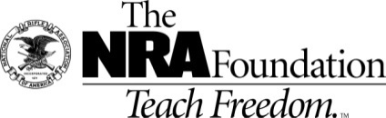
For Tickets: friendsofnra.org/events
Linda Tuhkanen – 218-482-3360 or hltuk@arrowheadtel.net

Ticket and Table Packages NRA  Individual Tickets $40  $800 Table Package  8 Dinners - $320 in White Bucket Tickets  And 1 of the guns on the right side of this page!!!!  $1911 Table Package  8 Dinner Tickets - 8 Special Gifts  8 $100 Ticket Packages and a  Colt Commander or Kimber Custom II 1911  at your table!!!!!  $5,000 Table Package  8 Dinner Tickets – 8 Special Gifts  8 $300 Ticket Packages AND  8 9mm’s at each table!!!!!!!  Couples Ticket $70 Exclusives  Sig Sauer P320 RX  9mm with NRA Logo and American Flag Design  Diamondback DB10 Rifle  .308 Win with NRA Seal and NRA Serialization  Henry Lever Action Shotgun  .410 Gauge with Second Amendment engraving,  NRA Seal and NRA Serialization  Colt Cobra® Double Action Revolver  .38 Spl with Custom NRA Grips  Crickett™ Precision Rifle  .22LR with Second Amendment Dipped Stock  AND MORE!  View all items at  www.friendsofnra.org/merchandise |  | $800  Table Gun Options  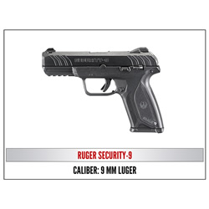  Ruger Security 9  OR  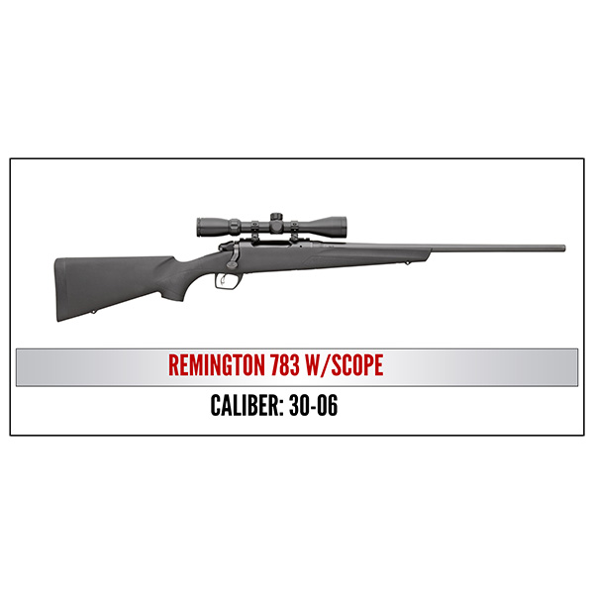  Remington 30-06 w/Scope
2018 sponsor program

ORDER FORM ● LAKE SUPERIOR FRIENDS OF NRA 9-6-2018
Order tickets online:
www.friendsofnra.org

All tickets held at door
Cancelled check or CC charge is your receipt/confirmation
Questions?
Linda Tuhkanen

218-482-3360
hltuk@arrowhweadtel.com

Or mail order by 9-1-2018
Clip address below & tape to envelope for easy addressing!

Linda Tuhkanen
PO Box 201
Cotton, MN 55724

QTY |  |  | $40 Individual Dinner Ticket or $70 Couples Dinner Ticket |  |  |  |  | $
 |  |  | $800 Table Package - $320 in White Bucket tickets and choice of gun |  |  |  |  | $
 |  |  | $1911 Table Package – 8-$100 packages, 8 Gifts, and choice of gun |  |  |  |  | $
 |  |  | $5,000 Table Package- 8 $300 packages, 8 gifts and 8 guns |  |  |  |  | $
 |  |  | TAX-DEDUCTIBLE SPONSORSHIP (Dinner tickets are not included) |  |  |  |  | $
 |  |  | [ ] $300 Liberty Buck Knife with Presentation Box
 |  |  | [ ] $750 Heritage Heritage Rough Rider or Yeti Cooler
 |  |  | [ ] $1,500 Freedom Kimber Micro 9 or Uberti 1873 Cattleman
 |  |  | [ ] $2,500 Pioneer Kimber Ultra CDP II or Weatherby Vanguard
[ ] $5,000 Patriot Winchester Model 73, Kimber Custom II Warrior,
or Remington UMC Commemorative 1911
Please enclose check to NRA FOUNDATION or complete credit card info below |  |  |  |  |  |  |  | $
AmEx/Disc/MC/Visa charged upon receipt. All sales are final.
Card # |  |  |  |  | Expiration
Signature |  |  |  |  | Sec Code
Name |  |  |  |  | Company
Address |  |  |  |  | Phone
City/St/Zip |  |  |  |  | Email
