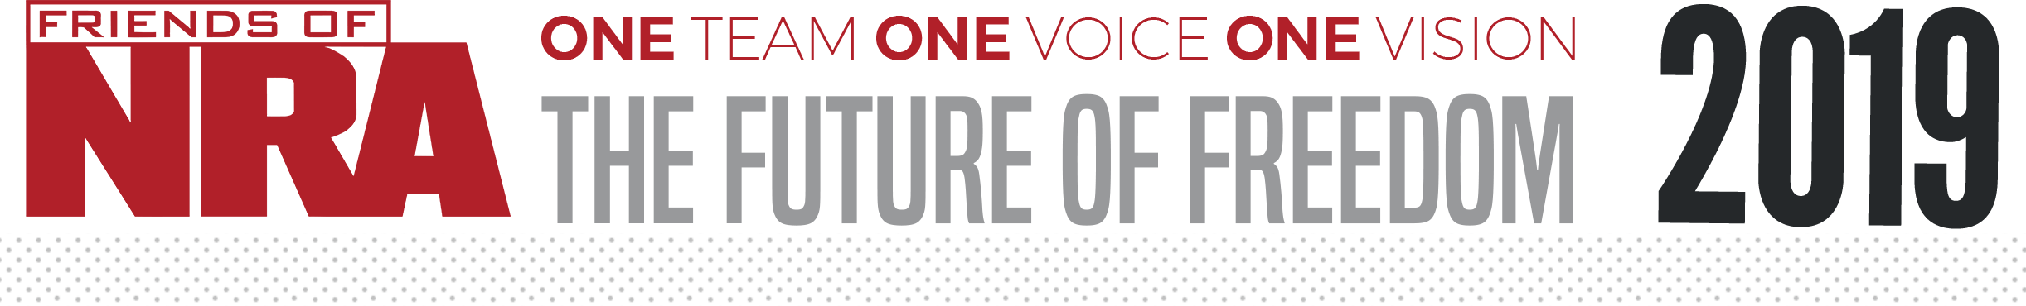
Beaver County Friends of NRA
ANNUAL FUNDRAISER ON BEHALF OF THE NRA FOUNDATION

FEBRUARY 23rd, 2019 ▪ 4:00 PM
Monaca Turners
1700 Old Broadhead Rd. Monaca, Pa.15061

Celebrate a legacy of shooting sports traditions.
Join other champions of the Second Amendment for dinner, raffles, auctions and fun with a chance to win exclusive NRA guns, gear, décor and collectibles!

AUCTION & RAFFLE HIGHLIGHTS

NRA Guns & Prizes |  | Special Raffles/  Table Packages
2018 GUN OF THE YEAR | NRA EXCLUSIVES
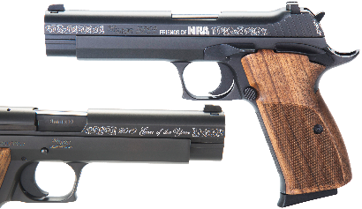  Sig Sauer P210 American  Standard 9mm Pistol with Logo  is a single stack 9mm reverse railed slide and frame accented with Friends of NRA and “2019 Gun of the Year”  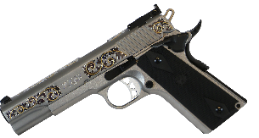  Club Level Committee Exclusive  Ruger® Engraved SR1911® | Kimber Micro 9  9mm with NRA Logo and NRA Serialization  Henry Single Shot Brass  .45-70 with NRA Seal and NRA Serialization  Sauer 100 Classic XT  6.5 Creedmoor with NRA Seal  S&W Model 60  .357 Mag Revolver with NRA Seal  CMMG The GUARD  9mm AR Pistol with Friends of NRA Logo  AND MORE!  View all items at www.friendsofnra.org/merchandise | RED, WHITE,BLUE AND GOLD RAFFLE  THE RAFFLE IS ALL GUNS AND HIGH END SPORTING EQUIPMENT!  ORDER PACKAGES EARLY BEFORE FEBRUARY 16th AND THERE WILL BE MORE GUNS!  OUR BUDGET ON GUNS CLOSES ON FEBRUARY 16TH!

The NRA Foundation is a 501(c)3 charity of the National Rifle Association. Net proceeds benefit shooting sports programs in our communities. NRA membership is not required to participate. All firearm laws apply. Winners are responsible for any taxes / transfer fees. Firearms transferred through John Browns Armory.
2019 Sponsorship Program

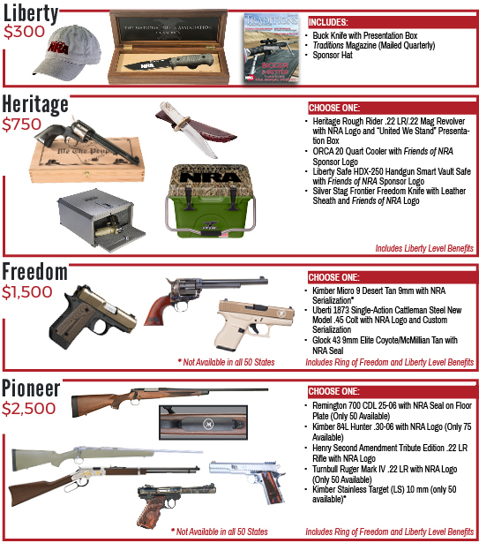

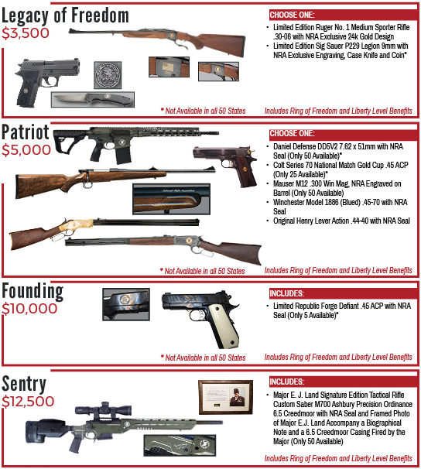
Beaver County Order From

All orders received by February 16th adds to the gun budget for the Red, White, Blue, and Gold Raffle.
Packages and Raffle Packs bought before that date, get the number of tickets on the top part of the raffle pack chart on back!

Order tickets online:
www.friendsofnra.org

All tickets held at door
Cancelled check or CC charge is your receipt/confirmation
Questions? Eric Anderson
Phone: 724-775-7740
Transmissionman637@comcast.net
Or mail order by 2-16-19
Clip address below & tape to envelope for easy addressing!

Eric Anderson
637 Pennsylvania Ave.
Rochester, Pa. 15074

 | QTY | Table Name ____________________________
 | ____ | $50 Dinner Ticket: 1 Dinner Ticket |  |  |  |  |  |  | $
 | ____ | $325 PA Knife Package: 1 dinner ticket + 1LT Wright Knife + $300 Raffle Pack + 1 chance on the Dinner Package /Sponsor Gun |  |  |  |  |  |  | $
 | ____ | $325 2 Person Package: 2 Dinners + $300 Raffle Pack + 1 Chance on the Dinner Package /Sponsor Gun |  |  |  |  |  |  | $
 | ____ | $800 1/2 TABLE: 4 Dinners + $400 Raffle Pack + 1 Chance on the Dinner Package /Sponsor Gun + 1 Gun (Please check your choice)  ___ Heritage Arms NRA embellished .22/.22mag  ___ Henry AR-7 Survival rifle.22  ___ North America Arms .22  ___ $300 Raffle Pack in place of the gun |  |  |  |  |  |  | $
 | ____ | $500 Table:: 8 Dinner tickets + 1 chance on the Dinner Package/Sponsor Gun |  |  |  |  |  |  | $
 | ____ | $1500 Table: 8 Dinner tickets + $500 Raffle Pack + 4 chance on the Dinner Package /Sponsor Raffle Gun + 1 Gun: (Please check your choice)  ___ Kel-Tec 9MM pistol  ___ Walther PPK .22  ___ Mossberg Patriot Rifle in 300win-mag |  |  |  |  |  |  | $
 | ____ | $3000 Table: 8 Dinner tickets + $1000 raffle pack + 8 chances on the Dinner Package/Sponsor Gun + 1 Gun (Please check your choice)  ___ Kimber Custom II .45 two tone  ___ Stag Arms .223/556 AR w/ Second Amendment on the Lower |  |  |  |  |  |  | $
 | ____ | $100 Red, White, Blue & Gold Raffle Packs - in quantities of $100….(see chart on back) |  |  |  |  |  |  | $
 | ____ | $50 Dinner Ticket and the purchase of a NRA Tax-Deductible Sponsorship (listed below): 1 Dinner ticket and 1 chances on the Dinner Package/Sponsor Gun |  |  |  |  |  |  | $
 | ____ | $300 Liberty Buck Knife & Presentation Box |  |  |  |  |  |  | $
 | ____ | $750 Heritage: [ ]Heritage Rough Rider .22LR/.22 Mag, [ ] Orca Cooler,  [ ] Libery Safe, or [ ] Silver Stage Knife with Leather Sheath |  |  |  |  |  |  | $
 | ____ | $1,500 Freedom: [ ]Kimber Micro 9, [ ]Uberti 1873 Cattleman or [ ]Glock 43 |  |  |  |  |  |  | $
 | ____ | $2,500 Pioneer: [ ]Remington 700, [ ]Kimber 84L Hunter, [ ]Henry Second Amendment, [ ]Turnbull Ruger, or [ ]Kimber Stainless |  |  |  |  |  |  | $
 | ____ | $3500 Legacy of Freedom: [ ]Ruger 30-06 or [ ]Sig Sauer 9mm |  |  |  |  |  |  | $
 | ____ | $5,000 Patriot: [ ]Daniel Defense DD5V7, [ ]Colt 70, [ ]Mauser M12,  [ ]Winchester Model 1886, or [ ]Henry Lever Action |  |  |  |  |  |  | $
Please enclose check to NRA FOUNDATION or complete credit card info below |  |  |  |  |  |  |  |  | $
(Circle one): AmEx/Disc/MC/Visa charged upon receipt. All sales are final.
Card # |  |  |  |  |  | Expiration
Signature |  |  |  |  |  | Sec Code
Name |  |  |  |  |  | Company
Address |  |  |  |  |  | Phone
City/St/Zip |  |  |  |  |  | Email

Red, White, Blue & Gold Raffle
Purchase by 2/10 and receive:
Purchase | $100 | $200 | $300 | $400 | $500 | $600 | $700 | $800 | $900 | $1000 | $1100 | $1200 | $1300 | $1400 | $1500
Receive:
$20 White Tickets | 5 | 10 | 15 | 20 | 25 | 30 | 35 | 40 | 45 | 50 | 55 | 60 | 65 | 70 | 75
$30 Red Tickets | 4 | 8 | 12 | 16 | 20 | 24 | 28 | 32 | 36 | 40 | 44 | 48 | 52 | 56 | 60
$50 Blue Tickets | 2 | 4 | 6 | 8 | 10 | 12 | 14 | 16 | 18 | 20 | 22 | 24 | 26 | 28 | 30
$100 Gold Tickets | 1 | 2 | 3 | 4 | 5 | 6 | 7 | 8 | 9 | 10 | 11 | 12 | 13 | 14 | 15

After 2/10 and at the banquet:
Purchase | $100 | $200 | $300 | $400 | $500 | $600 | $700 | $800 | $900 | $1000 | $1100 | $1200 | $1300 | $1400 | $1500
Receive:
$20 White Tickets | 5 | 10 | 15 | 20 | 25 | 30 | 35 | 40 | 45 | 50 | 55 | 60 | 65 | 70 | 75
$30 Red Tickets | 2 | 4 | 6 | 8 | 10 | 12 | 14 | 16 | 18 | 20 | 22 | 24 | 26 | 28 | 30
$50 Blue Tickets | 1 | 2 | 3 | 4 | 5 | 6 | 7 | 8 | 9 | 10 | 11 | 12 | 13 | 14 | 15
$100 Gold Tickets |  | 1 | 2 | 3 | 4 | 5 | 6 | 7 | 8 | 9 | 10 | 11 | 12 | 13 | 14

*Red, blue & gold tickets are bonus tickets
The Red, White, Blue and Gold Raffle is almost all guns.
We thought guns were more interesting to win than sporting items.
The more pre-event ticket packages and Raffle Packs you buy,
the more guns there will be to win! No limit!

The buckets are color coded and each color represents a different value gun. The white buckets (and white tickets) are the least expensive guns. The red bucket guns cost more than the white, blue bucket guns more than the red and the gold guns are the most expensive.
Raffle tickets come with the packages. They can also be bought straight out. The best deal is when you buy the packages that come with guns and tickets.

