**Premium Reserved Table**

**Reserved Table Benefits**: Admission, Dinner and Reserved seating for 8; Premium location based on table levels; Priority service after Veterans and Program & Event Recognition. All levels include Liberty level benefits.

**\*\*Includes Ring of Freedom Benefits**

***Sentry $12900 \*\****



The Ring of Freedom is a premier donor recognition program for freedom-loving individuals, families, or companies who make significant annual contributions to support our shared values. The NRA Ring of Freedom includes recognition at the NRA Annual Meeting & Exhibits, special invitations to exclusive events and a subscription to NRA Ring of Freedom magazine.



***Patriot $5400 \*\****

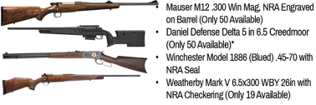

***Legacy of Freedom $3900\*\****



***Freedom $1900\*\****



***Pioneer $2900\*\****

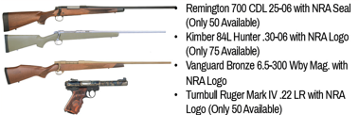

***Liberty $650***

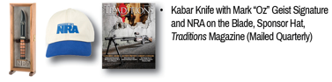

***Heritage $1150***

