**$1500 Premium Reserved Table - $2020- Does not include Liberty Sponsor**

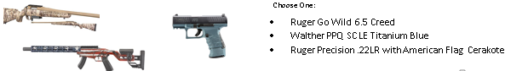

**$2020 Premium Reserved Table - $2020- Does not include Liberty Sponsor**

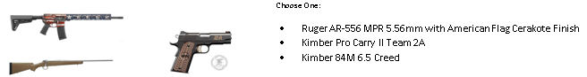

** The Ring of Freedom is a premier donor recognition program for freedom-loving individuals, families, or companies who make significant annual contributions to support our shared values. The NRA Ring of Freedom includes recognition at the NRA Annual Meeting & Exhibits, special invitations to exclusive events and a subscription to NRA Ring of Freedom magazine.



***Sentry $13000 \*\****



***Patriot $5300 \*\****

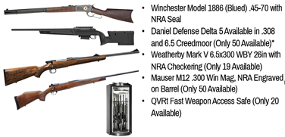

***Legacy of Freedom $3800\*\****

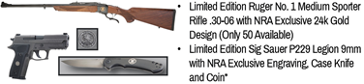

***Pioneer $2800\*\****

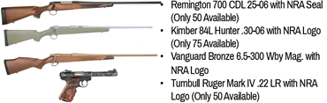

***Freedom $1800\*\****



***Heritage $1050***



***Liberty $600***

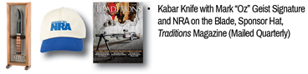

**Reserved Table Benefits**: Admission, Dinner and Reserved seating for 6; Premium location based on table levels; Priority service after Veterans and Program & Event Recognition. All levels include Liberty level benefits.

**\*\*Includes Ring of Freedom Benefits**

**Premium Reserved Table**