EASTERN MAINE FRIENDS OF NRA
WINNER TAKES ALL RAFFLE CENTURY ARMS RAFFLE
ONE WINNER WILL WIN ALL 3 NEW CANIK 9mm PISTOLS!
Tickets: $50 each, only 100 Tickets to be Sold
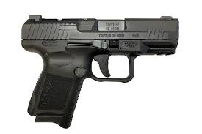
CANIK TP9 Elite 9mm w/ Warren Tactical Sights
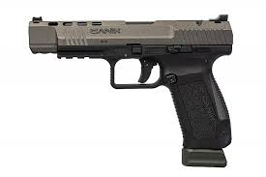
CANIK TP9 SFX 9mm Ported
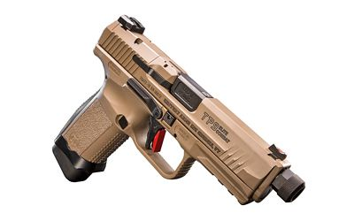
CANIK TP9 Elite Combat 9mmw/SAI Sights in FDE

Winner of all 3 Pistols will be drawn when all tickets are sold!

