SAGINAW BAY FNRA ANNUAL FUNDRAISER Saturday-April 10, 2020 ▪ 5:30 pm
Gateway Sportsmen Club▪ 4126 W. Bay City Forestville Rd ▪ Unionville, MI. 48767
$100 Big Shooter Package
1 Event Ticket, 1 Meal, 30 White Bucket Tickets, 10 Blue Bucket Tickets, 5 Red Tickets for the Early Bird Gun Drawing
:If purchased by 4/6/2020

$200 Super Shooter Package
2 Event Ticket, 2 Meals, 60 White Bucket Tickets, 20 Blue Bucket Tickets, 5 Red Tickets for the Early Bird Gun Drawing
:If purchased by 4/6/2020

$300 Magnum Shooter Package
2 Event Ticket, 2 Meals, 80 White Bucket Tickets, 40 Blue Tickets, 10 Red Tickets for the Early Bird Gun Drawing
:If purchased by 4/6/2020

LOADED GUN SAFE RAFFLE
Win the night of event Firearm
Sig Sauer P365 Nitron 9mm
To be Entered to win a Safe and 10 Firearms.
2019 Winner – Todd B. – Alpena, MI
NRA Guns & Prizes  2020 GUN OF THE YEAR  HENRY siDE Gate lever aCTION .45-70  WITH nra SEAL  Engraved with 2020 Friends of NRA  Gun of the Year  Early Bird- Red Bucket Gun- Buy tickets by 4/6/2020  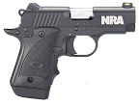  Kimber Micro 9mm with NRA logo | NRA EXCLUSIVES  Kimber NRA Protector  .45 ACP with NRA Seal  Weatherby Vanguard Wilderness  6.5-300 Wby with NRA Seal  Fostech Eagle Lite Rifle  .223/5.56 with Friends of NRA Logo  Sig Sauer P320 M17  9mm with Friends of NRA Logo  “We the People” Guitar  Signed by Ted Nugent  TO BUY TICKETS:  www.friendsofnra.org  or contact Al Herman at:  989-686-3013 or email at: aherman@nrahq.org

RESERVED TABLE PACKAGES
(All Package Firearms subject to change due to availability)
Silver Table Package for $600 – (8) Event tickets with Reserved Seating, (8) Meals, (8) FNRA Gift Items, (240) White Bucket Raffle Tickets, (80) Blue Bucket Tickets, (40) tickets on the Red Bucket Early Bird Firearm-: (If purchased by 4/6/2020)
Gold Table Package for $1,200 - (8) Event tickets with Reserved Seating, (8) Meals, (8) FNRA Gift Items, (480) White Bucket Raffle Tickets, (160) Blue Bucket Tickets, (40) tickets on the Red Bucket Early Bird Firearm: (If purchased by 4/6/2020) - Plus choice of one Table Firearm: Glock 43, Mossberg 500 Combo, Kel-Tec CP33, Ruger Precision Flag Cerakote .22, Taurus .357, Kel-Tec PMR 30 .22 Mag or Double the Bucket Raffle Ticket Package. (960 White, 320 Blue and 80 Red Bucket Tickets)
Diamond Table Package for $1,800 - (8) Event tickets with Reserved Seating, (8) Meals, (8) FNRA Gift Items, (640) White Bucket Raffle Tickets, (320) Blue Bucket Tickets, (80) tickets on the Red Bucket Early Bird Firearm: (If purchased by 4/6/2020)- Plus choice of one Table Firearm: Glock 19,Mauser M18 6.5 Creedmoor w/ NRA logo, Kimber Micro 9, Sig P938, Tristar Viper 28 GA, Ruger PC Carbine, S&W .357 w/ NRA seal Or Double the Bucket Raffle Ticket Package. (1280 White, 640 Blue and 160 Red Bucket Tickets)
Platinum Table Package for $2,600 - (8) Event tickets total with Reserved seating, (8) Meals, (8) FNRA Gift Items, (880) White Bucket Raffle Tickets, (400) Blue Bucket Tickets, (120) tickets on the Red Bucket Early Bird Firearm: (If purchased by 4/6/2020)- Plus choice of one Table firearm: examples may include but not limited to: Colts, Kimber’s, Daniel Defense etc. Or Double the Bucket Raffle Ticket Package. (1760 White, 800 Blue and 240 Red Bucket Tickets.) Call or email a committee member or the local NRA Field Representative for details and higher end Custom NRA Firearms.
The NRA Foundation is a 501 c3 charity of the National Rifle Association. 100% of the Net proceeds benefit National level safety programs and local youth shooting sports programs in our local communities. 24 FNRA Committees have raised and provided over 1.5 Million Dollars over the past 48 months to over 425 projects here in Michigan and we THANK YOU for your continued contribution to the cause. NRA membership is not required to participate. All firearms laws and transfer laws apply!
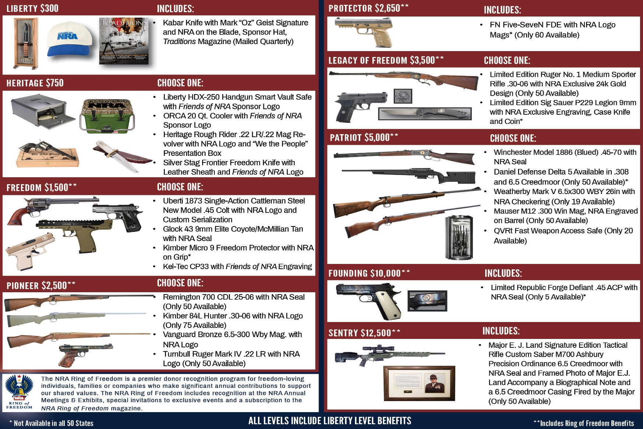
2020 SPONSOR PROGRAM

Mail This Portion --- Order Early and SAVE
Name: __________________________________________ Address: ________________________________________________
City: ______________________ State: _______ Zip: _____________ (Must be same as CC Billing) Phone: (____) _____-_________
Email: ________________________________________________________

Please reserve _____Event Ticket and Meal at $40 each. $_________
Please reserve _____Kids (Under 14) Event Ticket and Meal at $20 each $_________
Please reserve _____$100 Big Shooter Package and 1 Meal- Over $200 Value – (4/6/2020 Deadline) $_________
Please reserve _____$200 Super Shooter Package and 2 Meals – Over $400 Value- (4/6/2020 Deadline) $_________
Please reserve _____$300 Magnum Shooter Package and 2 Meals – Over $600 Value – (4/6/2020 Deadline) $_________
Please reserve _____Michigan Loaded Gun Safe Raffle ticket(s) $20 Each) (Only 150 Sold) $_________
Please reserve _____Silver Table $600 (Over $1,700 Value) _____ Gold $1,200 (Over $3,000 Value) _____
Diamond $1800 (Over $4,000 Value) _____ Platinum $2,500 (Over $6,000 Value) _____ $_________
Please reserve Sponsor: ___ Liberty ___ Heritage ___ Freedom ___ Pioneer ___ Legacy ___ Patriot $_________

Please List your choice of Table and or Sponsor Firearm Here or call the contacts below_____________________________
Enclosed please find my check/money order, payable to Friends of NRA......................totaling: $__________

Tickets ordered on this form may be picked up at the door the night of the event.
Please charge my Credit Card: (circle) Visa/ MC/ AMEX/ Discover #___________--___________--__________--__________ Expiration Date (Month/Year) ______/________ Security Code: _______
MAIL TO: Saginaw Bay FNRA For more information call: Al Herman @ 989-686-3013
3221 Beaver Rd. or e-mail at: aherman@nrahq.org
Bay City, MI 48706
Log onto www.friendsofnra.org THIS FORM MAY BE COPIED 12/15/2019

