BOONE COUNTY
21st Annual Fundraiser on behalf of The NRA Foundation

Prime Rib Dinner 7:00 pm
November 7th, 2020 ▪ 5:30 pm
Become and FNRA Sponsor today!!!
Boone County Event center – South 11th St Albion, NE
For Tickets: friendsofnra.org/events
Chad Martinsen 402-843-0218 OR Dr. Jeremy Young 402-741-2337

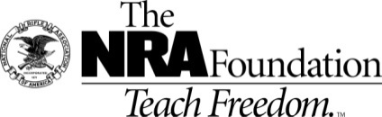
AUCTION & RAFFLE HIGHLIGHTS

Tickets & Tables NRA Guns & Prizes |  | Special raffle
Single Ticket - $30.00  Kids under 15 have a chance to win a lifetime hunting permit (with paid dinner ticket)! | NRA EXCLUSIVES | Don’t Miss out!!!!
$1,500 Table  Table includes  8 Dinner tickets  $300 Raffle Pack  And Choice of Gun at your table!!!!  (Check with Chad or Jeremy for gun table options)  ---------------------------------------------------------------------------------  Limited Edition guns available at our event  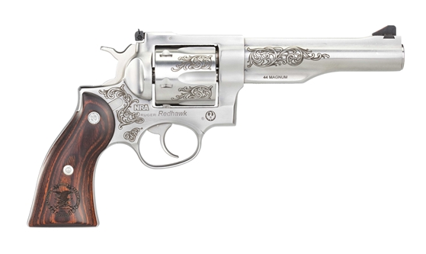  Ruger Redhawk 44 MAg | Kimber NRA Protector  .45 ACP with NRA Seal  Weatherby Vanguard Wilderness  .6.5-300 Wby with NRA Seal  Fostech Eagle Lite Rifle  .223/5.56 with Friends of NRA Logo  Keystone NRA Crickett® Overwatch  Precision Rifle  .22 Long Rifle with Exclusive NRA Mossy Oak Overwatch Dipped Stock  Sig Sauer P320 M17  9mm with Friends of NRA Logo  “We the People” Guitar  Signed by Ted Nugent  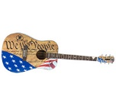  AND MORE!  View all items at www.friendsofnra.org/merchandise | Loaded Gun Safe Raffle  (See back for list of guns)  1 for $20  or  6 for $100  Only 600 Sold  Need not be present to win
2020 SPONSOR PROGRAM
ORDER FORM ● BOONE COUNTY FRIENDS OF NRA November 7th, 2020
2020 Order tickets online:
www.friendsofnra.org

Other Table Packages Available
Questions?
Chad Martinsen
402-843-0218
DR. Jeremy Young
402-741-2337

Or mail order by
Oct 28
Clip address below & tape to envelope for easy addressing!

Chad Martinsen
PO BOX 182
Elgin, NE 68636

QTY |  |  | $30 INDIVIDUAL TICKET (PRIME RIB DINNER) by Uptown Cooking Creations |  |  |  |  |  | $
 |  |  | Loaded Gun Safe Raffle 1 for $20 or 6 for $100 |  |  |  |  |  | $
 |  |  | $250.00 Early Bird 2 dinners $300.00 in raffle tickets & we add 1 gun to the drawing for every 10 sold. |  |  |  |  |  | $
 |  |  | $500.00 Early Bird 2 dinners, $500.00 in raffle tickets, a three gun chance that night, you are also entered in the ($250 package, only for the 1 gun for every 10 sold). That's a lot of chances for YOU to win guns that night! |  |  |  |  |  | $
 |  |  | $1500 Reserve Table: 8 Dinners + $300 Raffle Pack + Choice of Gun (contact Chad or Jeremy) |  |  |  |  |  | $
 |  |  | Tax Deductible Sponsorship (Dinner tickets are not included) |  |  |  |  |  | $
 | [ ] $300 Liberty [ ] $2,500 Pioneer [ ] $5,000 Patriot
 | [ ] $750 Heritage [ ] $2,650 Protector [ ] $10,000 Founding
 | [ ] $1,500 Freedom [ ] $3,500 Legacy [ ] $12,500 Sentry
Please enclose check to NRA FOUNDATION or complete credit card info below |  |  |  |  |  |  |  | $
AmEx/Disc/MC/Visa charged upon receipt. All sales are final.
Card # |  |  |  |  | Expiration
Signature |  |  |  |  | Sec Code
Name |  |  |  |  | Company
Address |  |  |  |  | Phone
City/St/Zip |  |  |  |  | Email
