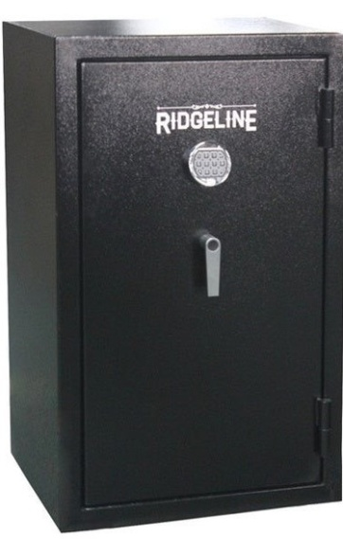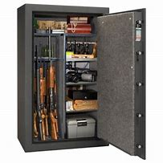

Boone County Friends of NRA

Loaded Gun Safe Raffle 2020

Only 600 tickets sold

$20/1 ticket

$100/6 tickets

NGL 35-11446803

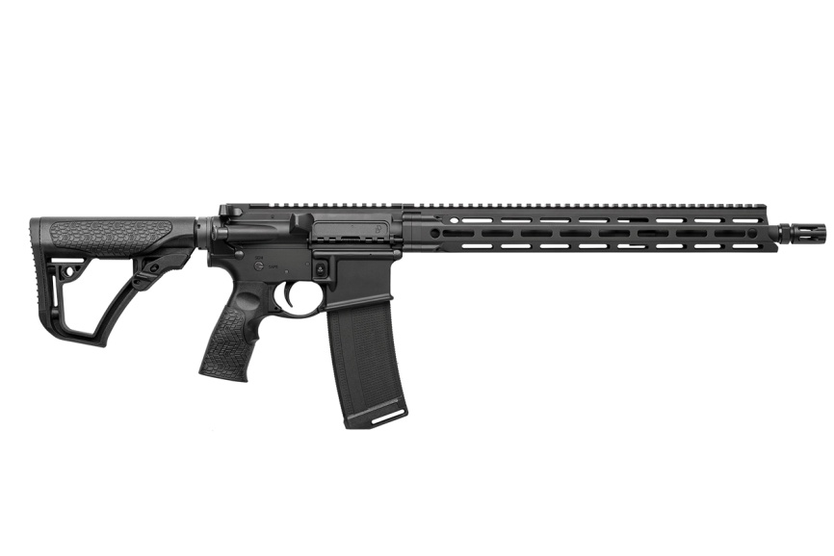

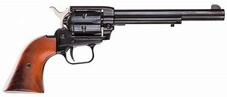

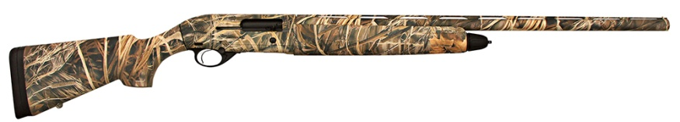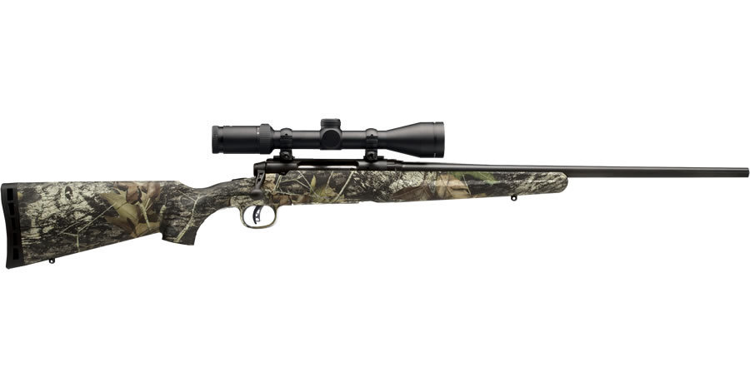

Raffle is for: 1st Ticket Winner Takes: Ridgeline 40 Gun Safe,

Daniel Defense AR 5.56, Beretta A300 Camo 12ga Shotgun, Savage Axis XP Camo 30-06 SPFLD & Heritage NRA Rough Rider .22

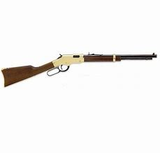

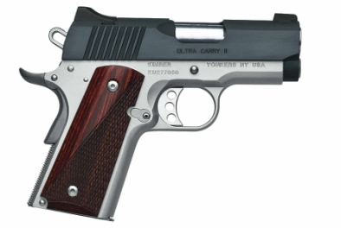

2nd Ticket Winner Takes: Kimber Ultra Carry II 45 &

Henry Golden Boy .22

Drawing to be held at

BCFNRA Banquet

Sat. November 7th, 2020

Boone County Fairgrounds

Social Hour 5:30 Dinner 7:00

Chad Martinsen 402-843-0218 Dane Nielsen 402-750-3747

Dr. Jeremy Young 402-741-2337 Chad Shabram 402-929-0016

Roy Ketteler 402-843-6487 Mark Hooker 402-741-2563

Shawn Olnes 402-608-0225 Travis Landauer 402-741-0923

Nick Krohn 402-841-8889 Tammy Starman 402-843-8833

Chris Levander 402-741-1075 Larry Starman 402-843-8394

Jennifer Blackburn-Nielsen 402-750-9931 Also at Bunky's Gun Shop