Help us Celebrate a Legacy of Shooting Sports Traditions!!

LAKES AREA FNRA
Annual Fundraiser on behalf of The NRA Foundation

July 18th, 2020 ▪ 5:00 pm
Frazee Event center
114 Lake st n ▪ Frazee, MN 56544
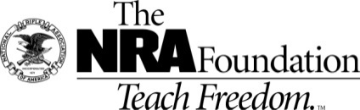
Friendsofnra.org/events
Johnson Performance – matt@johnsonperformance.biz or 218-639-9673
Jud Komrosky – jkomrosky@ver-tech.com or 218-234-6101

NRA Guns & Prizes |  | Table Packages
2020 GUN OF THE YEAR | NRA EXCLUSIVES | $400 Table Package  8 – Dinners
HENRY siDE aCTION .45-70 WITH nra SEAL  Engraved with 2020 Friends of NRA Gun of the Year  $800 Table Package Gun options  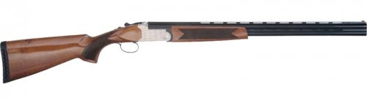  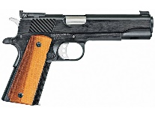  2020 Individual Dinner Ticket Special- $20.00 | Kimber NRA Protector  .45 ACP with NRA Seal  Weatherby Vanguard Wilderness  .6.5-300 Wby with NRA Seal  Fostech Eagle Lite Rifle  .223/5.56 with Friends of NRA Logo  Keystone NRA Crickett® Overwatch  Precision Rifle  .22 Long Rifle with Exclusive NRA Mossy Oak Overwatch Dipped Stock  Sig Sauer P320 M17  9mm with Friends of NRA Logo  “We the People” Guitar  Signed by Ted Nugent  AND MORE!  View all items at www.friendsofnra.org/merchandise | 1 – Midland Break Action Shotgun .410, 20 Ga, 12 Ga.  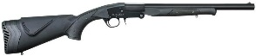  $800 Table Package  8 – Dinners  8- $40 General Raffle Tkts  1 – Rock Island 45 OR  Henry Golden Boy OR  Tristar 12 Ga O/U  See photos on opposite side of this page!!!  $2,400 Table Package  8 – Dinners  8 - $100 Ticket Packages  8 – Special Gifts  Either 8 guns or 1 gun  Contact Johnson Performance for options..  218-639-9673
The NRA Foundation is a 501(c)3 charity of the National Rifle Association. Net proceeds benefit shooting sports programs in our communities. NRA membership is not required to participate. All firearm laws apply. Winners are responsible for any taxes / transfer fees. Firearms transferred through [Johnson Performance – Matt Johnson ].
2020 SPONSOR PROGRAM
ORDER FORM ● LAKES AREA FRIENDS OF NRA July 18th, 2020
Early Bird tickets must be ordered by July 10th, 2020 Order tickets online:
www.friendsofnra.org

All tickets held at door
Cancelled check or CC charge is your receipt/confirmation
Questions? Ashlee
Am88608@gmail.com
701-205-6769
Clip address below & tape to envelope for easy addressing!

Ashlee Fairbanks
414 Willow St W
Detroit Lakes, MN 56501
QTY |  |  | $20 INDIVIDUAL TICKET |  |  |  |  | $
 |  |  | $400 TABLE PACKAGE Includes 8 Dinner Tickets and a Midland Shotgun – 410, 20 Ga., or 12 Ga. |  |  |  |  | $
 |  |  | $800 Table Package Includes 8 Dinner Tickets, General Raffle tickets and Choice of Gun |  |  |  |  | $
 |  |  | $2,400 Table Package-Includes 8 Dinner Tickets, 8 Gifts, 8 $100 Tickets, Custom gun choices |  |  |  |  | $
 |  |  | Tax Deductible Sponsorship (Dinner tickets are not included) |  |  |  |  | $
 | [ ] $300 Liberty [ ] $2,500 Pioneer [ ] $5,000 Patriot
 | [ ] $750 Heritage [ ] $2,650 Protector [ ] $10,000 Founding
 | [ ] $1,500 Freedom [ ] $3,500 Legacy [ ] $12,500 Sentry
Please enclose check to NRA FOUNDATION or complete credit card info below |  |  |  |  |  |  |  | $
AmEx/Disc/MC/Visa charged upon receipt. All sales are final.
Card # |  |  |  |  | Expiration
Signature |  |  |  |  | Sec Code
Name |  |  |  |  | Company
Address |  |  |  |  | Phone
City/St/Zip |  |  |  |  | Email
