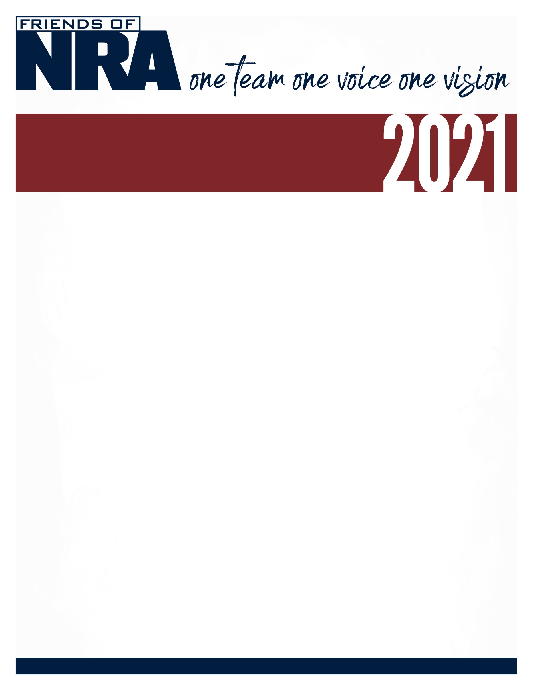

Laclede Area
Annual Fundraiser on behalf of The NRA Foundation

Thursday, June 24 ▪ 5:30 pm
Cowan Civic Center
500 East Elm St. Lebanon, MO. 65566

Celebrate a legacy of shooting sports traditions.
Join other champions of the Second Amendment for dinner, raffles, auctions and fun with a chance to win exclusive NRA guns, gear, décor and collectibles!

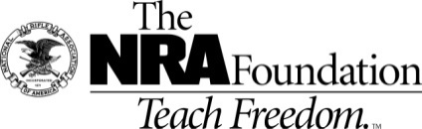
AUCTION & RAFFLE HIGHLIGHTS

NRA Guns & Prizes |  | Special Raffles
 | NRA EXCLUSIVES
Kimber Custom II  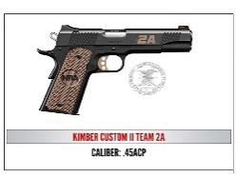  Fos-Tech AR-15 Phantom | Kimber .45 Pistols  Ruger 57  Springfield 10 MM- NRA  Fostech Phantom AR-15  Smith & Wesson Pistols  Kel-Tec Pistols  Springfield HellCat 9 mm  Glock Pistols  Henry Rifles  Sig Sauer Pistols  & Much More! | $100 Raffle  $100 per TICKET  ONLY 30 Chances  TO BE SOLD  Plus you receive  $100.00 in white bucket  Raffle Tickets!  Winners Choice  On Firearm
ORDER FORM ● FRIENDS OF NRA
Order tickets online:
www.friendsofnra.org

All tickets held at door
Cancelled check or CC charge is your receipt/confirmation

Questions? Mike
Email: wb9m@fidnet.com

573-718-3818

Or mail order by June 15
Clip address below & tape to envelope for easy addressing!

Mike Edwards
201 Hillside Ct
Lebanon, MO. 65536
QTY |  |  | $35.00 SINGLE TICKET |  |  |  |  | $
 |  |  | $XX TABLE PACKAGE TYPE |  |  |  |  | $
 |  |  | $XX PRE BUY BUCKET RAFFLE PACKAGE TYPE |  |  |  |  | $
 |  |  | $100.00 AMMO BOX RAFFLE |  |  |  |  | $
 |  |  | TAX-DEDUCTIBLE SPONSORSHIP (Dinner tickets are not included) |  |  |  |  | $
 | [ ] $300 Liberty [ ] $750 Heritage [ ] $1,500 Freedom
Please enclose check to NRA FOUNDATION or complete credit card info below |  |  |  |  |  |  |  | $
AmEx/Disc/MC/Visa charged upon receipt. All sales are final.
Card # |  |  |  |  | Expiration
Signature |  |  |  |  | Sec Code
Name |  |  |  |  | Company
Address |  |  |  |  | Phone
City/St/Zip |  |  |  |  | Email
Reserved seating
$35.00 single ticket: (1) dINNER TICKET You Can purchase tickets ON LINE
www.friendsofnra.org
$350.00 Supporting table:
- (8) DINNER TICKETS
- 1 table gift
$550.00 Bronze table:
- (8) DINNER TICKETS
- 1 Heritage .22 Pistol or Rossi .22 Rifle
- SUBJECT TO AVAILABILITY
$1000.00 Silver table:
- (8) DINNER TICKETS
- 1 Smith & Wesson M&P 9 mm Pistol
*SUBJECT TO AVAILABILITY
$1500.00 Gold table:
- (8) DINNER TICKETS
heritage level sponsorship or kimber 84 m- hunter rifle OR KIMBER.45 acp pistol or Smith & Wesson 5.56 AR
- Or Springfield 10 mm Pistol NRA Engraved
$2500.00 Platinum table:
- (8) DINNER TICKETS
- 1 Colt Pythan .357 Magnum revolver
$100.00 raffle:
Details: 1- 30 limited chances. Winners Choice of either gun of year or Kimber nra Protector 45 pistol. you receive a consulation item. plus $100.00 in white bucket raffle tickets for additonal chance prizes.
$100 0r $200.00 pRE pURCHASED bUCKET rAFFLE PACKAGES. IF YOU PRE PURCHASE YOUR BUCKET RAFFLE PACKAGE. YOU WILL RECEIVE DOUBLE AMOUNT OF WHITE bucket raffle TICKETS FOR THE GENERAL RAFFLE and EXTRA Gun RAFFLE table chances.
$500.00 Gold Table Bucket raffle package: if you pre purchase your gold table upgrade raffle package. you receive triple amount of white, red, blue and 1 gold ticket for a 1 - 7 chance drawing for a nra speciality fiream. Plus YOU’RE entered into the statewide drawing for additional year end prize drawings.
$50.00 Raffle game.
details: 1-36 chances. plus you receive $40.00 in white bucket raffle tickets for additional chance prizes.

These limited raffles generally sell out fast. reserve yours today for a chance to win a speciality NRA engraved fiream.

