ONE OF THE TOP 25 BANQUETS IN THE UNITED STATES IN 2019
Itasca County

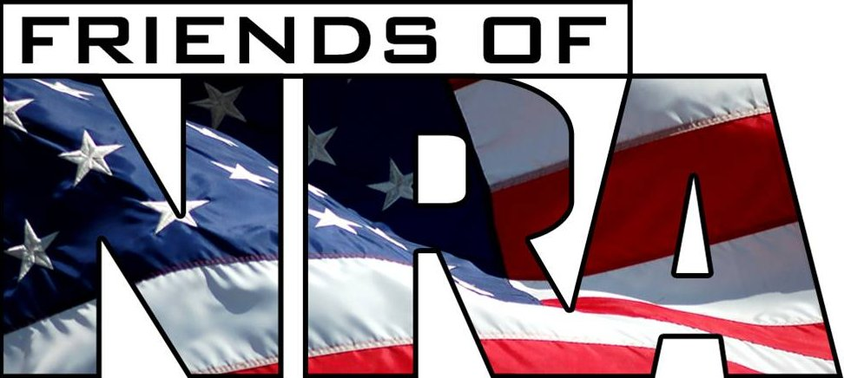

26nd Annual Fundraiser

on behalf of The NRA Foundation

April 16th, 2021 ▪ 5:00 pm
Timberlake Lodge
144 SE 17th Street ▪ Grand Rapids, MN

Celebrate a legacy of shooting sports traditions.
Join other champions of the Second Amendment for dinner, raffles, auctions and fun with a chance to win
exclusive NRA guns, gear, décor and collectibles!
AUCTION & RAFFLE HIGHLIGHTS

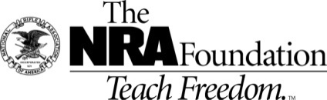
NRA Guns & Prizes |  | Table Packages
2020-2021 GUN OF THE YEAR  HENRY SIDE ACTION .45-70 WITH  NRA SEAL  Club Level Committee exclusive  THIS IS 1 OF 25 IN THE NATION  AWARDED TO THE TOP 25 BANQUETs  OF 2019  Ruger® Redhawk® Double-Action 44 Magnum Revolver with NRA Seal  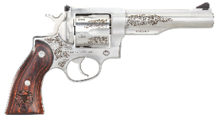 | NRA EXCLUSIVES  Kimber NRA Protector  .45 ACP with NRA Seal  Weatherby Vanguard Wilderness  .6.5-300 Wby with NRA Seal  Fostech Eagle Lite Rifle  .223/5.56 with Friends of NRA Logo  Keystone NRA Crickett® Overwatch  Precision Rifle  .22 Long Rifle with Exclusive NRA Mossy Oak Overwatch Dipped Stock  Sig Sauer P320 M17  9mm with Friends of NRA Logo  “We the People” Guitar  Signed by Ted Nugent  AND MORE!  View all items at www.friendsofnra.org/merchandise | $900 Table Package  8 - Dinners  8 - $40 Ticket Package  1 in 8 chance on a Taurus G2C 9mm or a Ruger American Rimfire 22LR  $1700 Table Package  8 - Dinners  8 - $100 Packages  1 in 8 Chance on a S&W M&P .380 Shield EZ2.0 or a TC Compass II 300WIN  $2,500 Table Package  8 – Dinners  8 - $300 Raffle Packages  1 in 8 chance on a S&W Sport II 5.56 or a STEVENS 555E Enhanced .410ga, or a Browning Abolt III Syn. .270,.243 or 30-06 w/ scope and case  DINNER TICKETS - $ 50.00  Reserved Seating Dinner $150.00  (Includes a 1 in 8 chance at a gun)

The NRA Foundation is a 501(c)3 charity of the National Rifle Association. Net proceeds benefit shooting sports programs in our communities. NRA membership is not required to participate. All firearm laws apply.
Winners are responsible for any taxes / transfer fees. Firearms transferred through
REEDS OUTDOOR OUTFITTERS.
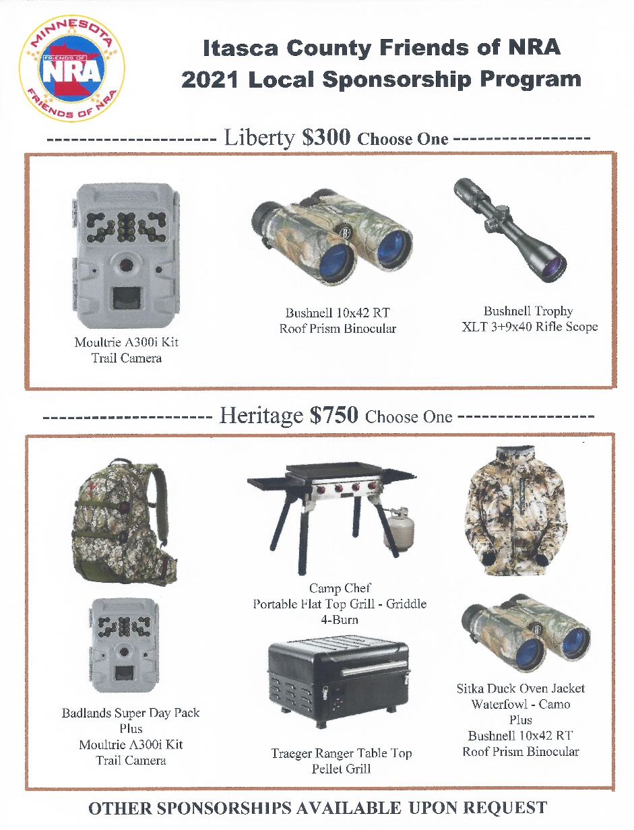
2021 BIG SHOOTER TICKET –RELOAD RAFFLE
Ticket $ 100.00 each

1. Browning III Syn Gray 30-06 Spfld 9. Smith & Wesson M+P 9 Shield Bug Out Bag Bundle 9mm
2. Franchi Momentum Black Syn 300WIN 10. Springfield XDS Mod 2 OSP CT Black 9mm
3. Glock G19 Gen 3 Black 9mm 11. Stevens 555 O/U Turkish Walnut 16ga
4. Kel-Tec PMR 30 .22Mag 12. Stoeger M3500 Max-5 Camo 12ga
5. Ruger LCP II .380ACP Viridian Laser 13. Thompson Center Venture II Silver WS 5.56
6. SAR-X9 Black 9mm 14. Typhoon Defense XII Black 12ga
7. Savage Axis 6.5 CM 15. Weatherby Mark V Weathermark 6.5Wby RPM 24in TB
8. Smith & Wesson M+P 15 Sport II Black 5.56 16. More Guns ADDED if more than 150 Tickets Sold

LOCKED & LOADED GAME CARD $140.00 Value for ONLY $100.00
Pre-Sale Only Includes 6 Game Entries
- $50.00 Entry for a chance to win a Fort Knox Safe ($2,600 value)
2 - $20.00 Entries in the Wall of Guns (1 in 60 Chance to win)
1 - $20.00 Entry into the Knife Game
1 - $20.00 20/20 Raffle (1 in 20 chance to win)
1 - $10.00 Mystery Box Game

Contact info: itascanra@gmail.com or call: 218-259-0317

