Bluff Country Friends of NRA
21st Annual Fundraiser on behalf of The NRA Foundation
February 26, 2022 ▪ 2pm- 6pm

EVENT LOCATION: Ettrick Rod and Gun Club
W11934 Whalen Rd, Ettrick WI

Celebrate a legacy of shooting sports traditions.
Join other champions of the Second Amendment for dinner, games, auctions and fun with a chance to win exclusive NRA guns, gear, décor and collectibles!

AUCTION & RAFFLE HIGHLIGHTS

NRA Guns & Prizes |  | Special Raffles/  Table Packages
2022 GUN OF THE YEAR | NRA EXCLUSIVES
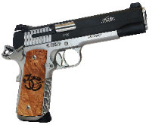  SIG SAUER 1911 STX .45  With Friends of NRA 30th Anniversary Grips  Henry Single Shot Rifle  .350 Legend with 30th Anniversary Logo  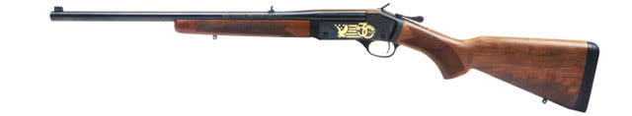 | Diamondback DB-15 Rifle  With 30th Anniversary Logo  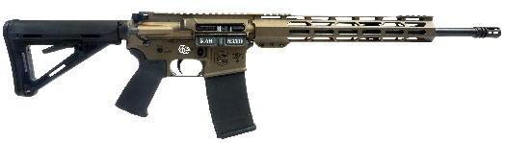  Smith & Wesson M&P9  Shield Plus 9mm with NRA Logo  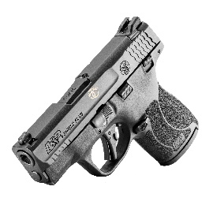  AND MORE!  View all items at www.friendsofnra.org/merchandise | E-Cell - E–Bike  Super Monarch  700 Watt  $20 per ticket  3 tickets for $50  See Additional Flyer  Table Packages  See Registration Form
The NRA Foundation is a 501(c)3 charity of the National Rifle Association. Net proceeds benefit shooting sports programs in our communities. NRA membership is not required to participate. All firearm laws apply. Winners are responsible for any taxes / transfer fees. Firearms transferred through Holtans in Whitehall, WI

EVENT REGISTRATION / ORDER FORM
BLUFF COUNTRY FRIENDS OF NRA
SATURDAY, FEBRUARY 26TH , 2022 2PM – 6PM
eTTRICK rOD AND GUN cLUB
w11934 wHALEN rD, eTTRICK, wi
PLEASE PRINT

nAME:___________________ aDDRESS:____________________________ _
CITY: sTATE:________________ZIP:___________ __
PHONE:_____________________________EMAIL:_______________________________ _
aLL EVENT TICKETS, SPONSOR MATERIALS, AND RAFFLE TICKETS WILL BE AVAILABLE AT THE DOOR THE NIGHT OF THE EVENT.
iF NOT ATTENDING THE EVENT, THE WINNER OF THE PRE-EVENT RAFFLE WILL BE CONTACTED.

pLEASE RESERVE______EVENT TICKETS AT $50 EACH tOTAL $_____________

rESERVE TABLE OF 8 OPTION #______IN THE NAME OF:________________________ __
OPTION 1: $400 = eVENT TICKET, DINNER, 8 BUCKET RAFFLE STRIPS ($560 Value!!)
oPTION 2: $1000 = EVENT TICKET, DINNER, 24 BUCKET RAFFLE STRIPS – 1 Henry .22 Lever Action ($1,400 Value!!)
OPTION 3: $2500 = EVENT TICKET, DINNER, 48 BUCKET RAFFLE STRIPS – 1 NRA Custom Fostech Phantom 5.56 or Springfield Ronin 1911 .45 acp ($2,900 Value!!!)
PLEASE PROVIDE NAME AND ADDRESS OF ALL 8 ATTENDEES tOTAL $________________ __

SPONSOR OPTIONS: REQUEST DETAILS FROM COMMITTEE
[ ] $300 Liberty [ ] $2,500 Pioneer [ ] $5,000 Patriot
[ ] $750 Heritage [ ] $2,650 Protector [ ] $10,000 Founding
[ ] $1,500 Freedom [ ] $3,500 Legacy [ ] $12,500 Sentry
DINNER TICKETS NOT INCLUDED IN SPONSORSHIPS

pRE-EVENT RAFFLE: E – Bike $20 per ticket / 3 for $50 ______ TICKETS $ ____________ Super Monarch 700 Watt AWD Dual Motors

bUCKET RAFFLE TICKETS – ADVANCE PURCHASE Pricing
$200 RAFFLE TICKETS (10 STRIPS) FOR $100 $__________
$800 RAFFLE TICKETS (40 STRIPS) FOR $350_______________________$__________

ENCLOSE CHECK PAYABLE TO: FRIENDS OF NRA: $______________
CHARGE MY CREDIT CARD: VISA_____ MASTERCARD_____AMERICAN EXPRESS_____DISCOVER____ $______________

CREDIT CARD #_____-_____-_____-_____ EXPIRES__________ SEC CODE________
SIGNATURE: _________________________________________________________________

MAIL THIS PAGE TO: FOR MORE INFORMATION CONTACT:
BLUFF COUNTRY FRIENDS OF NRA Kris VanAcker - 608-323-7010
PO BOX 222 , Arcadia, WI 54612 vanacker55@gmail.com

