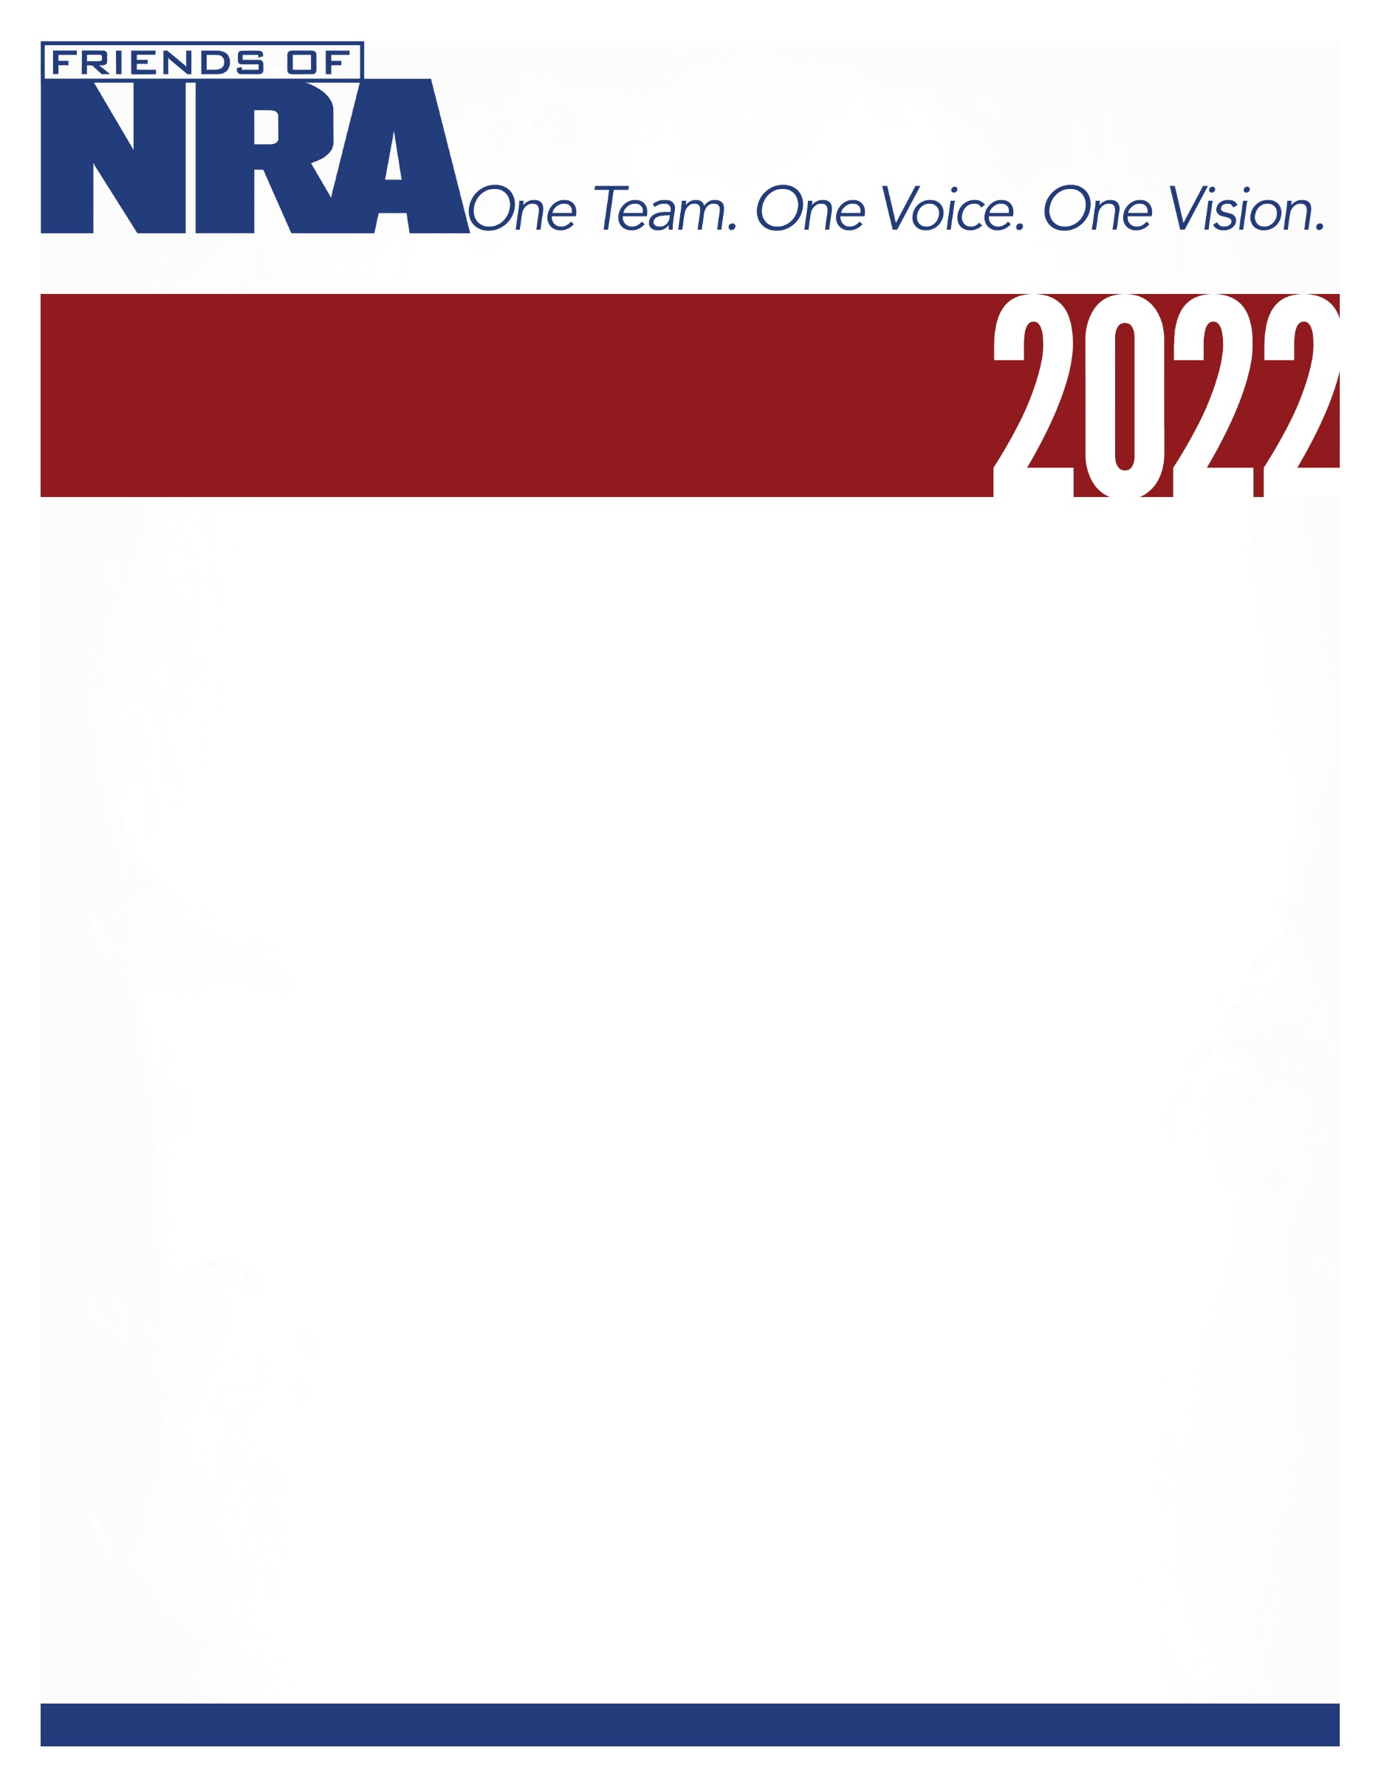

Mississippi Valley
8th Annual Fundraiser on behalf of The NRA Foundation

June 16, 2022 ▪ 5:00 pm
American Legion Post 55
3819 Hwy MM, Hannibal, MO. 63401

Celebrate a legacy of shooting sports traditions.
Join other champions of the Second Amendment for dinner, games, auctions and fun
with a chance to win exclusive NRA guns, gear, décor and collectibles!

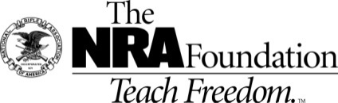
AUCTION & RAFFLE HIGHLIGHTS

NRA Guns & Prizes |  | Special Raffles/  Table Packages
2022 GUN OF THE YEAR | NRA EXCLUSIVES
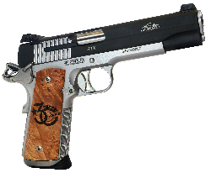  SIG SAUER 1911 STX .45  With Friends of NRA 30th Anniversary Grips  Club Level Committee Exclusive  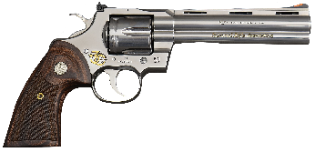  2022 Colt Python .357Mag 6” Engraved with Gold Friends  of NRA 30th Anniversary Logo | Diamondback DB-15 Rifle  With 30th Anniversary Logo  Smith & Wesson M&P9 Shield Plus  9mm with NRA Logo  Henry Single Shot Rifle  .350 Legend with 30th Anniversary Logo  Baby Bowie Knife with Stag Handle  With 30th Anniversary Logo  AND MORE!  View all items at www.friendsofnra.org/merchandise | $100 Raffle  1-36 chance sold for specialty NRA firearm plus you receive a gift & bucket tickets!  $50 Knife Raffle  only 40 chances sold for a choice of NRA firearm

The NRA Foundation is a 501(c)3 charity of the National Rifle Association. Net proceeds benefit shooting sports programs in our communities. NRA membership is not required to participate. All firearm laws apply. Winners are responsible for any taxes / transfer fees. Firearms transferred through [FFL DEALER].

2022 NATIONAL SPONSOR PROGRAM
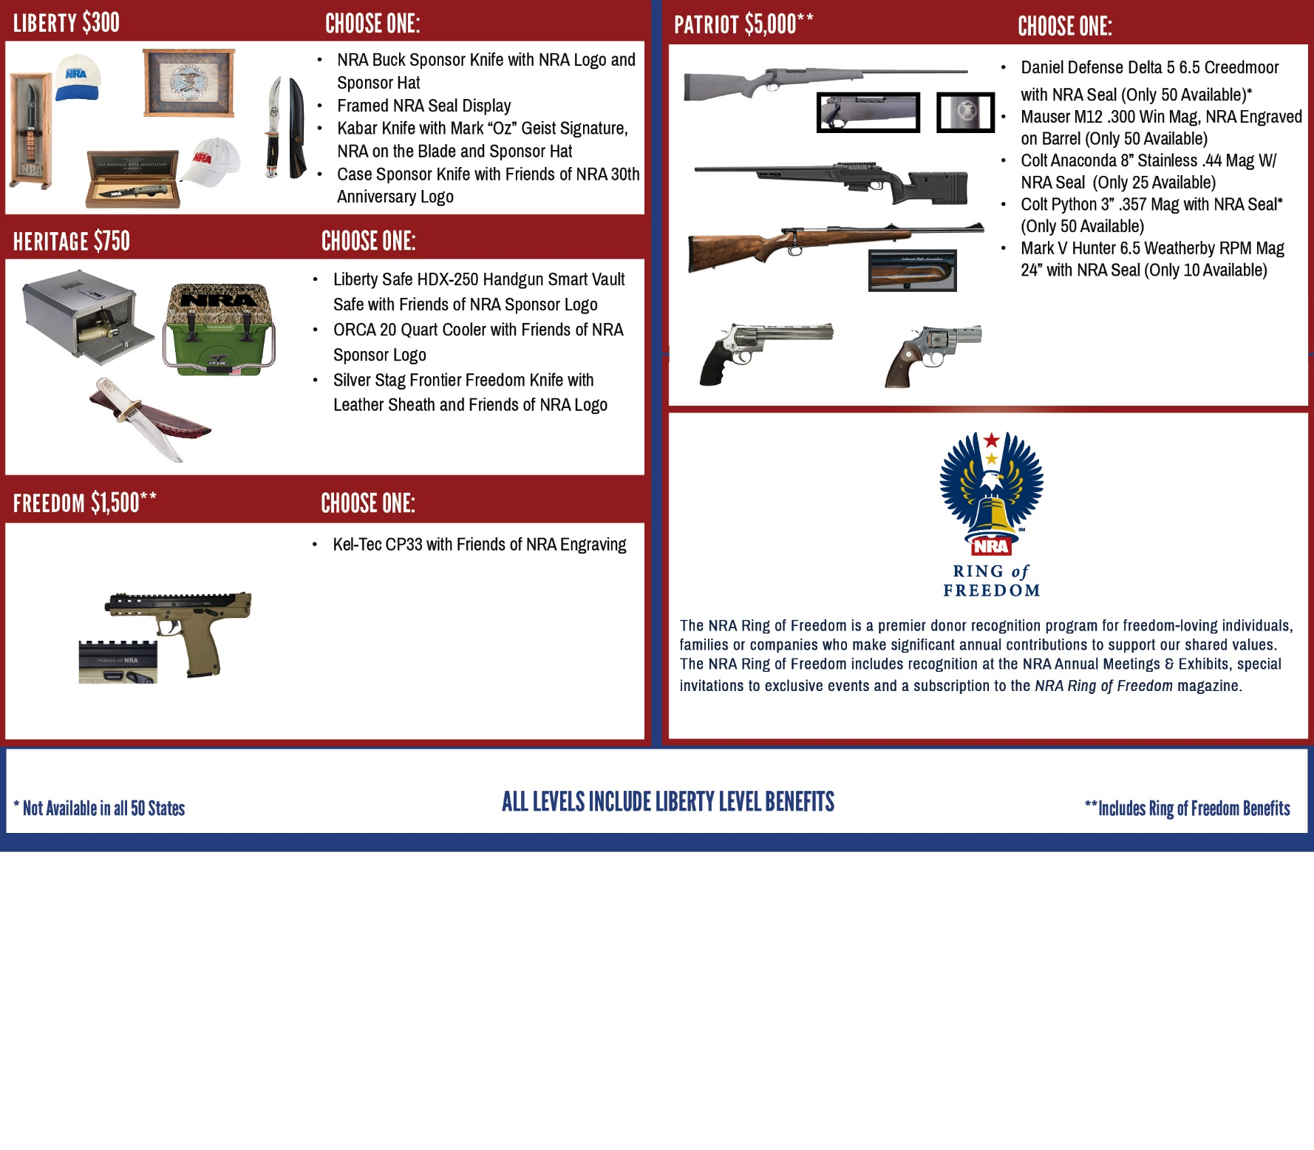
ORDER FORM ● (NAME) FRIENDS OF NRA (DATE)
Order tickets online:
www.friendsofnra.org

All tickets held at door
Cancelled check or CC charge is your receipt/confirmation
Questions? Brian
Email: brianpowell@charter.net
Phone: 573-406-5477

Or mail order by June 10
Clip address below & tape to envelope for easy addressing!

Brian Powell
13 D Ville Place
Hannibal, MO. 63401
QTY |  |  | $XX (NAME) RAFFLE |  |  |  |  | $
 |  |  | $XX INDIVIDUAL: 1 Dinner |  |  |  |  | $
 |  |  | $XX COUPLES: 2 Dinners |  |  |  |  | $
 |  |  | $XXXX TABLE: 8 Dinners + 1 Gun |  |  |  |  | $
 |  |  | TAX-DEDUCTIBLE SPONSORSHIP (Dinner tickets are not included) |  |  |  |  | $
 | [ ] $300 Liberty [ ] $1,500 Freedom [ ] $5,000 Patriot
 | [ ] $750 Heritage [ ] $2,500 Pioneer
Please enclose check to NRA FOUNDATION or complete credit card info below |  |  |  |  |  |  |  | $
AmEx/Disc/MC/Visa charged upon receipt. All sales are final.
Card # |  |  |  |  | Expiration
Signature |  |  |  |  | Sec Code
Name |  |  |  |  | Company
Address |  |  |  |  | Phone
City/St/Zip |  |  |  |  | Email

