Coulee Region
Annual Fundraiser on behalf of The NRA Foundation

March 31st 2022 ▪ 5:00 pm
Fox Hollow Golf Course
N3287 County Rd OA. ▪ La Crosse, WI 54601

Celebrate a legacy of shooting sports traditions.
Join other champions of the Second Amendment for dinner, games, auctions and fun with a chance to win exclusive NRA guns, gear, décor and collectibles!

FIREARMS AND RAFFLE HIGHLIGHTS

NRA Guns & Prizes |  | Special Raffles
2022 GUN OF THE YEAR | NEW Table Packages: | Early Bird Raffle Packs:  $100 for $200 Pack
SIG SAUER 1911 STX .45  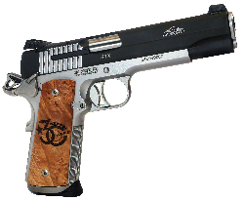  With Friends of NRA 30th Anniversary Grips  NRA EXCLUSIVES  Diamondback DB-15 Rifle  With 30th Anniversary Logo  Smith & Wesson M&P9  Shield Plus 9mm with NRA Logo  Henry Single Shot Rifle  .350 Legend with 30th Anniversary Logo | $500 Reserved Table: (8) Event tickets,  (8) Bucket raffles Strips-$20 value each  $560 VALUE!!!!  $800 Bronze Table: (8) Event Tickets,  (16) Bucket Raffle Strips, (1) Henry .22  $1,100 VALUE!!!!!  $1200 Silver Table: (8) Event Tickets, (24) Bucket Raffle Strips,  (1) Sig Sauer P320 9MM  $1,500 Value!!!!!  $2,500 Gold Table: (8) Event Tickets,  (48) Bucket Raffle Strips,  (1) Springfield 1911 Ronin .45 ACP  $2,900 VALUE!!!! | $350 for $800 Pack  New Night of Raffle:  Raffle Pack Raffle  $100 per TICKET  ONLY 50 TICKETS  TO BE SOLD  Purchase a Ticket and Receive a $100 Bucket Raffle Pack For-  2022 Gun Of The Year  Sig Sauer 1911 STX .45
The NRA Foundation is a 501(c)3 charity of the National Rifle Association. Net proceeds benefit shooting sports programs in our communities. NRA membership is not required to participate. All firearm laws apply. Winners are responsible for any taxes / transfer fees. Firearms transferred through [FFL DEALER].

2022 SPONSOR PROGRAM
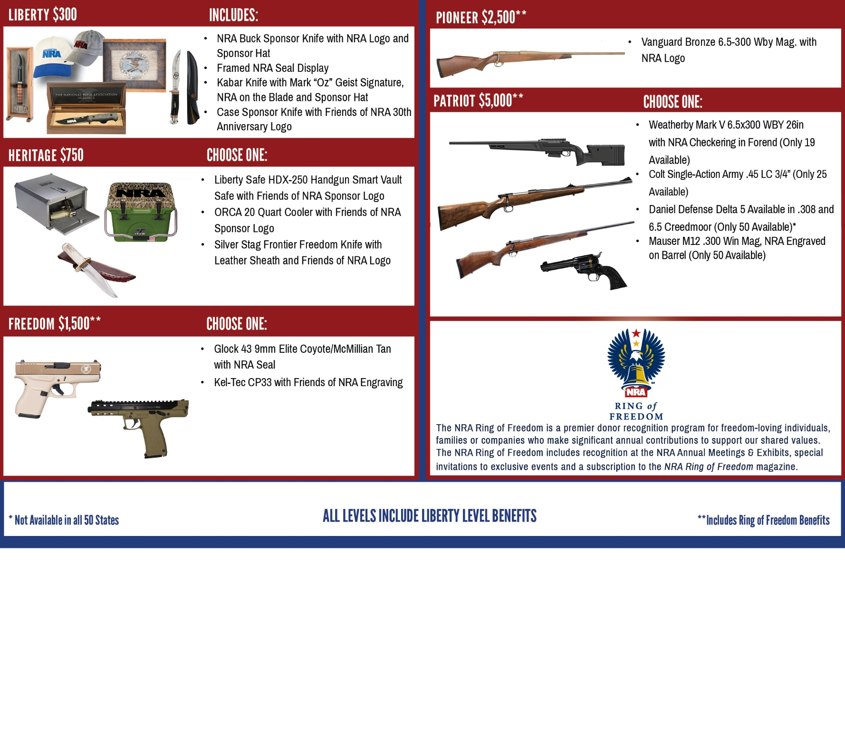
______ $100 for $200 Bucket Raffle Pack (Deadline 3/21/2022) $ __________
______ $350 for $800 Bucket Raffle Pack (Deadline 3/21/2022) $ __________
30th Anniversary Diamond Back DB-15 Tickets (1/$20, 3/$50, 7/$100)
______ /$20 (each) _____/$50 (Per 3) _____/$100 (Per 7) $ __________
Order tickets online:
www.friendsofnra.org

All tickets held at door
Cancelled check or CC charge is your receipt/confirmation
Questions? Hubert Hoffman
huberthoffman@outlook.com
608-792-0669

Or mail order by (3/21/22)
Clip address below & tape to envelope for easy addressing!

Channon Kennedy
W5632 County Rd K
Stoddard, WI 54658
 |  |  | $50 INDIVIDUAL: 1 Event Ticket |  |  |  |  | $
 |  |  | $500 Reserved Table: 8 Event Tickets, 8 Bucket Raffle Sheets |  |  |  |  | $
 |  |  | $800 Bronze Table: 8 Event Tickets, 16 Bucket Raffle Sheets, 1 Gun |  |  |  |  | $
 |  |  | $1,200 Silver Table: 8 Event Tickets, 24 Bucket Raffle Sheets, 1 Gun |  |  |  |  | $
 |  |  | $2,500 Gold Table: 8 Event Tickets, 48 Bucket Raffle Sheets, 1 Gun |  |  |  |  | $
 | [ ] $300 Liberty [ ] $2,500 Pioneer [ ] $5,000 Patriot
 | [ ] $750 Heritage [ ] $2,650 Protector [ ] $10,000 Founding
 | [ ] $1,500 Freedom [ ] $3,500 Legacy [ ] $12,500 Sentry
Please enclose check to NRA FOUNDATION or complete credit card info below |  |  |  |  |  |  |  | $
AmEx/Disc/MC/Visa charged upon receipt. All sales are final.
Card # |  |  |  |  | Expiration
Signature |  |  |  |  | Sec Code
Name |  |  |  |  | Company
Address |  |  |  |  | Phone
City/St/Zip |  |  |  |  | Email

