May 16th, 2022 ▪ 5:00 PM
Mickey Finn’s 345 N Milwaukee Ave, Libertyville, IL 60048

AUCTION & RAFFLE HIGHLIGHTS
NRA GUNS & PRIZES  2022 GUN OF THE YEAR  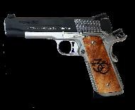  SIG SAUER 1911 STX .45  WITH 30TH ANNIVERSARY Friends of NRA GRIPS | NRA EXCLUSIVES:  Heritage Rough Rider Rancher .22 LR with Buckhorn Sight and Leather Sling  Smith and Wesson M&P Shield PLUS 9mm with 30 Anniversary Friends of NRA Logo  Henry Single Shot Rifle .350 Legend with 30th Anniversary Friends of NRA Logo  Tons of other guns and prizes from Henry, Kimber, Sig Sauer, Springfield Armory, Fostech, Orca, and many more!  DIAMONDBACK DB-15 RIFLE WITH 30TH ANNIVERSARY Friends of NRA LOGO  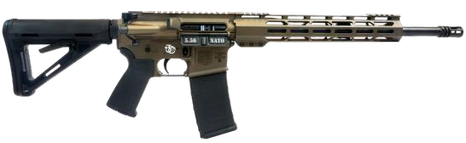 | $100 SINGLE SHOT PACKAGE  - Event Ticket, 1 Meal, 30 White Bucket Tickets, 10 Blue Bucket Tickets, 1 RED Ticket if purchased by 05/06/2022  $200 DOUBLE BARREL PACKAGE  - Event Tickets, 2 Meals, 60 White Bucket tickets, 20 Blue bucket tickets, 3 RED tickets IF PURCHASED BY 05/06/2022  $300 Super Value Package  1 Event Ticket, 1 Meal, 80 White Tickets, 40 Blue Tickets, 5 RED Tickets If Purchased by 05/06/2022  Early Bird Gun Ticket if purchased by 5/06/2022  Springfield MIL-SPEC 1911 .45ACP  BUY TICKETS:  Call Kevin at (847) 652-5959  lakecountyfnra@gmail.com  Or go online at www.friendsofnra.org

RESERVED TABLE PACKAGES
$700 Silver Table Package: 8 event tickets with reserved seating, 8 Meals, 8 FNRA Gift Items, 60 White Bucket tickets, 20 Tickets for the Blue Bucket Firearms, 8 chances on the Early Bird/Red Bucket Firearm.
$1300 Gold Table Package: 8 event tickets with reserved seating, 8 Meals, 8 FNRA Gift Items, 80 White Bucket Tickets, 40 Tickets for the Blue Bucket Firearms, 16 chances on the Early Bird/ Red Bucket Firearm. Plus choice of double the table raffle package or one firearm, please ask for a list of currently available firearms.
$1600 Diamond Table Package: 8 event tickets with reserved seating, 8 Meals, 8 FNRA Gift Items, 120 White Bucket tickets, 60 Tickets for the Blue Bucket Firearms, 20 chances on the Early Bird/ Red Bucket Firearm. Plus choice of double the table raffle package or one firearm, please ask for a list of currently available firearms.
$2500 Platinum Table Package: 8 event tickets with reserved seating, 8 Meals, 8 FNRA Gift Items, 160 White Bucket tickets, 80 Tickets for the Blue Bucket Firearms, 25 chances on the Early Bird/Red Bucket Firearm. Plus choice of double the table raffle package or one firearm, please ask for a list of currently available top tier firearms.

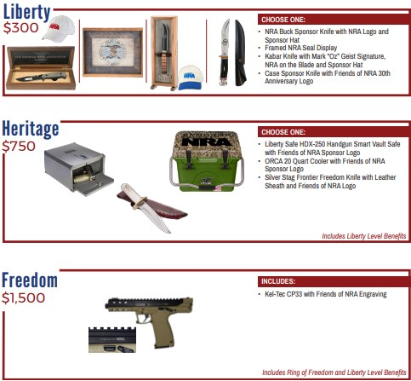
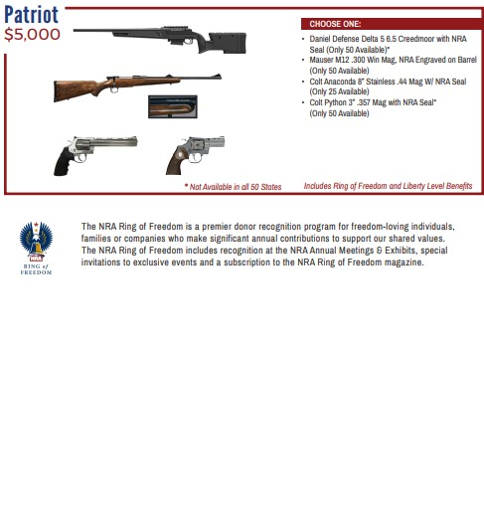
Mail This Portion --- Order Early and SAVE
Name: Address:
City: State: Zip: (Must be same as CC Billing) Phone: ( ) - Email:

Please reserve Event Ticket and Meal at $60 each | $
Please reserve $100 Single Shot Package and 1 Meal- Over $200 Value – (05/06/2022) | $
Please reserve $200 Double Barrel Package and 2 Meals – Over $400 Value- (05/06//2022) | $
Please reserve $300 Super Value Package and 1 Meal – Over $600 VALUE – (05/06/2022) | $
Please reserve Silver Table $700 Gold $1,300 Diamond $1,600 __Platinum $2,500 | $
Please reserve Sponsor: Liberty Heritage Freedom Pioneer Patriot | $
 | $

Please List your choice of Table and or Sponsor Firearm Here or call the contacts below
Enclosed please find my check/money order, payable to Friends of NRA......................totaling: $

Tickets ordered on this form may be picked up at the door the night of the event.
Please charge my Credit Card: (circle) Visa/MC/AMEX/Discover #

Expiration Date (Month/Year) / Security Code:
MAIL TO: Lake County FNRA For more information call: Kevin (847) 652-5959 or e-mail: lakecountyfnra@gmail.com 5076 DARLENE DR

Gurnee, IL 60031
Log onto www.friendsofnra.org THIS FORM MAY BE COPIED

