Awards Banquet
Annual Fundraiser on behalf of The NRA Foundation

January 29th 2022 ▪ 4:00 pm
Smiley’s Banquet Hall
5671 Pleasant Dr. ▪ Plover, WI 54467

Celebrate a legacy of shooting sports traditions.
Join other champions of the Second Amendment for dinner, games, auctions and fun with a chance to win exclusive NRA guns, gear, décor and collectibles!

AUCTION & RAFFLE HIGHLIGHTS

NRA Guns & Prizes |  | Special Raffles
2022 GUN OF THE YEAR | NEW Table Packages! | $100 for $200 Bucket Raffle Pack OR
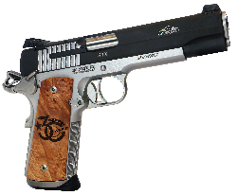  SIG SAUER 1911 STX .45  With Friends of NRA 30th Anniversary Grips  NRA EXCLUSIVES  Diamondback DB-15 Rifle  With 30th Anniversary Logo  Smith & Wesson M&P9  Shield Plus 9mm with NRA Logo  Henry Single Shot Rifle  .350 Legend with 30th Anniversary Logo | $500 Reserved Table: (8) Event tickets, (8) Meal tickets, (8) Bucket raffles Strips-$20 value each  $560 VALUE!!!!  $800 Bronze Table: (8) Event Tickets, (8) Meal Tickets, (16) Bucket Raffle Strips, (1) Henry .22  $1,100 VALUE!!!!!  $1200 Silver Table: (8) Event Tickets, (8) Meal Tickets, (24) Bucket Raffle Strips, (1) Choice of Sig Sauer P320 9MM or Savage Axis II 30-06  $1,500 Value!!!!!  $2,500 Gold Table: (8) Event Tickets, (8) Meals Tickets, (48) Bucket Raffle Strips, (1) Choice of NRA Custom FosTech Phantom or Springfield 1911 Ronin .45 ACP  $2,900 VALUE!!!! | $350 for $800 Pack  Raffle Pack Raffle  $100 per TICKET  ONLY 50 TICKETS  TO BE SOLD  Purchase a Ticket and Receive a $100 Bucket Raffle Pack For The  Sig Sauer 1911 STX .45  2022 Gun Of The Year  AND MORE!  View all items at www.friendsofnra.org/merchandise
The NRA Foundation is a 501(c)3 charity of the National Rifle Association. Net proceeds benefit shooting sports programs in our communities. NRA membership is not required to participate. All firearm laws apply. Winners are responsible for any taxes / transfer fees. Firearms transferred through [FFL DEALER].

2022 SPONSOR PROGRAM
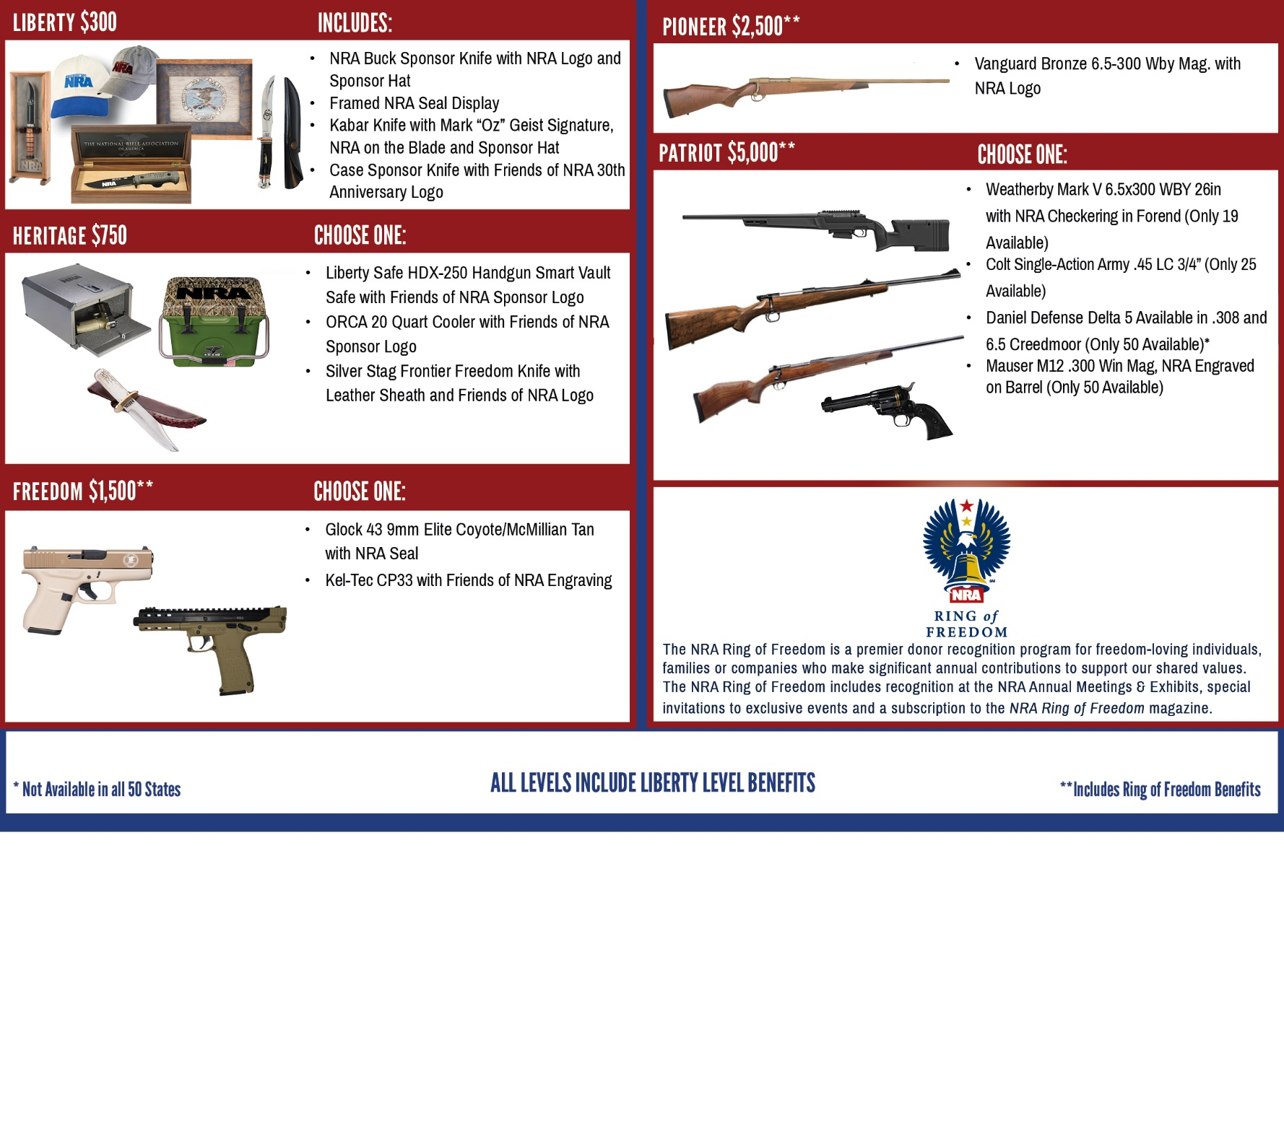
_____ $100 for $200 Bucket Raffle Pack $ __________
_____ $350 for $800 Bucket Raffle Pack $ __________
Order tickets online:
www.friendsofnra.org

All tickets held at door
Cancelled check or CC charge is your receipt/confirmation
Questions? Tylor Flynn
tflynn@nrahq.org
608-208-2868

Or mail order by (1/20/22)
Clip address below & tape to envelope for easy addressing!

Tylor Flynn
PO Box 126
Fort Atkinson, WI 53538
 |  |  | $50 INDIVIDUAL: 1 Event Ticket |  |  |  |  | $
 |  |  | $500 Reserved Table: 8 Event Tickets, 8 Bucket Raffle Sheets |  |  |  |  | $
 |  |  | $800 Bronze Table: 8 Event Tickets, 16 Bucket Raffle Sheets, 1 Gun |  |  |  |  | $
 |  |  | $1,200 Silver Table: 8 Event Tickets, 24 Bucket Raffle Sheets, 1 Gun |  |  |  |  | $
 |  |  | $2,500 Gold Table: 8 Event Tickets, 48 Bucket Raffle Sheets, 1 Gun |  |  |  |  | $
 | [ ] $300 Liberty [ ] $2,500 Pioneer [ ] $5,000 Patriot
 | [ ] $750 Heritage [ ] $2,650 Protector [ ] $10,000 Founding
 | [ ] $1,500 Freedom [ ] $3,500 Legacy [ ] $12,500 Sentry
Please enclose check to NRA FOUNDATION or complete credit card info below |  |  |  |  |  |  |  | $
AmEx/Disc/MC/Visa charged upon receipt. All sales are final.
Card # |  |  |  |  | Expiration
Signature |  |  |  |  | Sec Code
Name |  |  |  |  | Company
Address |  |  |  |  | Phone
City/St/Zip |  |  |  |  | Email

