**Brainerd Minnesota**

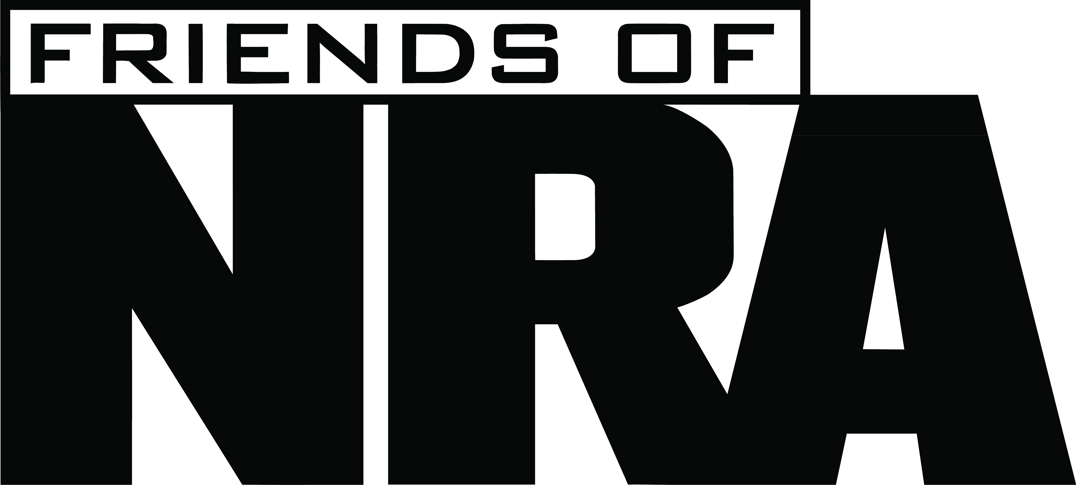

**8th Annual Fundraiser**

**on behalf of The NRA Foundation**

**October 6TH, 2015** ▪ **5:30 pm**

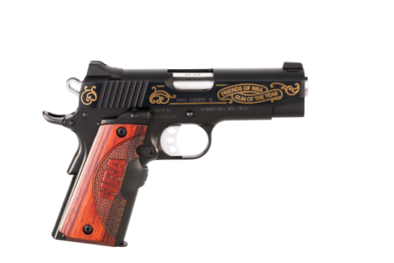***Get your tickets Early – Limited tickets available!***

Madden’s

11266 Pine Beach Peninsula Brainerd MN, 56401

Join other champions of the Second Amendment for dinner,

raffles, auctions and fun with a chance to win exclusive

***Gun of the Year***

***Kimber 1911***

NRA guns, gear, décor and collectibles!

**AUCTION & RAFFLE HIGHLIGHTS**



|  |  |  |
| --- | --- | --- |
| **Special Offers** | | **Table Packages (New for 2015)** |
|  |  |  |
| ***Early Bird Drawing***  **Tickets postmarked or turned in by Sept. 28th, 2015 will be entered in a special drawing.**  ***New Field Rep!!!!!!***  ***Come on the 6th to enjoy an evening of fun and meet the new NRA Field Rep!***  ***Eric Linder*** | **NRA EXCLUSIVES**  **Rossi Model 92 Rifle**  .44 Mag with NRA Coin  **Crickett .22LR Rifle**  With Pewter NRA Coin  **Savage Model 11 XP Predator Camo**  With Bushnell Scope and NRA Logo  **& MORE!**  View all items at friendsofnra.org/merchandise | **$800 Table Package**  8 Dinners tickets - $320 in White Bucket tickets  And a  **10-22 Ruger at your table**  **$1600 Table Package**  ($2000 Value)  8 Dinners tickets 8 Special Gifts  8 $100 Bucket raffle Packages and a  **Glock .45 Cal Handgun at your table!!**  **$5,000 Table Package**  **8 Dinners tickets 8 Special Gifts**  **8-$300 Buckets Raffle Packages**  **And**  **8 Diamondback 9MM**  **Or**  **1 Savage .338 Lapua Rifle**  **At your table!!!!** |

The NRA Foundation is a 501(c)3 charity of the National Rifle Association. Net proceeds benefit shooting sports programs in our communities. NRA membership is not required to participate. All firearm laws apply. Winners are responsible for any taxes / transfer fees. Firearms transferred through Mills Fleet Farm - Baxter



|  |  |  |  |  |  |  |  |  |  |  |  |
| --- | --- | --- | --- | --- | --- | --- | --- | --- | --- | --- | --- |
| **ORDER FORM ● Brainerd Friends OF NRA October 6th, 2015** | | | | | | | | | | | |
|  | | | | | | | | | | | **Order tickets online:**  [www.friendsofnra.org](http://www.friendsofnra.org)  **All tickets held at door**  Cancelled check or CC charge is your receipt/confirmation  **Questions?**  **Nancy Schroeder**  nwclw@tds.net  **218-568-6676**  **Or mail order by**  *Clip address below & tape to envelope for easy addressing!*  **Brainerd Friends**  **6182 25th Ave SW**  **Pequot Lakes, MN 56472** |
| **QTY** |  | | **$40 Individual Dinner** | | | | | $ |  |  |
|  |  | | **$ 70 Couples Dinner** | | | | | $ |  |  |
|  |  | | **$800 TABLE: 8 Dinners + 8 Gifts + $320 Tickets + Ruger 10-22** | | | | | $ |  |  |
|  |  | | **$1,600 TABLE: 8 Dinners + 8 Gifts + 8 $100 Ticket Pkgs + Glock .45** | | | | | $ |  |  |
|  |  | | **$5,000 TABLE: 8 Dinners+ 8 Gifts + 8 $300 Ticket Pckges** | | | | | $ |  |  |
|  |  | | ( ) **8 Diamondback 9MM Handguns** Or | | | | |  |  |  |
|  |  | | ( ) **1 Savage .338 Lapua Rifle** | | | | |  |  |  |
|  |  | |  | | | | | $ |  |  |
|  |  | | **Any one of our popular sponsors…($250, $600, $1250, $2500, etc…)** | | | | |  |  |  |
|  | |  |  | | | | |  |  |  |
| **Please enclose check to NRA FOUNDATION or complete credit card info below** | | | | | | | | **$** |  |  |
| **AmEx/Disc/MC/Visa charged upon receipt. All sales are final.** | | | | | | | |  |  |  |
| **Card #** | | | |  | **Expiration** |  | |  | | |
| **Signature** | | | |  | **Sec Code** |  | |  | | |
| **Name** | | | |  | **Company** |  | | | |  |
| **Address** | | | |  | **Phone** |  |  | | |  |
| **City/St/Zip** | | | |  | **Email** |  | | | |  |

**2015 Sponsor Program**

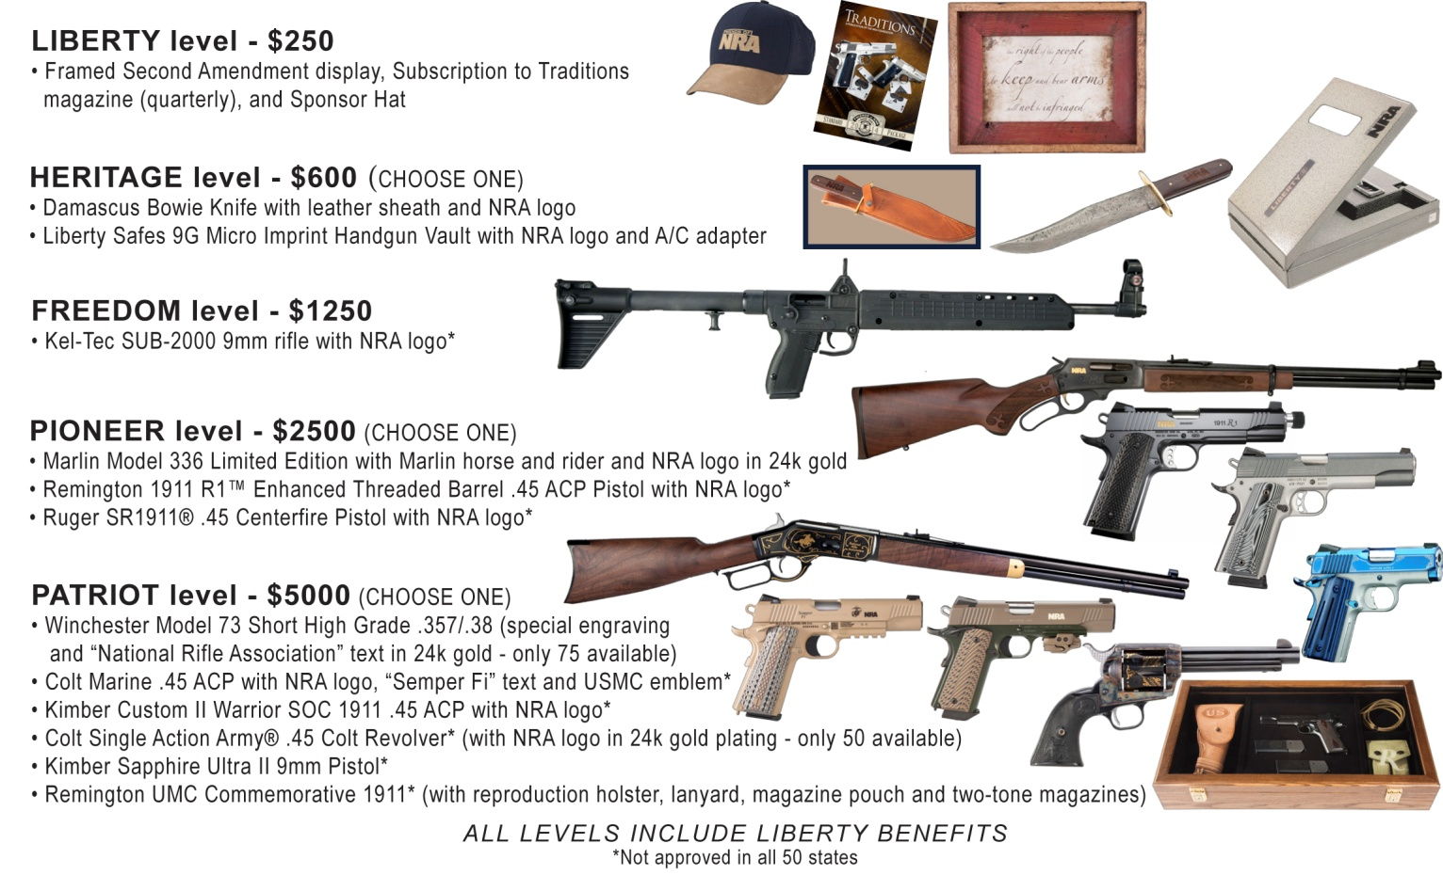

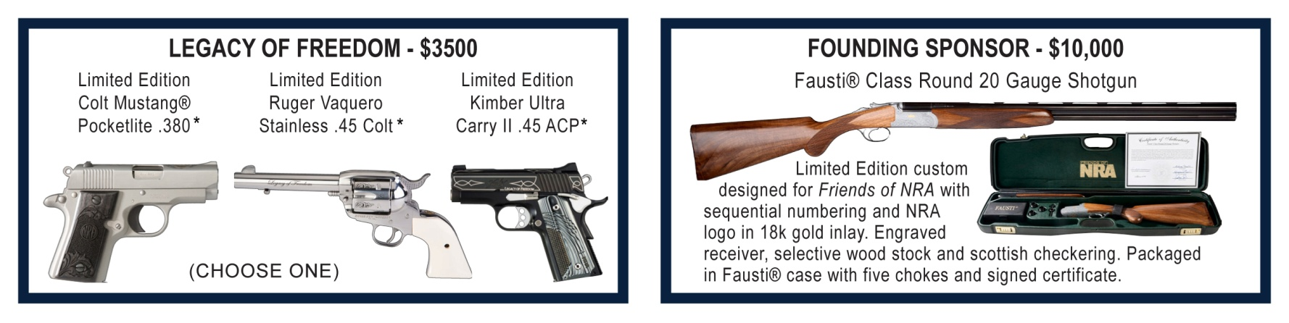

***For Sponsorship sign up please contact Nancy Schroeder at NWCLW@tds.net or 218-568-6676***