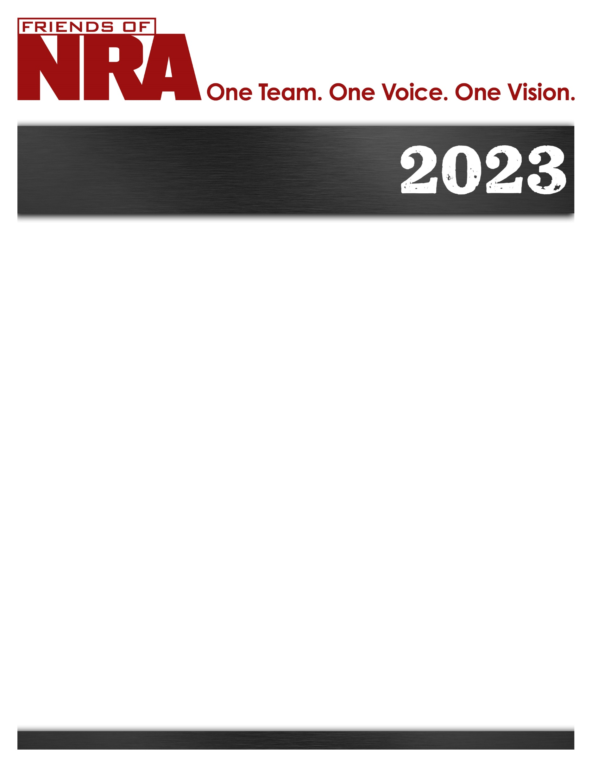

Sherburne County
Annual Fundraiser on behalf of The NRA Foundation

September 15th
Any and all tickets paid for by this date will be in the drawing
September 29th, 2023 ▪ 5:00 pm
Early Bird Bonus!
Gun Drawing!!
The Buff
16722 198th Ave – Big Lake, MN 55309
For Tickets: friendsofnra.org/events
Contact info: Mark Strempke m_a_strempke@hotmail.com or 763-286-6735

NRA Guns & Prizes |  | $10,000 Table
Single Tickets: $50.00 | NRA EXCLUSIVES | Best Deal!!!!!
$1,000 Table  8 Dinner tickets  AND A gun from these choices!!  Taurus Judge Glock 43  S&W 15-22 .22 cal Savage 9317 ,17 HMR  SAR USA 2000 9mm  $6,000 Table  8 Dinner Tickets  And 8 of the guns listed above!! | 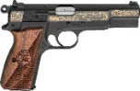  2023 GUN OF THE YEAR  Springfield Armory SA-35 9mm with NRA Grips  Sig Sauer M400 Tread 5.56mm NATO  with NRA Seal  Henry “Homesteader” Carbine 9mm  with NRA Seal  Savage Arms 110 Classic 6.5 Creedmoor  with NRA Seal | 8 Dinner Tickets  8 Special Gifts  8 Guns at each table!!!!  Ruger LC Carbine 5.7X28mm  Kimber Micro 9mm  Please contact Mark for other options if interested!!

The NRA Foundation is a 501(c)3 charity of the National Rifle Association. Net proceeds benefit shooting sports programs in our communities. NRA membership is not required to participate. All firearm laws apply. Winners are responsible for any taxes / transfer fees. Firearms transferred through [FFL DEALER].
2023 SPONSOR PROGRAM
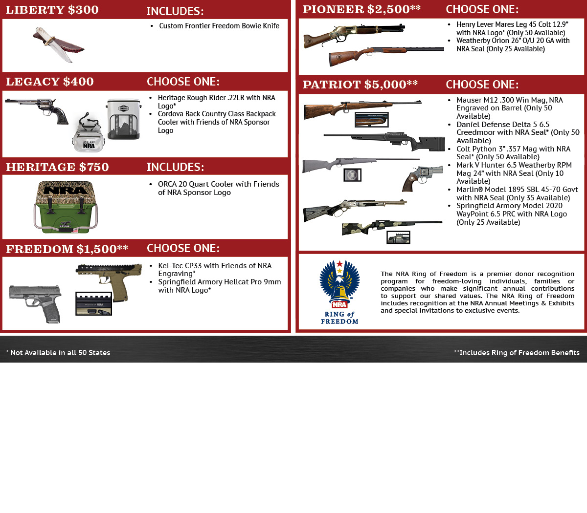
ORDER FORM ● SHERBURNE COUNTY MN FRIENDS OF NRA 9-29-23
Order tickets online:
www.friendsofnra.org

All tickets held at door
Cancelled check or CC charge is your receipt/confirmation
Questions?
Mark Strempke
m_a_stremke@hotmail.com
763-286-6735
Or mail order by 9-15-23
Clip address below & tape to envelope for easy addressing!

Mark Strempke
5042 Mitchell Rd
Big Lake, MN 55309
QTY |  |  | $50.00 INDIVIDUAL: 1 Dinner |  |  |  |  | $
 |  |  | $1,000 TABLE – Includes 8 Dinners and 1 Gun Choice |  |  |  |  | $
 |  |  | $6,000 TABLE – Includes 8 Dinners and 8 Gun Choices |  |  |  |  | $
 |  |  | $10,000 TABLE – Includes 8 Dinners, 8 Special Gifts and 8 Gun Choices |  |  |  |  | $
 |  |  | TAX-DEDUCTIBLE SPONSORSHIP (Dinner tickets are not included) |  |  |  |  | $
 | [ ] $300 Liberty [ ] $750 Heritage [ ] $2,500 Pioneer
 | [ ] $400 Legacy [ ] $1,500 Freedom [ ] $5,000 Patriot
Please enclose check to NRA FOUNDATION or complete credit card info below |  |  |  |  |  |  |  | $
AmEx/Disc/MC/Visa charged upon receipt. All sales are final.
Card # |  |  |  |  | Expiration
Signature |  |  |  |  | Sec Code
Name |  |  |  |  | Company
Address |  |  |  |  | Phone
City/St/Zip |  |  |  |  | Email

