**SMITH & WESSON 1854 .44 MAG**

**TICKETS ARE $100 EACH-ONLY 50 CHANCES SOLD**

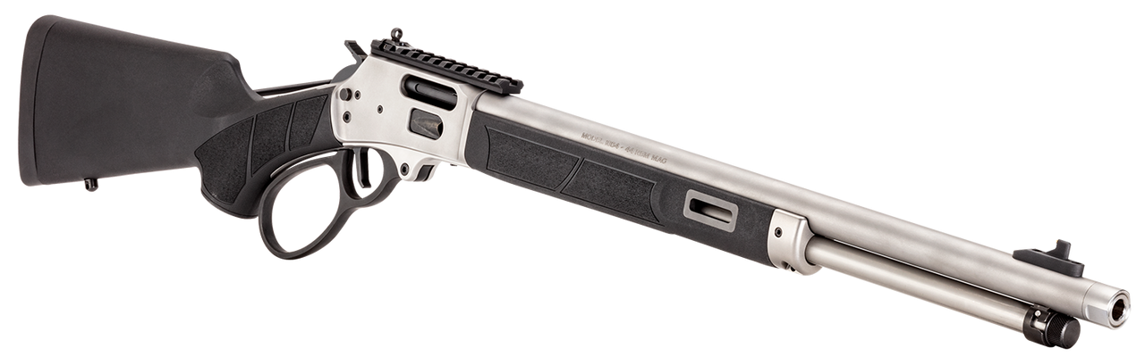

Introducing the Model 1854 by Smith & Wesson, a triumph of over 170 years of craftsmanship. This lever-action rifle seamlessly melds precision engineering and timeless design with modern features, including M-LOK slots and a Picatinny rail for optics. Experience the perfect blend of heritage and innovation - experience Smith & Wesson Smooth™

* 11/16-24 Threaded Barrel
* Accepts mounts compatible with Marlin® 1894 hole patterns
* Black synthetic stock with textured grip panels
* M-LOK® synthetic forend with textured grip panels
* Gold bead front sight
* XS Sights ghost ring rear sight
* 1:20" RH Twist 8-Groove Rifling
* Large loop operating lever
* Forged 416 SS Receiver
* 19.25" 410 SS Barrel