Lincoln County Friends of NRA 2024 Fundraising Event

**A Fun Evening with Games, Auctions and Raffles**

**Raising Money for the Shooting Sports!**

**Single Tickets: $60**

**Table purchase’s on Request**

**Tickets May be Purchased Online @**[**www.friendsofnra.org/eventtickets/Events**](http://www.friendsofnra.org/eventtickets/Events)

**Or by Contacting information Below!**

Friday, November 8th, 2024, 5:30 PM

Memorial Hall is located at

511 Park Street, Davenport Washington 99122

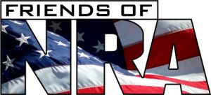**For questions CONTACT:**

Vicki Morcom   
Phone:(509)721-0306

Grandmamorc1@gmail.com