**South-Central Friends of NRA**

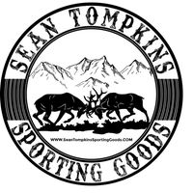

**Mossberg International Gold 12GA**

**Firearm Sponsored By:**

**ONLY 50 Chances Sold!**

**Chances are ONLY $50 Each!**

**(NEED NOT BE PRESENT TO WIN!)**

**(Each ticket comes with admittance to the inaugural South-Central Friends of NRA Event Thursday October 17th @ Henry Street Social in Edgerton! Doors Open at 5 O’clock!)**

*What is Friends of NRA?*

**The Friends of NRA, a 501(c)(3) charitable organization, raises funds to support eligible public interest activities of the NRA and other organizations that defend and foster the Second Amendment rights of all law-abiding Americans.**

**The Friends of NRA provides grants to fund activities and support programs in the United States to promote firearms and hunting safety, to enhance marksmanship skills of those in the shooting sports, and to educate the public about firearms in their historic, technological and artistic context.**

**These grants benefit constituencies such as children, women, people with physical disabilities, gun collectors, law enforcement officers, hunters and competitive shooters.**

**Friends of NRA in Wisconsin-**

**Since 1995 Friends of NRA volunteers across Wisconsin have rose 5.5 MILLION DOLLARS supporting the shooting sports across the state! Programs that have benefited from those grants range from Gun Range Improvements to High School Trap Shooting Teams!**

**Scan to find event flyer and to purchase tickets online!**