Southern West Virginia

M1 Carbine Rifle .30 Caliber
1943 Saginaw Steering Group

$100 Ticket
Only 100 Tickets Available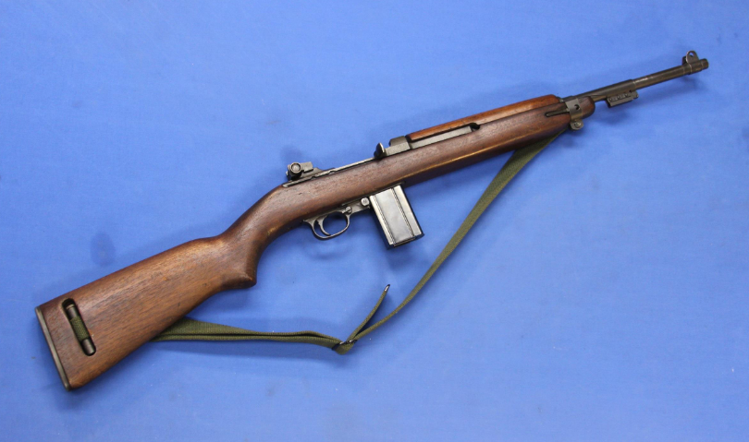

Drawing Held When All Tickets Are Sold. Need Not Be Present to Win. Winner Responsible for All Shipping and Transfer Costs.

