**CENTRAL VIRGINIA FRIENDS OF NRA**

**KIMBER GUN RAFFLE**

**WINNER TAKE ALL**

**TICKETS ARE $175 EACH-ONLY 75 SOLD**

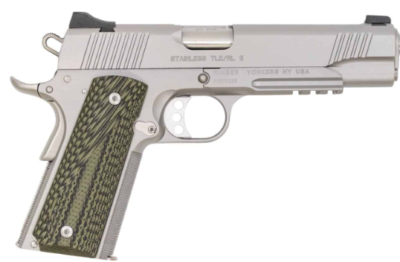

**Kimber Stainless TLE/RL II .45 ACP with Night Sight**

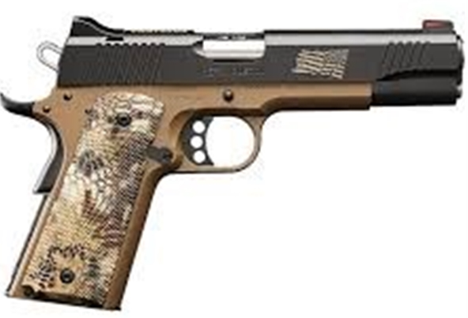

**Kimber Hero Custom II .45 ACP**