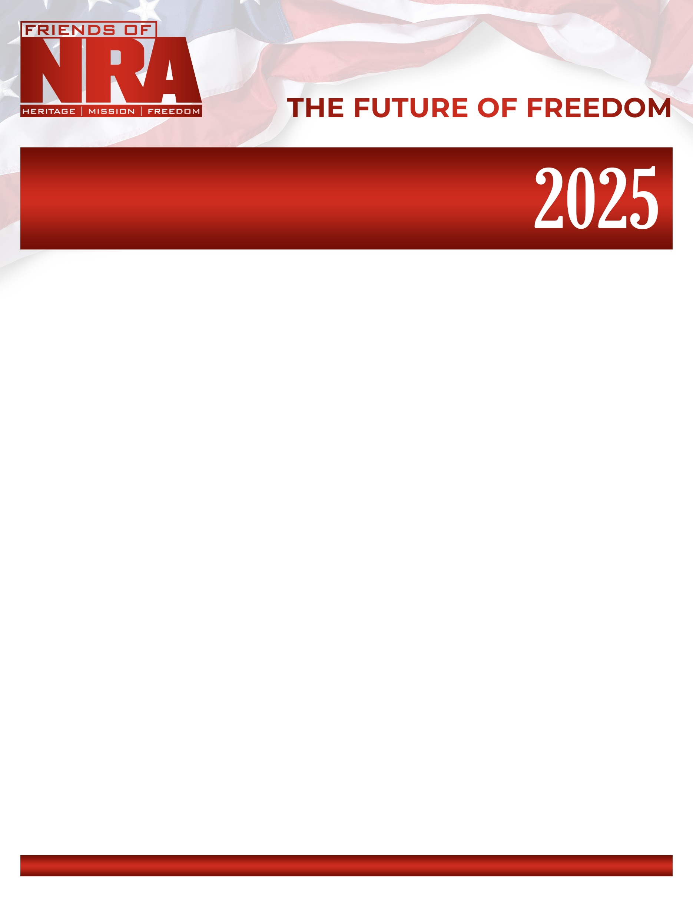

**Laramie Friends of NRA**

**Annual Fundraiser on behalf of The NRA Foundation**

**September 6 2025** ▪ **5:00 pm**

Albany County Fairgrounds 3510 S. 3rd St, Laramie Wy 82070

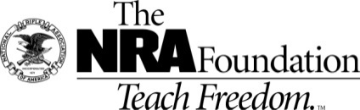

**AUCTION & RAFFLE HIGHLIGHTS**

|  |  |  |
| --- | --- | --- |
| **NRA Guns & Prizes** | | **$100 Single Shot Package**   1 Event Ticket, 1 Meal, 30 White Bucket Tickets, 10 Blue Bucket Tickets, 1 RED    **$200 Double Barrel Package** 2 Event Tickets, 2 Meals, 60 White Bucket tickets, 20 Blue bucket tickets, 2 RED  **$300 Super Value Package ($600 Value)**  1 Event Ticket, 1 Meal, 80 White Tickets, 40 Blue Tickets, 5 RED Tickets  **BUY TICKETS:**  **Call Robert 661-809-5577**  **Or Alexis 307-314-8332**  [**www.friendsofnra.org**](http://www.friendsofnra.org)  Field Representative: Nate Brown  [nbrown@nrahq.org](mailto:nbrown@nrahq.org)  307-823-3948 |
| **2025 GUN OF THE YEAR**    Henry Lever Action Supreme 5.56/.223  with Friends of NRA Logo  **Specialty Firearms**    **Ruger American Predator**  **22ARC** | **NRA EXCLUSIVE**  Kimber Stainless LW .45ACP  with NRA Logo*  Mossberg Patriot LR Tactical 308  with NRA Logo  Guitar Signed by Lee Brice  Firearms from Beretta, Browning, Colt, Ruger, Henry, Kimber, Sig-Sauer, S&W, Springfield Armory…  **AND MUCH, MUCH, MORE!**  View all items at  friendsofnra.org/merchandise |

**RESERVED TABLE PACKAGES**

**$750 Silver Table Package:** 8 Event tickets with reserved seating, 8 Meals, 8 FNRA Gift Items, 8 Single Shot Raffle packs.

**$1500 Gold Table Package:** 8 Event tickets with reserved seating, 8 Meals, 8 FNRA Gift Items, 8 Single Shot Raffle packs. Plus choice of one GOLD TABLE LEVEL Firearm or Double the Table Raffle tickets. Please contact the local committee for a list of firearms that are currently available.

**$1750 Diamond Table Package:** 8 Event tickets with reserved seating, 8 Meals, 8 FNRA Gift Items, 8 Single Shot Raffle packs. Plus choice of one DIAMOND TABLE LEVEL Firearm or Double the Table Raffle tickets. Please contact the local committee for a list of firearms that are currently available.

**$2500 Platinum Table Package:** 8 Event tickets with reserved seating, 8 Meals, 8 FNRA Gift Items, 16 Single Shot PACKS. Plus choice of one PLATINUM TABLE LEVEL Firearm or Double the Table Raffle tickets. Please contact the local committee for a list of firearms that are currently available.

The NRA Foundation is a 501(c)3 charity of the National Rifle Association. Net proceeds benefit shooting sports programs in our communities. NRA membership is not required to participate. All firearm laws apply. Winners are responsible for any taxes / transfer fees. Firearms transferred through [FFL DEALER].

***Once they’re gone, they’re gone—so act fast!***

Contact us to secure your custom item today.

As a token of our appreciation for your unwavering support & Sponsorship, we're creating custom firearms & merchandise available *exclusively* to our National Sponsors.

**What makes a Sponsorship Special?**

* Custom Firearms & Merchandise from Partnering Vendors
* Embellished with NRA Logo and Unique Details
* Limited Quantities Available

**Name:** __________________________________________ **Address:** ________________________________________________

**City: ______________________ State: _______ Zip: _____________ (Must be same as CC Billing) Phone: (____) _____-_________**

**Email: ________________________________________________________**

**Please reserve _____$45 Event ticket and Meal- $_________**

**Please reserve _____$100 Single Shot raffle pack, event tickets, 1 Meal- $_________**

**Please reserve _____$200 Double Barrel Raffle Pack, 2x event tickets and 2 Meals $_________**

**Please reserve _____$300 Super Value Pack ($600 Value), event ticket and 1 Meal $_________**

**Please reserve _____Silver Table $750 _____Gold $1,500 _____Diamond $1,750 _____Platinum $2,500 $_________**

**Please List your choice of Table Gun here:_______________________________________________________________**

**(Contact Committee or Field Rep. for available firearms)**

**Enclosed please find my check/money order, payable to *Friends of NRA-WY-9* $__________**

***Tickets ordered on this form may be picked up at the door the night of the event.***

**Please charge my Credit Card: *(circle) Visa/MC/AMEX/Discover #___________--___________--__________--__________ Expiration Date (Month/Year) ______/________ Security Code: _______***

***MAIL CHECK TO:***

***Lexi Wayne***

**25 South St**

**Laramie Wy 82072**

**For more information call Robert 661-809-5577 or email robertwyn@aol.com**

Get a group of Friends or Family members together and get a table!

Save money, PLUS get a Table Gun!

Call Robert 661-809-5577 or Lexi 307-314-8332 to get a list of table guns available.