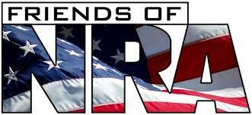

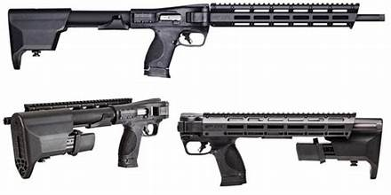

**2 Guns 2 Winners!!!**

**S&W M&P FPC Black Carbine 9MM**

**Tickets are $10 and only 250 tickets are being sold.**

**Go to the Bitterroot Trading Post**

**1010 N 1st. St. Hamilton, MT 59840**

**or**

**Save the date!!!! March 1st. 2025 is the Friends of NRA banquet.**

**Call one of us.**

**Don 406-360-5275**

**April 406-360-9130**