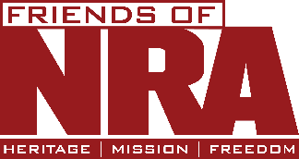
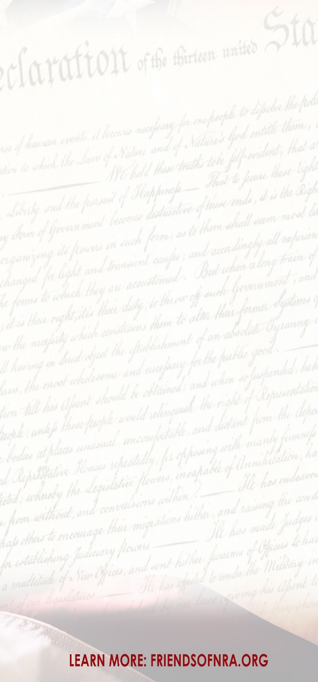
Locked & Loaded
Game Card
$100 Each
$130 Value
GAME CARDS NOT SOLD AT EVENT
SAVE $30!
ORDER AS MANY AS YOU WANT!
INCLUDES 5 GAME ENTRIES:
One $50. Entry into"A.T.F. Game
(Chance to win a Firearm, Humidor, & Decanter set)
One $20 Entries into "Wall of Guns"
(1 in 50 Chance to win 2 vouchers to the Wall of Guns)
One $20 Entry into "Cooler Bag"
(6 cooler bag 25 Tickets per bag - 6 great prizes
One $20 Entry into "Lucky 21"
(1 in 21 Chance to win a gun)
One $20 Entry into "Dice Game"
4 possible chances to Win!!!
Must be present to use Must be used the night of the event

Shock & Awe
$600
Raffle Pack!
Limited Quantity of Raffle Packs Available
Includes:
1- $500 Raffle Pack
(White, Red, Blue, & Gold)
1- Shock & Awe Raffle Ticket
Shock & Awe Raffle is
Biggest Draw of the evening!
Gun Safe Loaded with 6 Guns!!
Winner takes all!
MUST BE PRESENT TO WIN

$400 Event Package Add-ons
Choose: One option per event package Add-on purchased from the list below

- Four Locked & Loaded Game Card
- One Gun Voucher
- Four NRA Bucks
- Ten NRA Hats One Locked & Loaded Came Two NRA Bucks
Pre- Event Raffles
Want to Win a Gun?
Don't miss our Amazing Pre-Event Raffles!!!

Contact: Julia Soto for details
(805) 423-8278

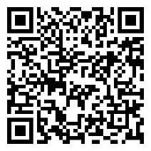

Paso Robles
FRIENDS OF NRA
Dinner Event
Saturday,
MARCH 7, 2026
Doors open: 4:00 PM
ANNUAL FUNDRAISER
Paso Robles Event Center

2198 Riverside Ave.
Paso Robles, CA 93446
Join other champions of the Second Amendment for dinner, raffles, auctions, and fun with a chance to win exclusive NRA guns, gear, and collectibles!

Guns, Fun, and Guns!!!
Tickets Start at $75 each
NON-PROFIT - NON-POLITICAL - NO MEMBERSHIP REQUIRED

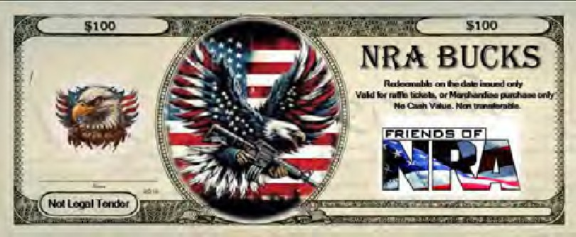
$8,500 We The People Table | $850 Half Table Plus Pack  RESERVED HALF TABLE FOR 4  4- $100 NRA BUCKS 1- Gun Voucher
RESERVED TABLE FOR 8
16- $100 NRA BUCKS 16 - GUNS VOUCHERS
$7,000 The Shock & Awe Table RESERVED TABLE FOR 8  8 - $600 Shock & Awe Packs includes:  8 - Locked & Loaded Cards  Must Call Committee Directly for purchase! | $600 No Frills Table  Reserved Table of 8
$4,570 The Armory Table RESERVED TABLE FOR 8 | $1,400 Couples Premium Pack
10- $100 NRA BUCKS (4) GUNS VOUCHERS includes: | 2 - EVENT ENTRY TICKET - Open Seating
(1) Kimber Custom LW Shadow Ghost 1911 .45acp  (1) SAV STV 334 308 WALNUT 20B | 4 - $100 NRA BUCKS  2 - 1 Gun Voucher
$3,030 The Rifleman Table RESERVED TABLE FOR 8  10 - $100 NRA BUCKS includes:  (1) Legacy National Sponsor with Choice of  (4) Gun Vouchers or (1) Henry Lever Action X Model 30-30 | $350 Double up For Dinner  2 - EVENT ENTRY TICKETS - Open Seating  2 - $100 NRA Bucks
$2,026 Table of the Year RESERVED TABLE FOR 8 | $700 Single Premium Pack
8 - $100 NRA BUCKS Includes:  Choice of (3) Gun Vouchers or (1) SPG HELLCAT OSP 9MM CA 10RDCA | 1 - EVENT ENTRY TICKET - Open Seating 4 - $100 NRA BUCKS  1 - Gun Voucher
$1,850 Buy a table get a Gun RESERVED TABLE FOR 8 | $75 Single Ticket  1 - EVENT ENTRY TICKET - Open Seating  SEATING LIMITED - NO TICKETS AVAILABLE AT THE DOOR
8 - $100 NRA BUCKS includes:
Choice of (2) Gun Vouchers or (1) Canik METE MC9
$100 NRA BUCKS (redeem at event, or call Julia Soto (805) 423-8278
- One Locked & Loaded Game Card
- One $100 Raffle Pack or Combined for larger Raffle packs
- National Sponsorships
- Live Auction or Silent Auction credit
Must be used the Night of event Purchased.
No Cash value Non-Refundable. | $600 Shock & Awe packs are excluded)
Become a Sponsor to receive these benefits!
- 100% Tax Deduction | - All: Your Name/Business listed in the Program
- Event Sponsors receive Special Recognition | - Game Sponsors will have a Large Sign by the Game they are Sponsoring
- $200 & Up Sponsors can display a Banner at the entrance of the Event. | - All: Your Name/Business will be Announced during the Event by the MC
100% of your donation goes directly towards costs of putting on our event!

For Event Tickets and Information
Call: Julia Soto (805) 423-8278
Event Table Packages & Tickets
We the People Table The Shock & Awe Table The Armory Table  The Rifleman Table Table of the Year  Buy a Table get a Gun Half Table Plus Pack No Frills Table  Couples Premium pack Double up for Dinner Single Premium pack  Single Ticket | QTY | @ | $8,500 = | $
 | QTY | @ | $7,000 = | $
 | QTY | @ | $4,570 = | $
 | QTY | @ | $3,030 = | $
 | QTY | @ | $2,026 = | $
 | QTY | @ | $1,850 = | $
 | QTY | @ | $850 = | $
 | QTY QTY  QTY | @ @  @ | $600 =  $1400 =  $350 = | $  $  $
 | QTY | @ | $700 = | $
 | QTY | @ | $75 = | $
Shock & Awe Raffle Pack | QTY | @ | $600 = | $
Locked & Loaded Card  Event Package Add-on | QTY QTY | @ @ | $100 =  $400 = | $  $
Sponsors - 100% TAX DEDUCTION
$500 Game Sponsor $
$200 Live Auction Item Sponsor $
$100 Silent Auction $
Sponsor’s Name
ORDER TOTAL: |  | $
Payment Information
Name: Address:

Phone: Name on Card: Type of Card: [ ] MC [ ] Visa [ ] Amex [ ] Disc
CC# Expiration Date: CVV Email: Make Checks out to: Friends of NRA
Contact Julia Soto (805) 423-8278

