Montana Friends of NRA Sponsorships
Your sponsorship pledge supports local, state, and national shooting sports programs through funds raised by Friends of NRA. As a token of our appreciation for your unwavering support and Sponsorship, we've created custom firearms and merchandise available exclusively to our Sponsors.
$365 NRA EVERY DAY Or $500 FREEDOM LEVEL

Receive a Full $365 tax deduction Receive $300 tax deduction

Receive $1,025 tax deduction
$1,500 FREEDOM LEVEL
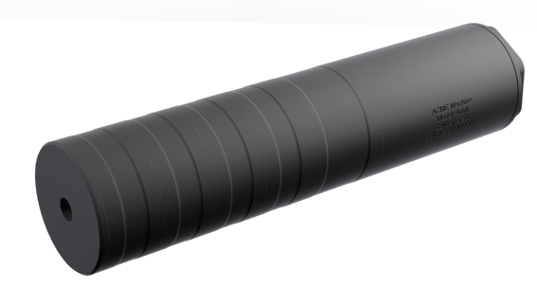  ACME Anvil Suppressor 17-4  Stainless Steel Plan-B Hub Mount  Available in: 5.56, .30, .46, 9mm | 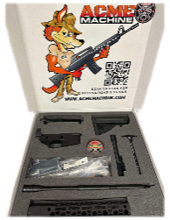  Build Your Own AM-15 Rifle 16” Barrel Hive MLOK Handyguard  Available in: 5.56, 330 Blackout, 350 Legend, 7.62x39, 6.5 Grendel, .22LR
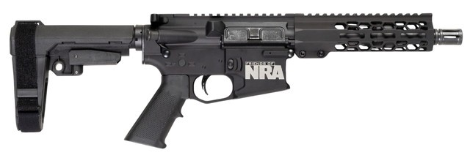  FNRA Proximal AM-15 Pistol 7.5” or 10.5” Barrel, Hive MLOK Handyguard  Available in:  5.56, 300 Blackout, 350 Legend, 7.62x39, .22LR | 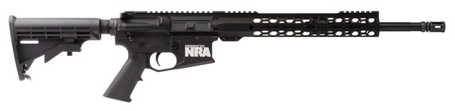  FNRA Minimalist AM-15 16” Barrel, Hive MLOK Handyguard Handyguard  Available in: 5.56, 300 Blackout, 350 Legend, 7.62x39, 6.5 Grendel, .22LR, .450 Bushmaster, 458 SOCOM
$2,500 PIONEER LEVEL
Receive $1,700 tax deduction

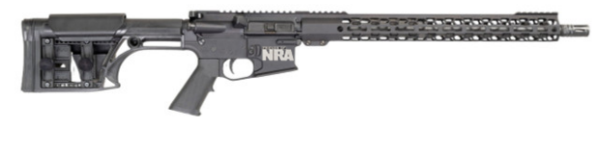  FNRA D.M.R. AM-15 Performance Rifle MLOK Hive Handyguard  Available in: .223 Wilde, .22 ARC, 6 ARC, 6.5 Grendel, 350 Legend, 400 Legend with 18” or 20” Barrel | 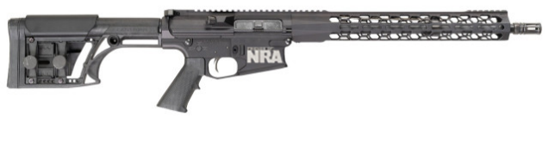  Available in: .308, 6.5 Creedmoor with 16”, 18”, 20” or 22” Barrel  FNRA Scout AM-10 LR-306 Performance Rifle MLOK Hive Handyguard
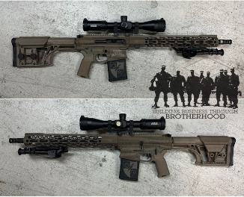
AM-15 Premium Custom Rifle Package
Available in: 5.56, .223 Wylde, 6.5 Grendel, .22 ARC,
350 Legend, 300 Blackout with 16”, 18” or 20” Barrel
Color: Silver, Black, Purple, Blue, Green, Yellow, Orange,
Red, Pink and Camo

$3,500 LEGACY LEVEL
Receive $2,500 tax deduction

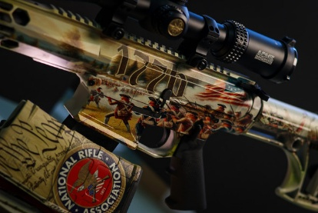
AM-10 Premium Custom Rifle Package
Available in: .308, 6.5 Creedmoor with 16”, 18” or 20” Barrel
Color: Silver, Black, Purple, Blue, Green, Yellow, Orange, Red, Pink
MORE SPONSORSHIP OPPORTUNITIES

- VALOR: $3,200 ($2,000+ Tax Deduction) Choice of Valor Trips
- INDEPENDENCE: $6,400 ($4,000 Tax Deduction) Choice of Independence Trips
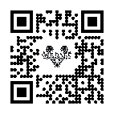
- CONSTITUTION: $6900 ($4,200 Tax Deduction) Choice of Constitution Trip
See Valor, Independence &
Constitution Sponsors Here:
>> SCAN ME

- HEADLINE SPONSORSHIPS: Get spotlighted as a Presenting Sponsor with a 100% tax write-off —ask us about available options.

OTHER CUSTOM SPONSORSHIPS: We also offer sponsorship levels ranging from $5K to $25K and beyond. Talk to us about creating a custom level that fits you!
Sign up today!
Contact NRA Senior Field Representative, Joe Crismore at
jcrismore@nrahq.org or (406) 293-2498

THANK YOU FOR YOUR SUPPORT!

