$200 Table

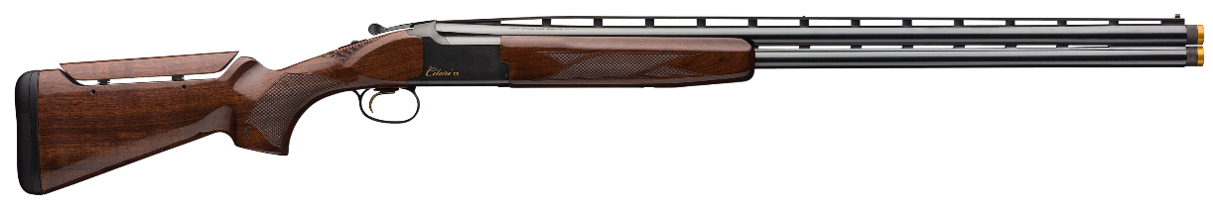
Browning Citori CX 12 GA 32"

Bergara Rifles Premier MG Lite 6.5 Creedmoor 22”
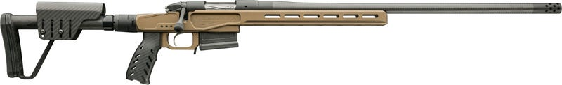

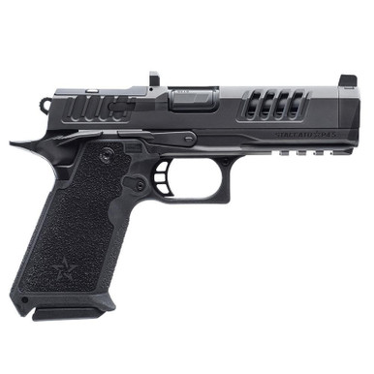
Staccato Preferred HD P4.5 9mm

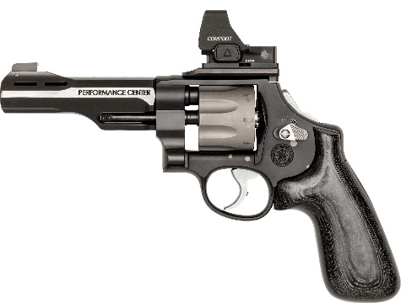
Smith and Wesson Performance Center Model 327

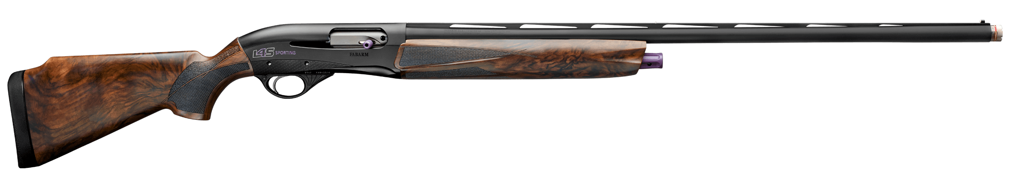
SYREN L4S SPORTING 12G 30”

$300 Table
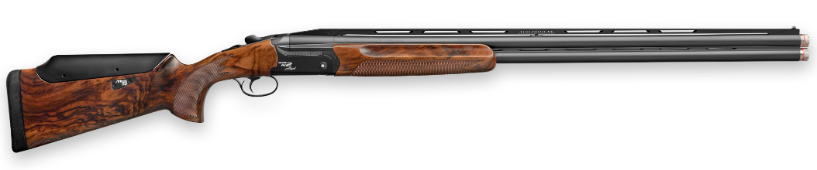
FABARM Elos N2 Allsport 12g 30”

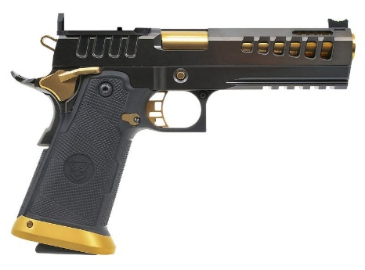
Watchtower Firearms Demolitia Full Size 2011 9mm

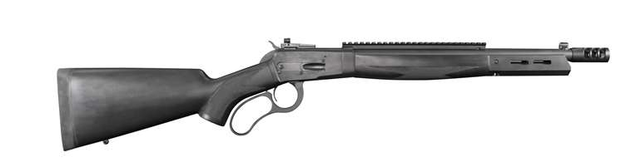
BIG HORN ARMORY M89 - Black Thunder 16" 500S&W

Nighthawk Custom GRP Recon 1911 45ACP 5"
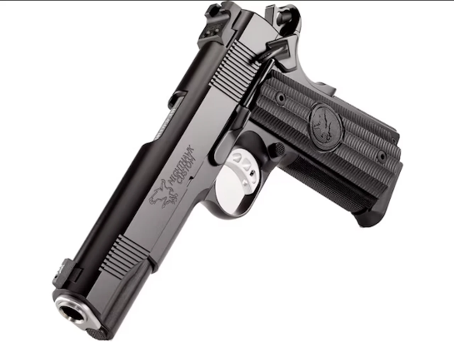

Q Fix 6.5Creedmoor or 308Win
